## **OPEN SOURCE VOIP: ASTERISK/FREEPBX**

For any organization, communication services are an incredibly important factor of productivity. In order to give employees a method to communicate, a call server must be implemented for user IP Phones to connect and call with each other. In this instance, we will be setting up a free open source VoIP solution known as FreePBX Asterisk.

Prerequisite services

* Active directory is configured and reachable from the lab network
* DHCP must be configured
* ESXi 8 must be installed and configured on the desired server

### INSTALLATION INSTRUCTIONS

This installation will take place directly on the ESXi server to simplify installation steps. First, the FreePBX ISO will be downloaded. Then, it will be uploaded to ESXi and some basic configuration will be set.

1. Go to <https://www.asterisk.org/downloads> to download the ISO image
   1. Find the **Download Full ISO Now** button under the FreePBX option



1. If the network is not getting internet from the ESXi network, connect directly to the ESXi lab network. Otherwise, connect to the lab network and either get DHCP address or configure a static address yourself. Enter **10.33.7.103** (MSP ESXI) into your browser to connect to the ESXI server. Enter the ESXI credentials to log in.

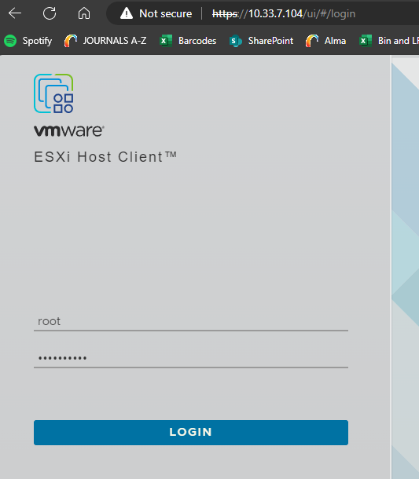

1. Reference appendix **Appendix B: Server Datastore Allocation** to create a datastore called **CNIT450Fa23grp2_Asterisk** with **30 GB** of space at minimum. Assign it more if you would like to take snapshots You should be able to see it under **Storage > Datastores**

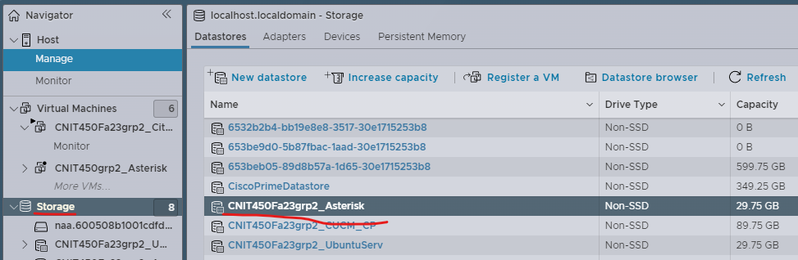

1. Click **Virtual Machines > Create / Register VM**

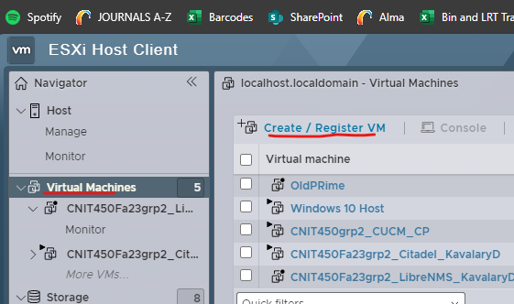

1. Select **Create a new virtual machine**

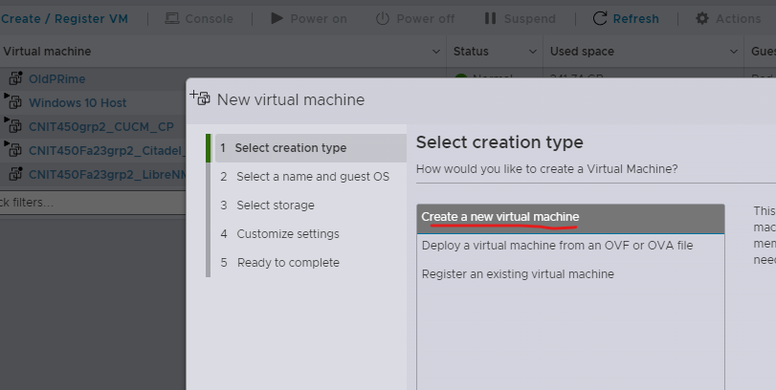

1. Enter the below
   1. Name: **CNIT450Fa23grp2_Asterisk**
   2. Compatibility: **workstation 15 virtual machine**
   3. Guest OX: **Linux**
   4. Guest OS Version: **Other Linux 64 bit**

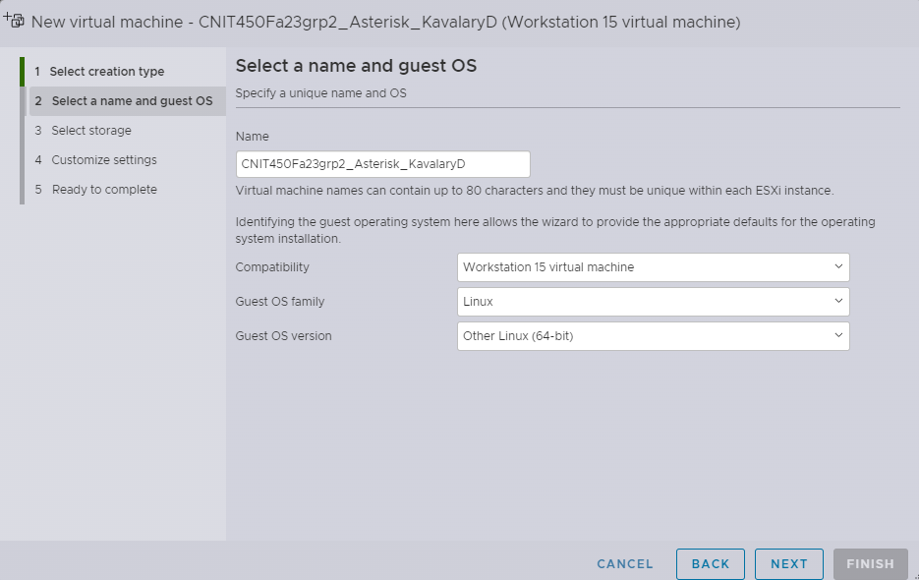

1. Select the datastore created earlier

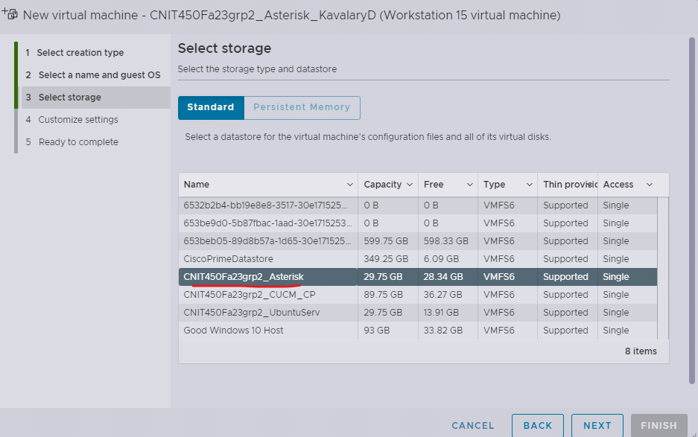

1. Use the below for settings:
   1. CPU: **2**
   2. Memory: **4 GB**
   3. Storage: **25 GB**
   4. Disk provisioning: **Thin**

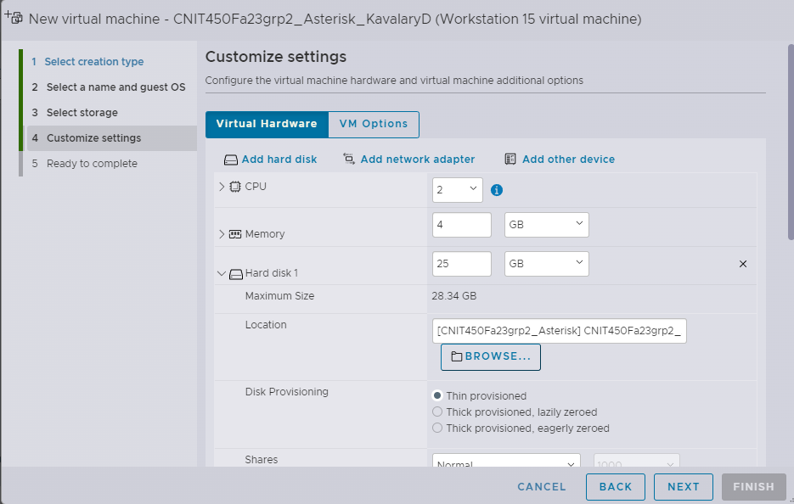

* 1. Network adapter: **CNIT450Fa23grp2_MSP_PG**
  2. CD/DVD: **Datastore ISO File** (this will open a popup window)

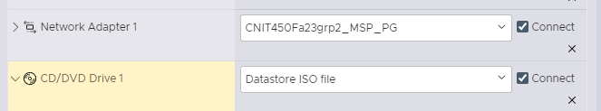

* + 1. Select the datastore you made previously and click upload.
    2. Find the Asterisk FreePBX ISO downloaded earlier on the host device and upload it to ESXI

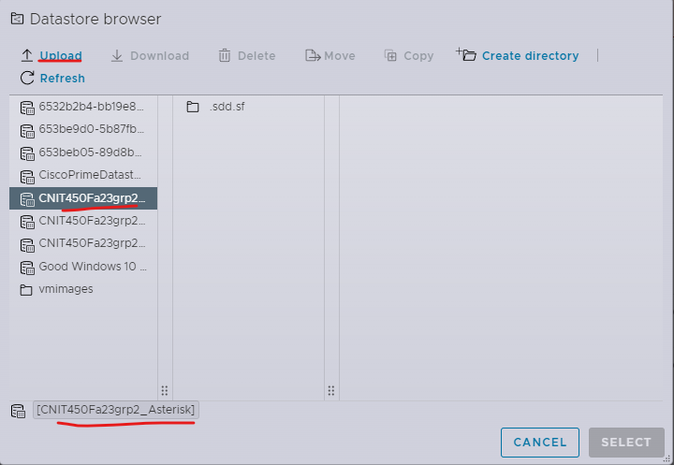

* + 1. Once uploading starts, there should be a progress bar in the upper right hand corner, once it reaches 100 the ISO file should show up. Select it, then click select.

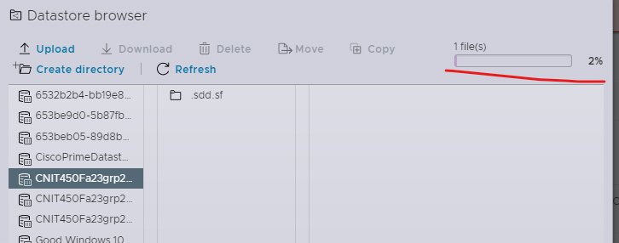

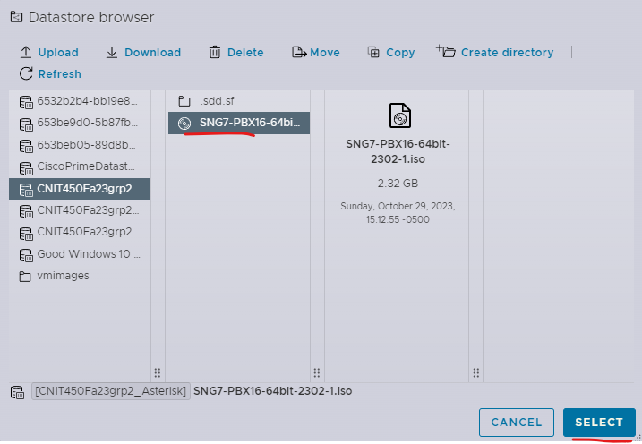

1. Confirm the settings created and click finish

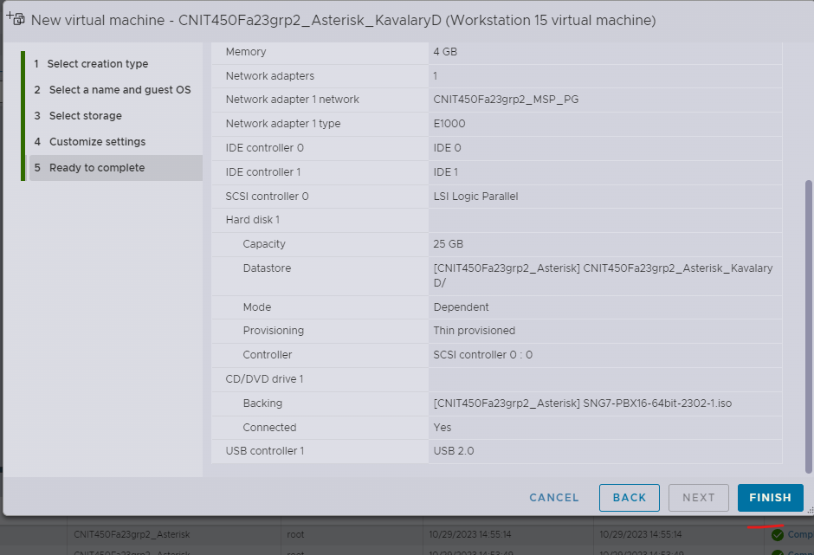

1. Go to **Virtual Machines** and power on the VM

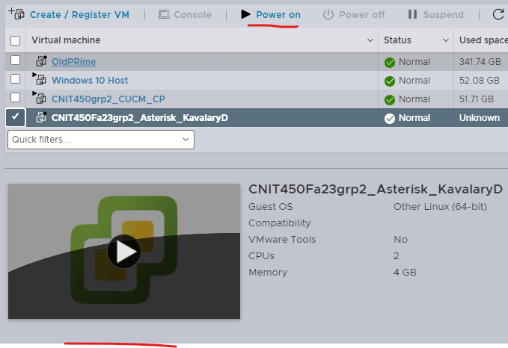

1. Select **FreePBX 16 installation (Asterisk 18) - Recommended**

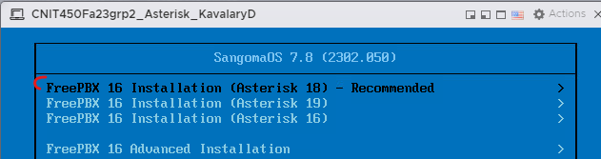

1. Select **Output to VGA** for the Graphical installation

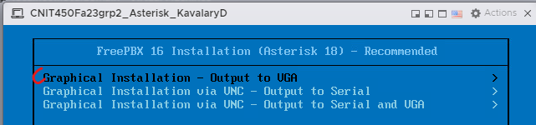

1. Select **FreePBX Standard**

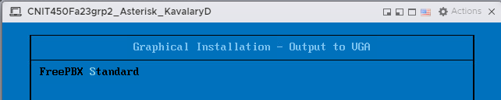

1. Wait a minute while the setup initializes, once it does you will see a configuration screen. Click on the **Root Password** option

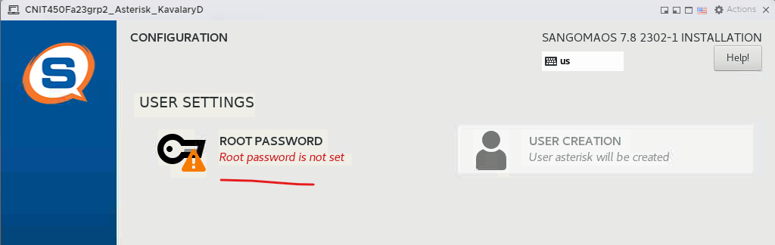

1. Enter a password for the root user, in this instance we will use **CNIT450grp2**

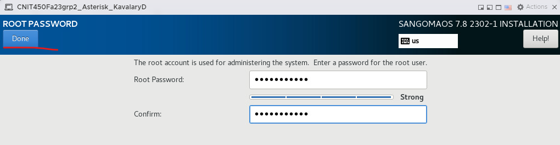

1. Wait until the installation has completed, this may take up to an hour.

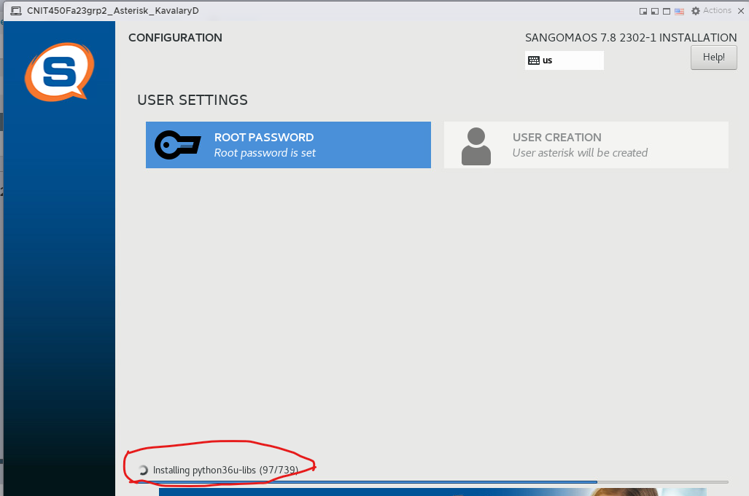

1. Click the **Reboot** option that becomes available after installation is complete

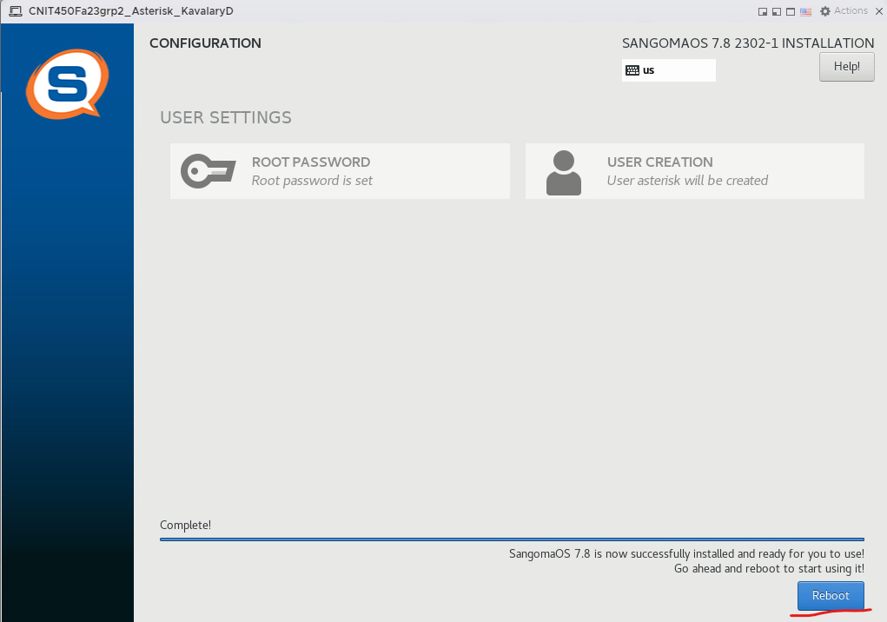

1. Once the system restarts, log in with the user **root** and the root password created earlier

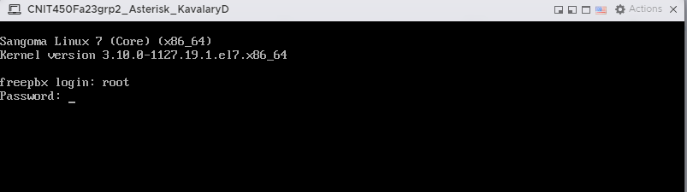

1. Fail2Ban is an intrusion prevention system built into Asterisk. Typically, this is rigorously configured for the needs of the organization, this is out of scope for this demonstration. However; since fail2ban has the known issue of blocking even its own admin user’s IP unless specifically configured not to, we will disable fail2ban for the time being with the below commands.
   1. **systemctl stop fail2ban**
   2. **systemctl disable fail2ban**

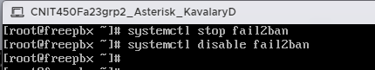

1. Type **nano /etc/sysconfig/network-scripts/ifcfg-eth0** to configure a static address for the server. It should be modified to look like the image with highlighted portions below
   1. Before modification:

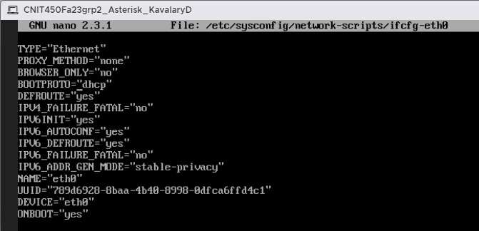

* 1. The main considerations are as follows
     1. **BOOTPROTO=”static”**
     2. **IPADDR=”172.20.128.26”**
     3. **GATEWAY=”172.20.128.21”**
     4. **NETMASK=”255.255.255.240”**
     5. **ZONE=”trusted”**
     6. **OBNOOT=”yes”**

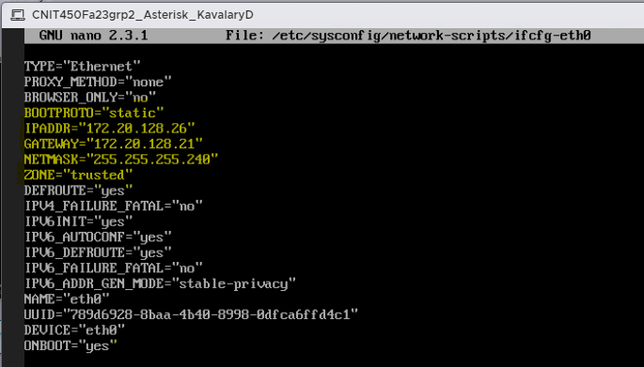

1. Enter the command **service network restart** to apply the network changes. You should receive an OK message, if not, the configuration may need to be checked for forgotten quotation marks or mistyped config.

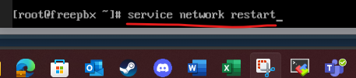

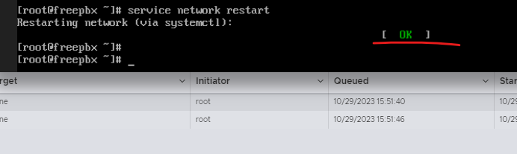

1. Type “**ifconfig**” to confirm the interface configuration changes

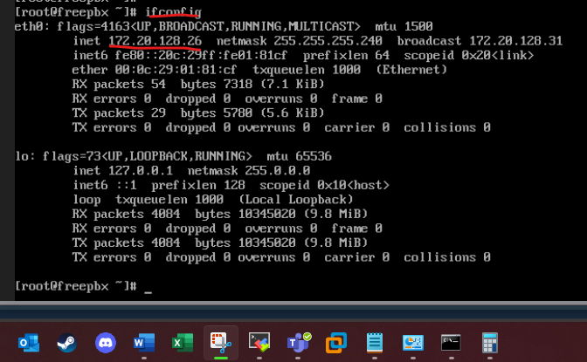

1. To ensure connectivity, ping the default gateway of the server. If this fails, troubleshoot end to end connection between the switches and the server. In addition, ping the address of the Active Directory Server(s) to ensure it can be reached when we must integrate.

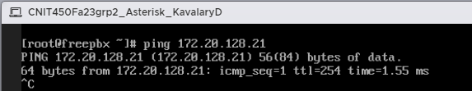

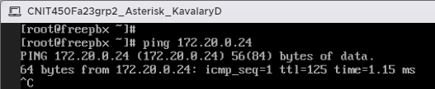

### CONFIGURATION INSTRUCTIONS

This next section will be dedicated to the configuration and set up of Asterisk and IP Phones. First, we will connect to asterisk to configure it through its web GUI. Next, we will obtain Asterisk users and extensions from Active Directory. Then, we will configure voicemail on a per user basis. After, we will demonstrate the set up of hardware and software phones and perform basic calling. Finally, we will create a SIP trunk with the CUCM server so that devices configured on both phone systems may communicate with each other.

1. If the lab network is not connected to the internet through the ESXi network, disconnect from the ESXi network and **connect your device to the Lab network**. Ensure your computer is connected to a switchport with the users VLAN and has reachability to the server.
2. Enter the address of the server **172.20.128.26** into the search bar of a browser window on the host device. You will be asked to complete initial setup, enter the below configuration and then click **Setup System**
   1. Username: **AsteriskAdmin**
   2. Password: **CNIT450grp2**
   3. Notifications Email Address: **Asterisk@cnit450fa23grp2.com**

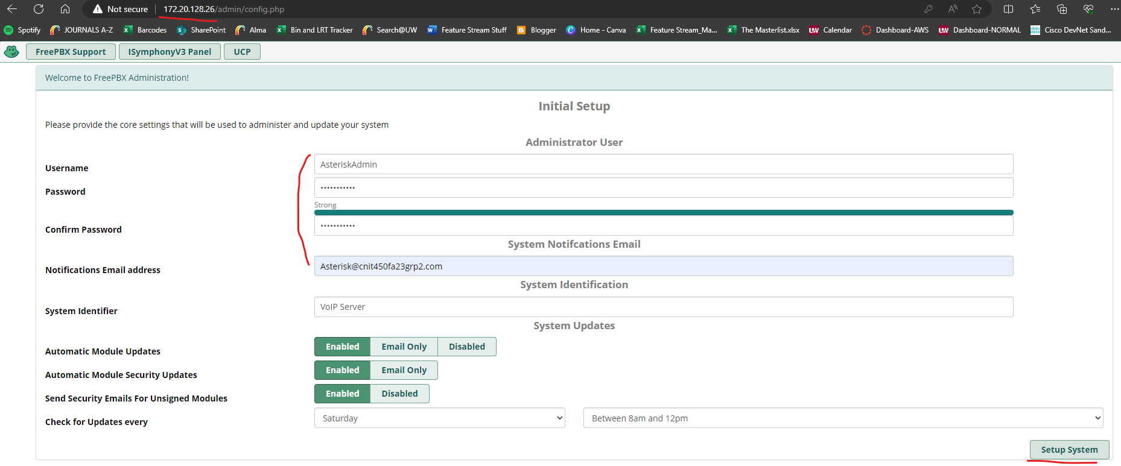

1. Click **Administration**

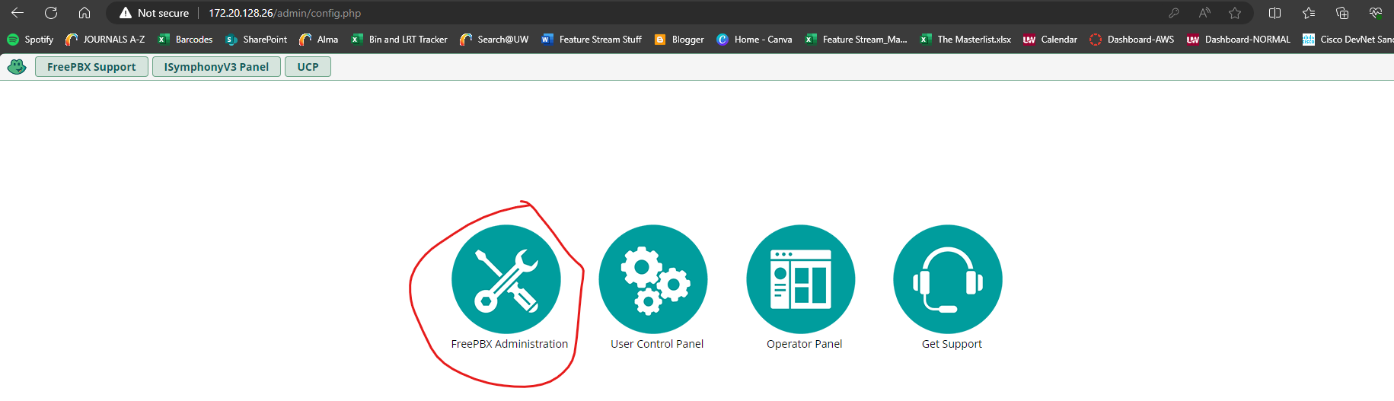

1. Enter the credentials of **AsteriskAdmin**

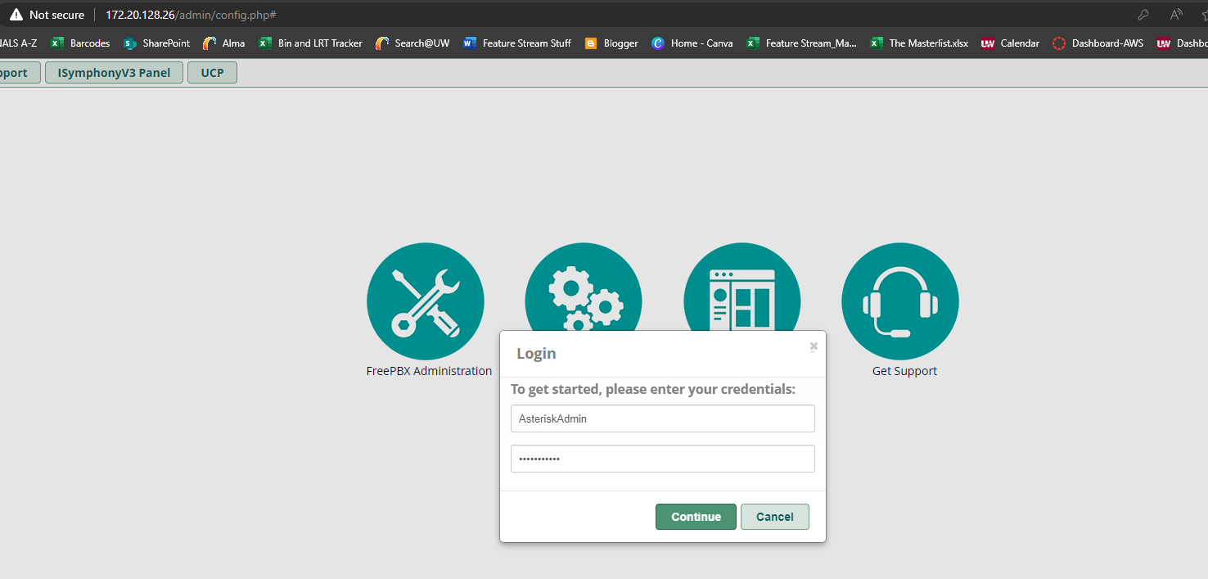

1. Submit with the default languages as English. If you see a resolve error this is if the network is not connected to the internet. This is okay and not needed.

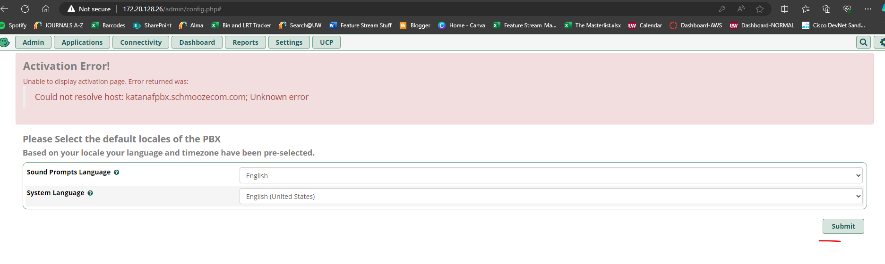

1. Disable the firewall by clicking **abort**. In a production environment this would not typically be done. This is to ensure any devices and phones will be able to register with Asterisk for this solution.

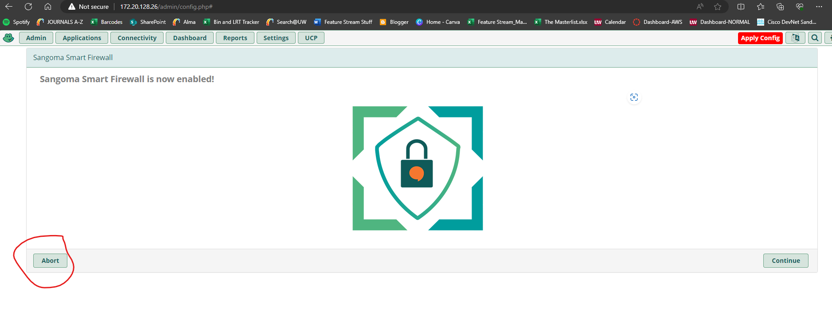

1. Click **Apply Config** in the top right corner

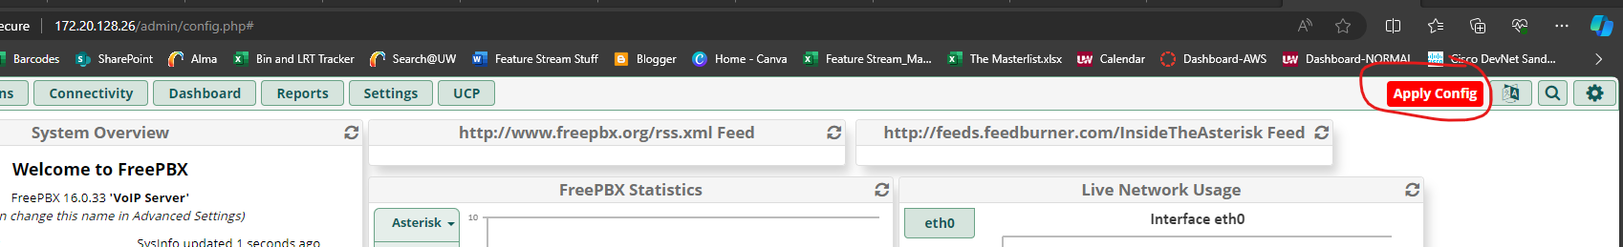

1. Initial Install is complete. It is recommended to snapshot your VM at this time if the space is available.
   1. if you see in the **System Overview** on the **dashboard** that the UCP Daemon or the Xmpp Daemon has the fire symbol next to it, this is not necessary to resolve for our purposes. But if you wish to, attempt to resolve this by typing **fwconsole restart UCP** and **fwconsole restart xmpp** in the terminal of the server
2. Go to **Admin > User Management** to begin integration with Active Directory
   1. Before integration can begin
      1. Ensure all users have been assigned IP Phone extensions in Active Directory. Adding an extension should look similar to below

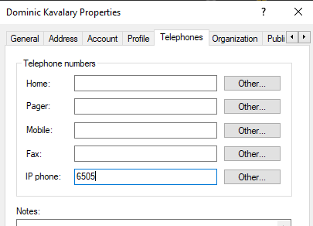

* + - 1. The Asterisk Phone Plan is as follows (CUCM is the same but with a 5 instead of a 6 at the start)
         1. Chicago: 61XX
         2. Omaha: 63XX
         3. Minneapolis: 65XX
         4. GBS: 67XX
    1. Ensure the bind user had been created. The bind user is a user in active directory with the first name of **Bind**, last name of **User**, logon of **binduser**, password of **CNIT450Fa23grp2!**. Its password must not be set to change at the next login. The password should not be able to expire. **This account is also used for the bind user in Citadel and LibreNMS. If this has already been completed there is no need to complete it again.**

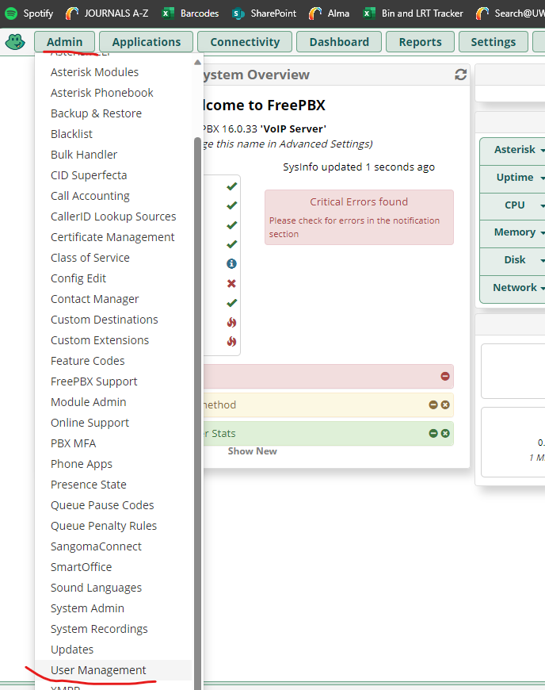

1. Click on **Directories > Add**

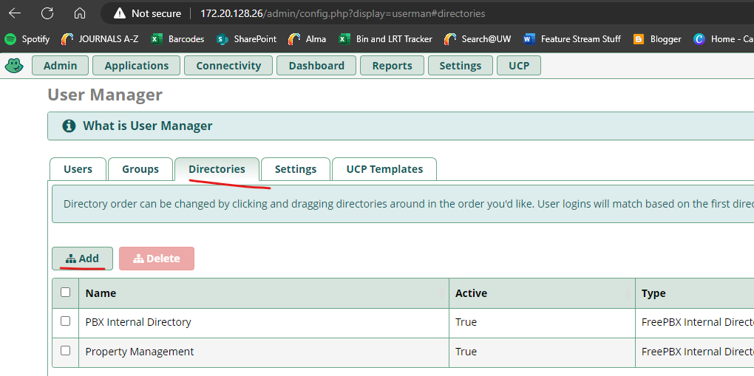

1. Make the directory type **Microsoft Active Directory**, and name it **CNIT450Fa23grp2 Active Directory**

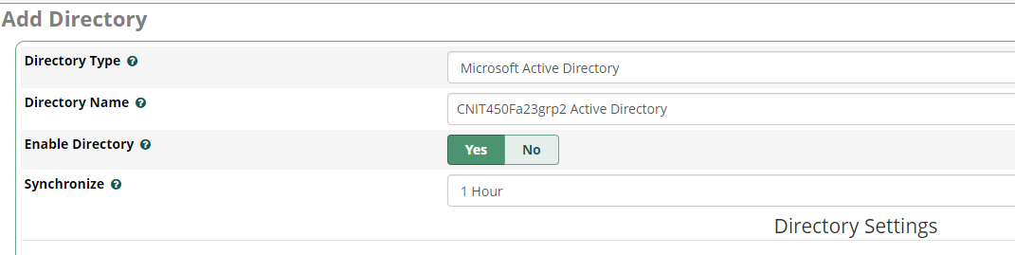

1. Configure the Active Directory connection by entering the following
   1. Host(s): **172.20.0.24, 172.20.128.29**
   2. Username: **binduser**
   3. Password: **CNIT450Fa23grp2!**
   4. Domain: **CNIT450Fa23grp2.com**
   5. Base DN: **dc=CNIT450Fa23grp2,dc=com**

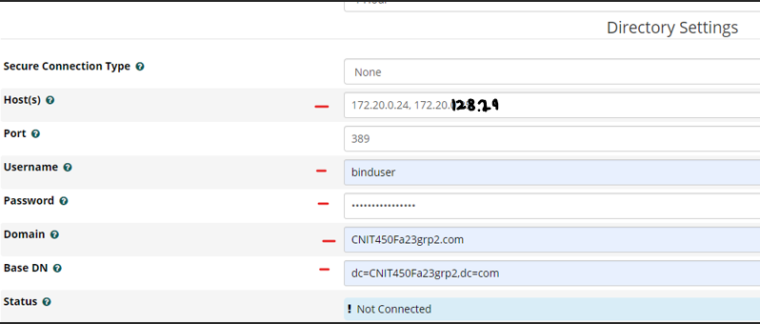

1. Ensure **Create Missing Extensions** is set to **SIP[chan_pjsip]**

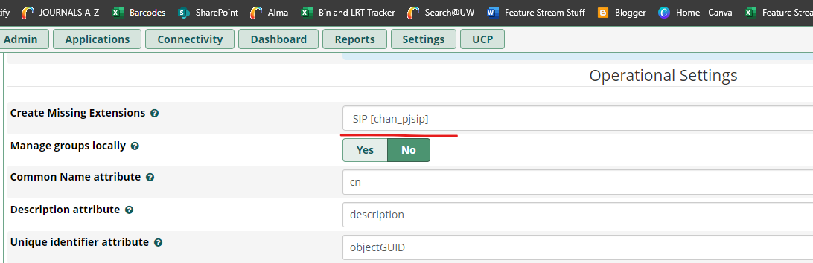

1. Set the User Object Filter to **(&(objectCategory=Person)(sAMAccountName=*)(ipPhone=*))**. This is to ensure that for a user to be added into the Asterisk directory, it must have an extension configured in Active Directory. In addition, ensure User Extension Link Attribute is set to **ipphone**

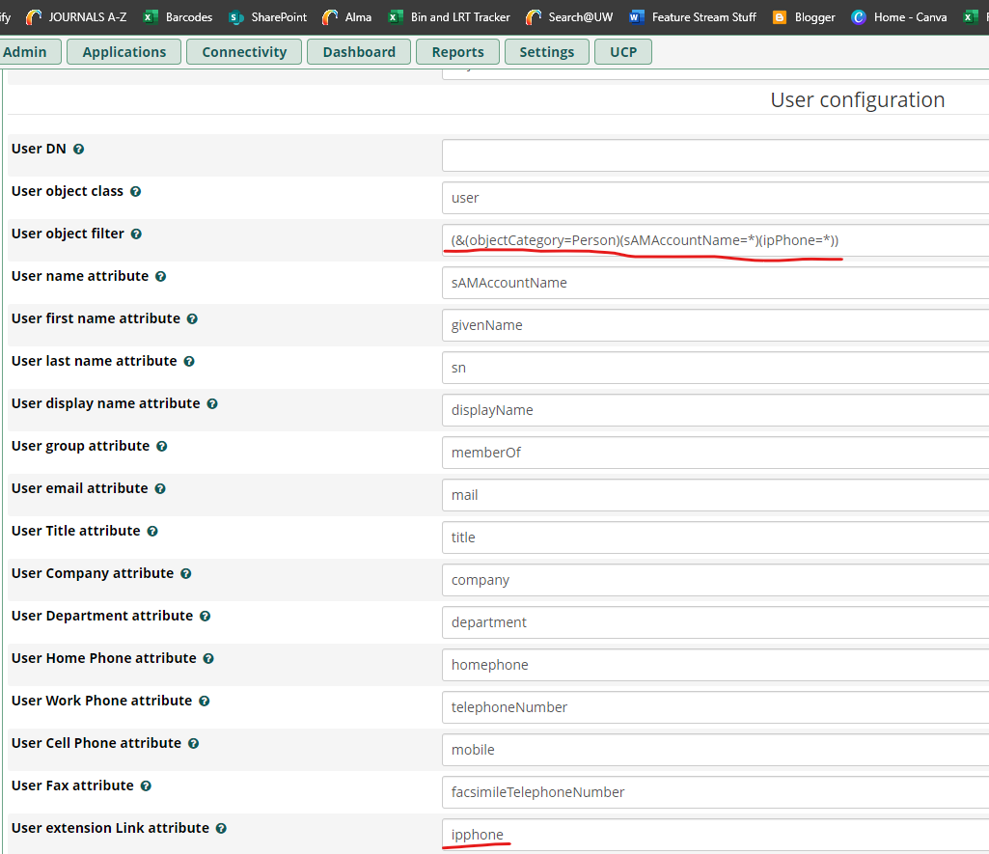

1. Click submit in the bottom right corner of the screen

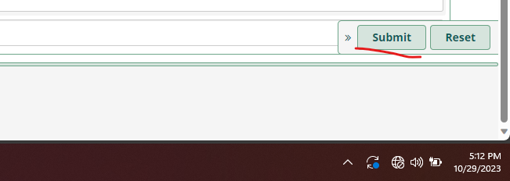

1. Hover your mouse over the **Default** column and select the grey check mark that appears to set the directory as the default directory

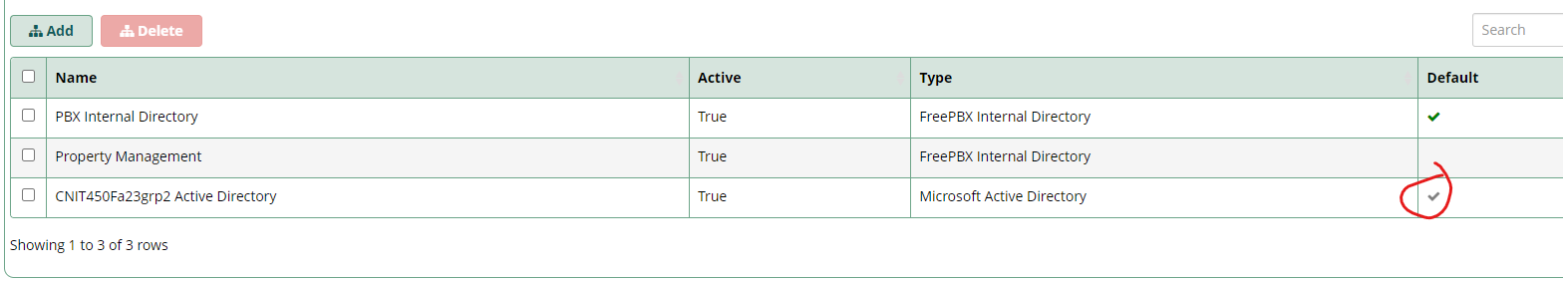

1. Confirm your choice

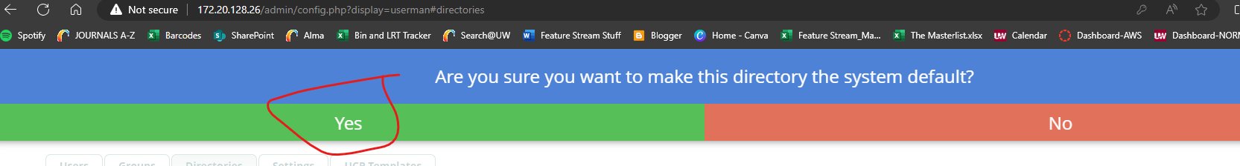

1. First, go to **Users** to see the created users

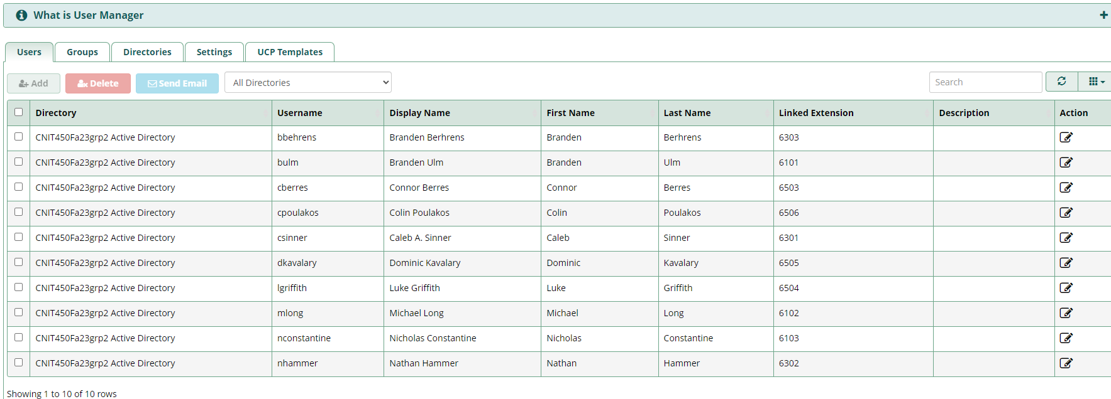

1. Now to configure the proper audio codecs for the softphones. To summarize, audio codecs are rules on how computers convert audio into ip packets to be sent across the network.
   1. Some VoIP client softwares may not support certain codecs used by asterisk so it’s important to ensure the client and server are compatible
2. Go to **Settings > Asterisk SIP Settings > General SIP Settings**

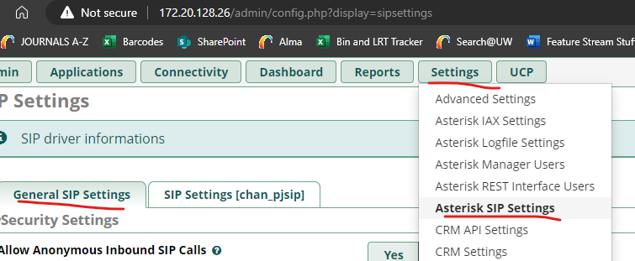

* 1. Scroll down to **Audio Codecs** and modify the codec list by selecting and dragging and dropping to have these codecs selected and in this order. (These work with Zoiper, CUCM, and the hardware phones we have available)
     1. Opus
     2. Speex16
     3. Ulaw
     4. Alaw

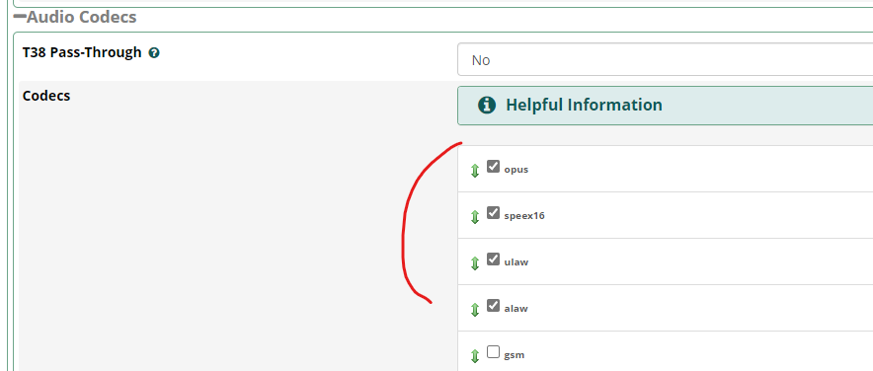

1. Next go to **Settings > Asterisk IAX Settings > General Settings**

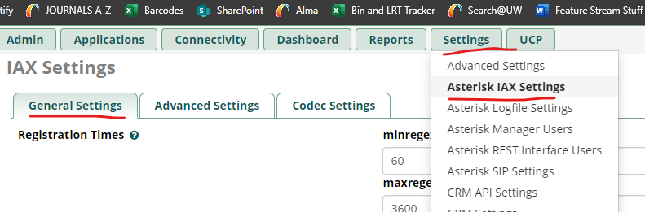

* 1. Enable and force a jitter buffer of 200ms. A jitter buffer allows for there to be smoother audio in exchange for slightly more latency.

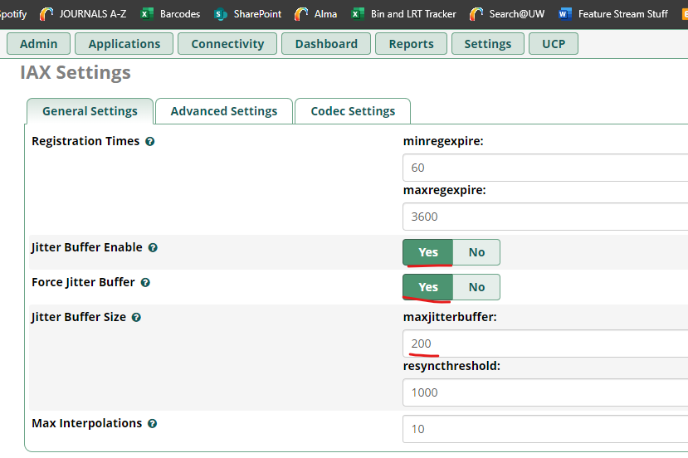

1. Click **Codec Settings** and modify the codecs in the same way as earlier

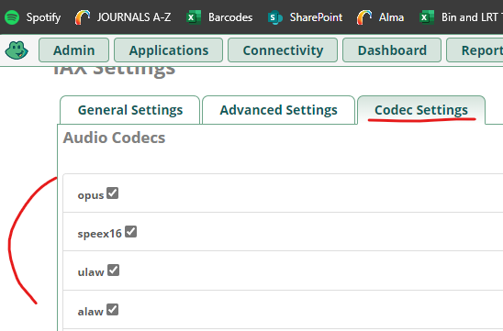

1. Now that we have our audio codecs set up to allow devices to properly communicate, we will want to also configure voicemail so that a user doesn’t miss an important message. Go to **Applications > Extensions** to begin configuration on a per user basis.
   1. Choose a user extension and click **edit**



* 1. Go to **Voicemail** and select **Yes** for the **Enabled** option, and below it set a voicemail password

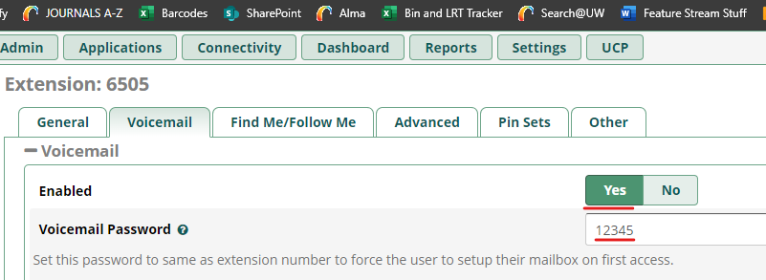

* 1. Submit and Apply Config
  2. If a user misses a call, they typically must call *97 on their softphone client (zoiper for example) to access their voicemail inbox. Afterwards it will ask for their password which they must then type in the password that was set. Wait a few seconds and voicemail related options will be listed for you. Typically, you then press 1 to listen to the voicemail.

1. Now that our settings have been configured, it is time to configure our softphone clients
   1. Go to <https://www.zoiper.com/en/voip-softphone/download/current> to download the latest free version of Zoiper for a user connected laptop. Alternatively you can download the linphone app on your smartphone and connect in a similar manner. This will not be shown
   2. Run the installer downloaded, and select all of the default options and agree to the license agreement

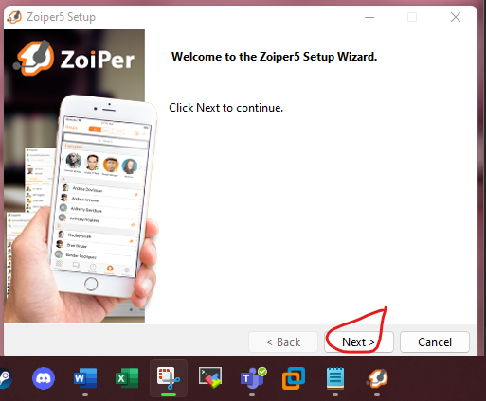

1. Open Zoiper and click **Continue as a Free User**

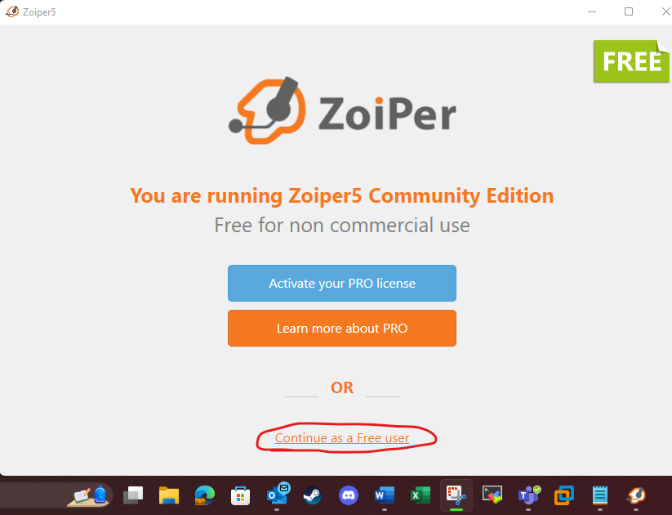

1. For the username, enter a user extension. For the password, enter the secret for said extension found in **Applications > Extensions**. You can also change that secret and apply the config to asterisk. Then click **login**.

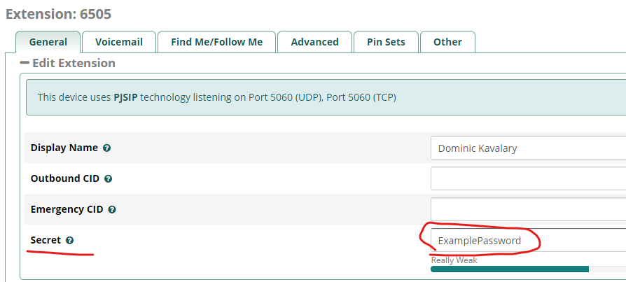

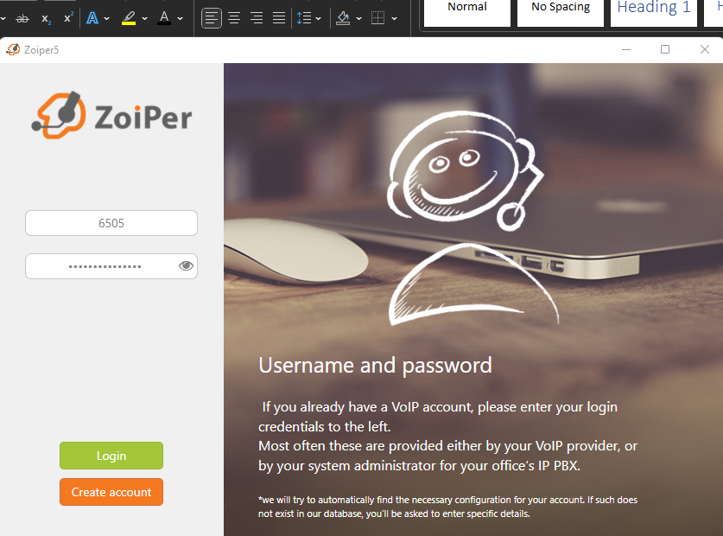

1. Enter the IP address of the server. In this case it is **172.20.128.26**

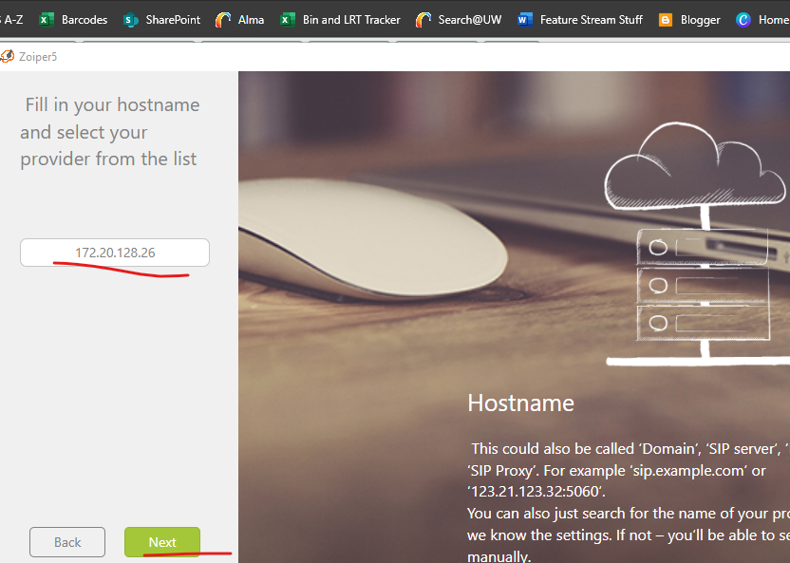

1. Skip the optional authentication

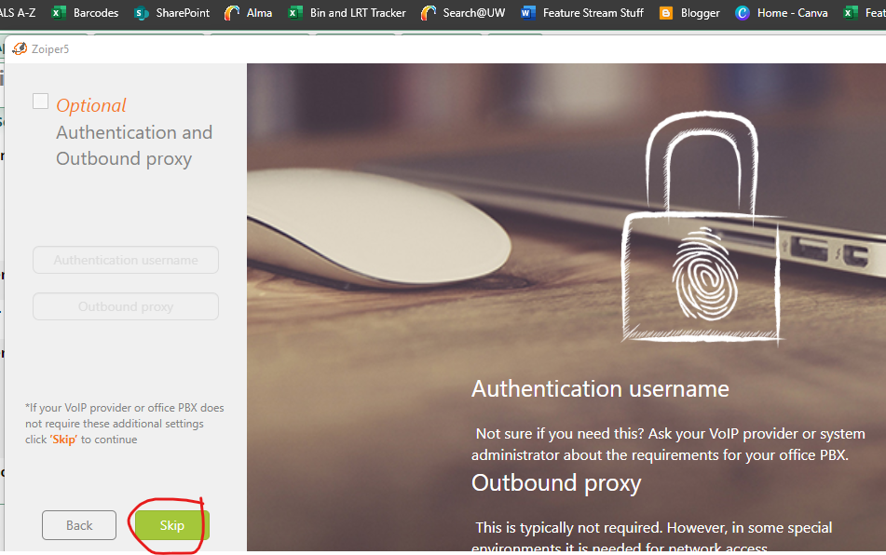

1. Select the configuration that is found. This should be UDP. If UDP shows up as “untested”, select that option and continue with default settings.

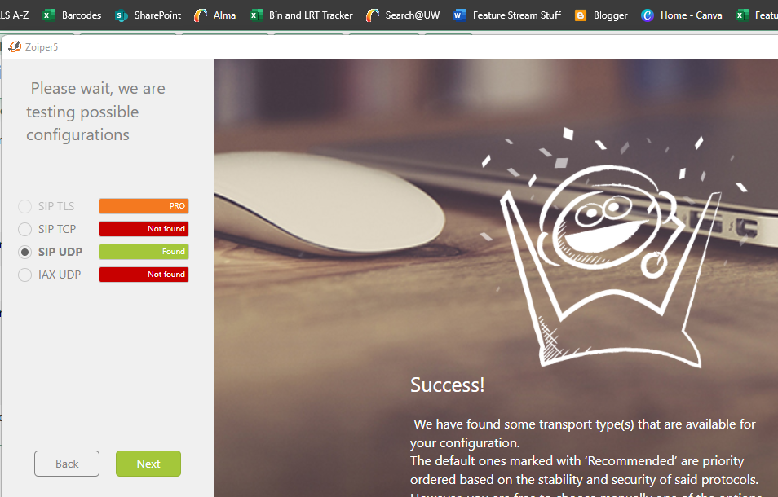

1. Click on the **Settings** gear

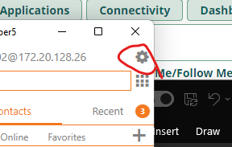

1. Click on **Accounts,** click on the account created for the SIP account, then click **Advanced**

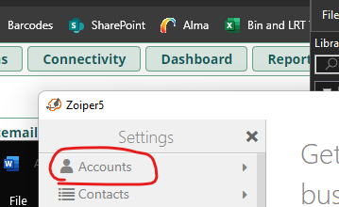

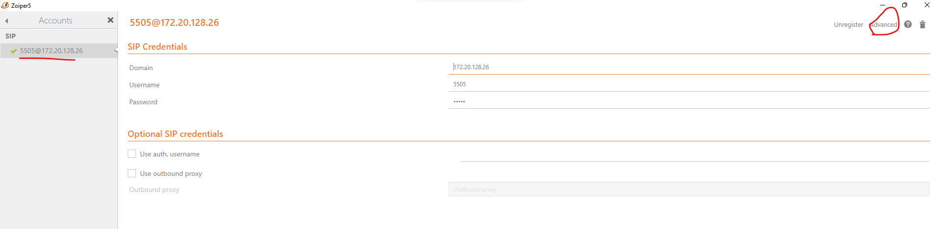

1. Assign the Caller ID name associated with the extension

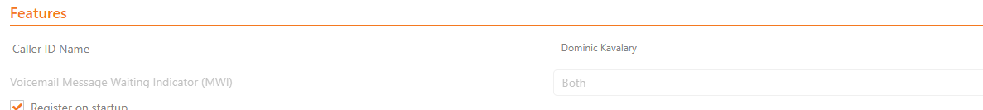

1. Set Use Stun to **Don’t use STUN**

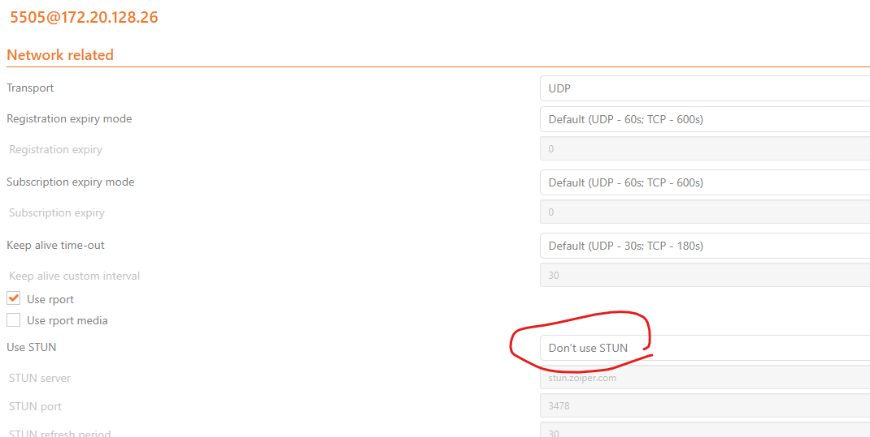

1. To ensure the software SIP phone can communicate properly with other devices. Assign the codecs configured in Asterisk.

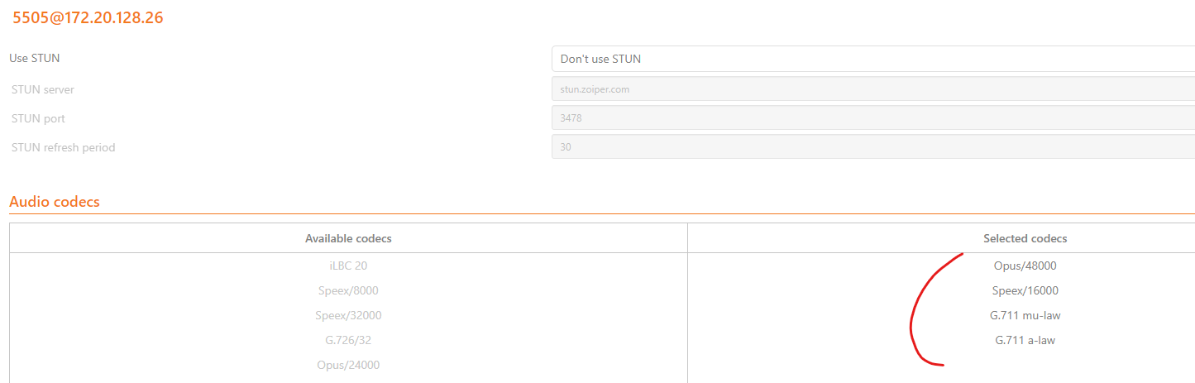

1. Now time to configure a hardware phone to work with asterisk. First, connect a hardware phone into the lab network. Ensure the phone is receiving an address through the DHCP scope associated with the Voice VLAN of the site the phone is plugged into.
   1. DHCP should be configured in the Domain Controllers, and ip-helper related commands should be placed on the switches and routers to reach said server
   2. If the phone is not grabbing an address…
      1. Ensure the proper IP helper commands are in the vlan interfaces on the switches
      2. Make sure the switchport the phone is connected to has the **switchport access voice vlan** command on it with the correct voice vlan assigned.
      3. Ensure reachability to the DHCP server
   3. If you must, assign a static address to the phone through the physical phone GUI
   4. For this example we will be using an **AudioCodes420HD** hardware phone.
2. First, Factory reset the phone. This must be done by powering on the phone while holding the **ok** and **menu** buttons for about 10 seconds as it powers on and then letting go of the buttons
3. Wait for it to start up and set the time zone and language
4. Go to the IP address of the phone through your browser
   1. Enter the default admin username and password **admin** and **1234**

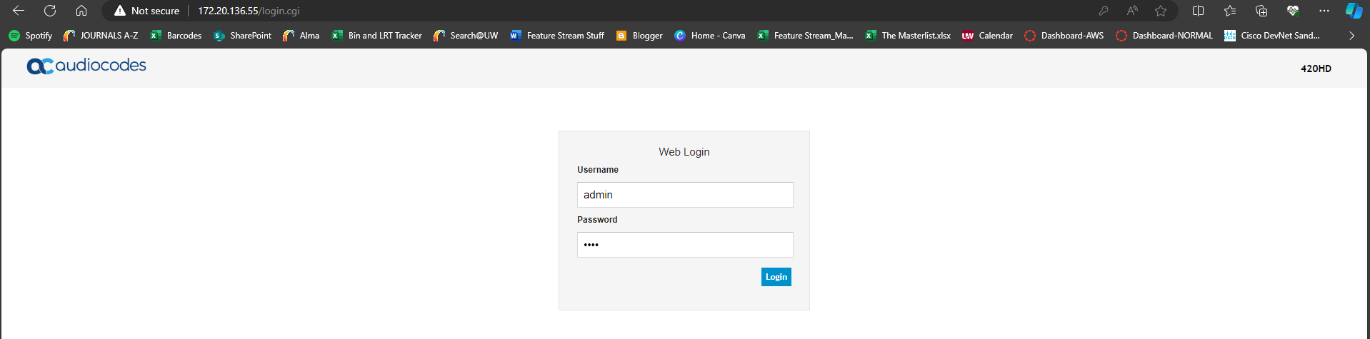

1. Download the latest AudioCodes firmware image from their website
2. Go to **management > manual update > firmware upgrade**

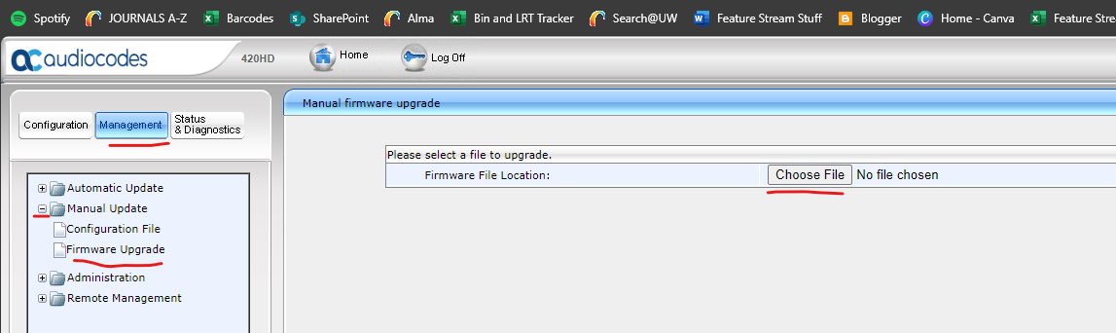

1. Upload the file, and **submit** the configuration
   1. The phone may take about 10 minutes to upgrade

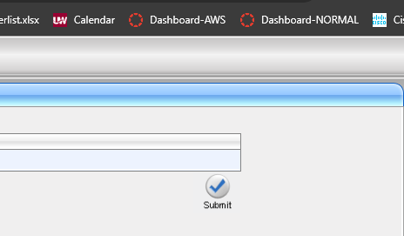

1. Go back into its web GUI and go to **configuration > quick setup > quick setup**

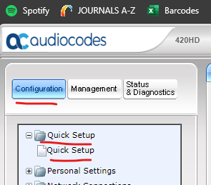

1. Enter the information of the Asterisk server as the SIP Registrar, as well as the extension information to register the phone

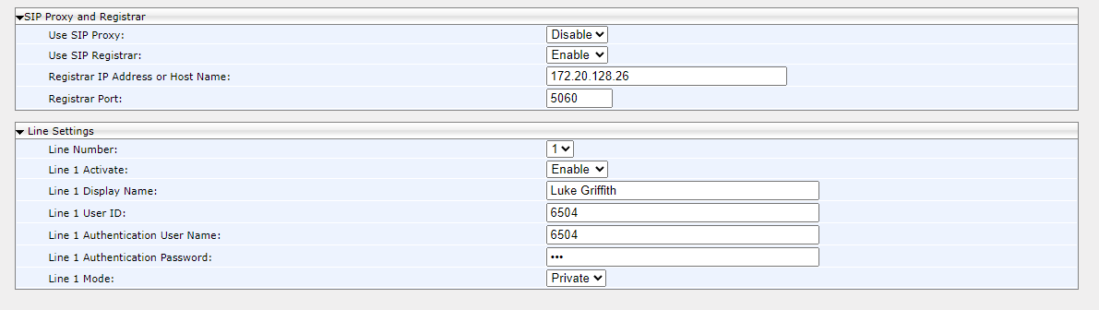

1. Submit this configuration, your phone may restart/register for a while. So long as it can reach Asterisk it will register and you will be able to call others
2. If another user is connected to asterisk, you may attempt to call them through their SIP extension
3. To allow phones configured through CUCM to call phones configured using Asterisk and vise versa, a SIP trunk needs to be created between the two servers for calls to be had between phone systems.
   1. This will not properly work until a SIP trunk is also configured in CUCM, see CUCM instructions for details
4. Go to **connectivity > trunks**

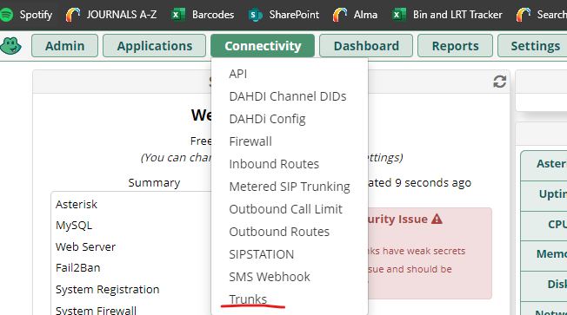

1. Go to **add trunk** > **add sip trunk**

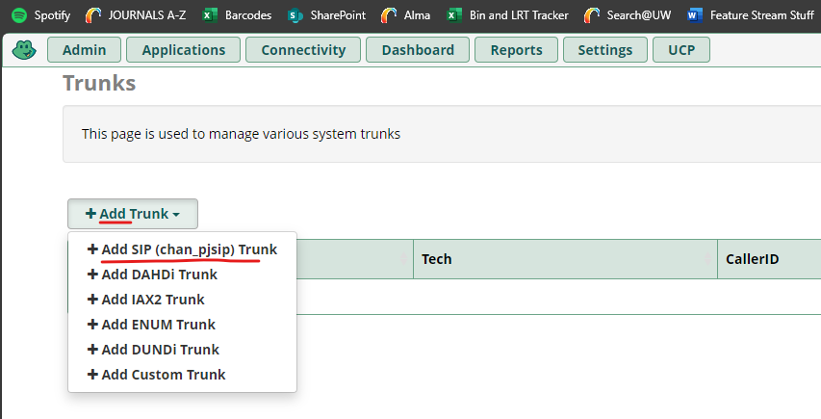

1. Name the trunk

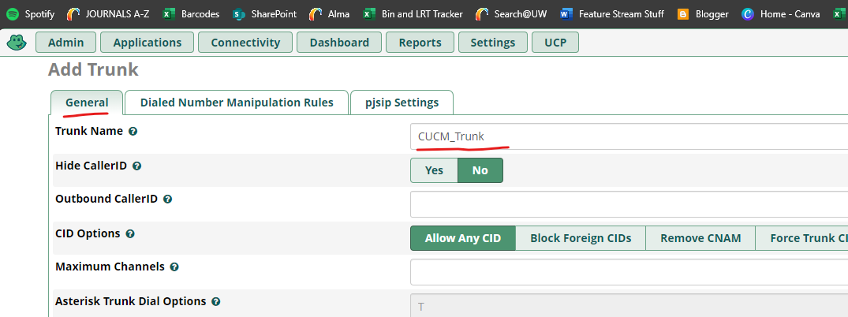

1. Set Authentication to **none,** the sip server to CUCM (**172.20.128.22**), and the port to **5060**

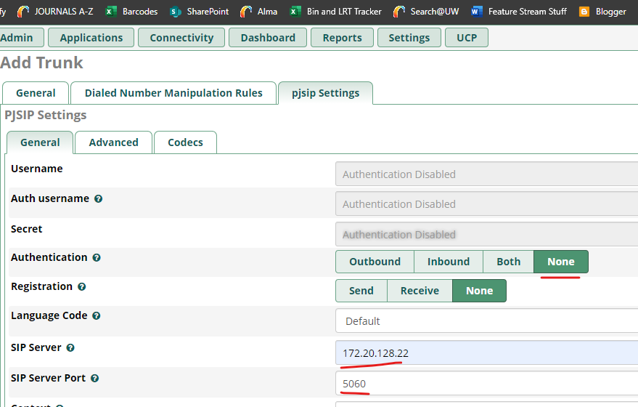

1. Under **Codecs** ensure our used codecs match our other equipment

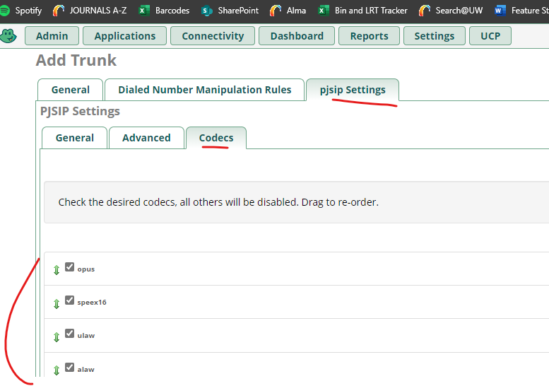

1. Submit

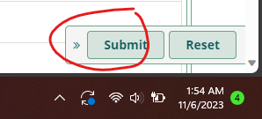

1. You may receive this notification, acknowledge it

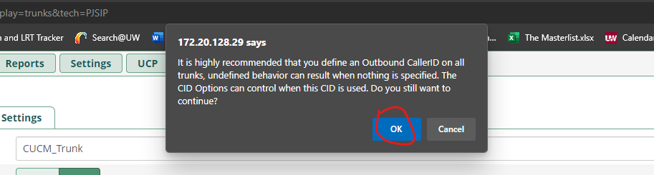

1. Go to **connectivity > outbound routes > add outbound routes**

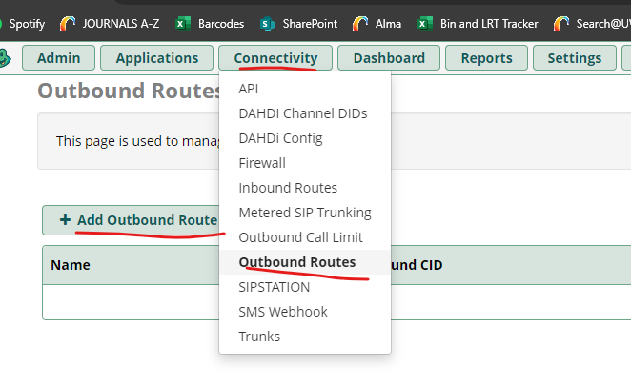

1. Name the **route**, mark it as **Intra-Company**, and set it to use the **CUCM trunk** created earlier

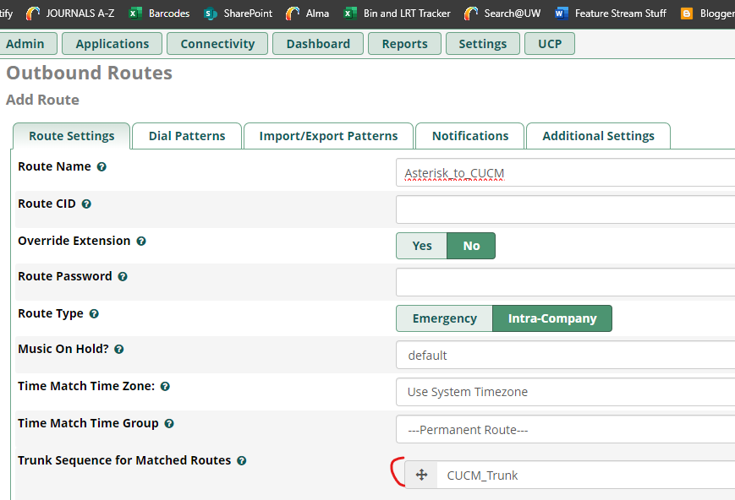

1. Enter the 5XXX as the dial pattern. Our CUCM uses 5XXX as the dial pattern for its devices, so this is somewhat of a summary statement. Any number in this pattern that is dialed such as 5101 will be recognized by the outbound route and sent through the created SIP trunk towards CUCM

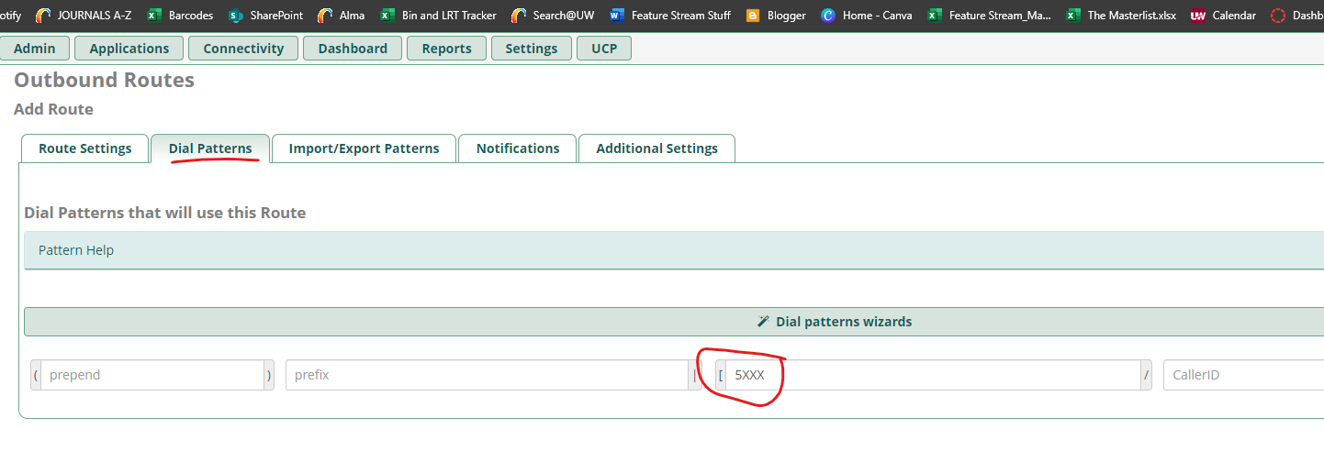

1. Hit **Submit**

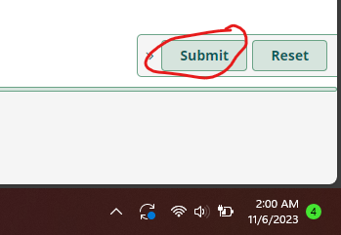

1. Hit **apply config**

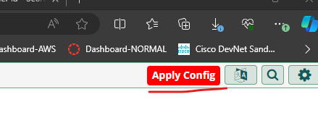

## **OPEN-SOURCE EXCHANGE EQUIVELANT: CITADEL**

For employees to be able to effectively organize, schedule, and collaborate on projects, a group productivity software medium called groupware can be used to facilitate said collaboration amongst users. To provide this group software, Citadel, an open-source server capable of Email, Notes, Task Management, Calendar, and Messaging, will be installed and configured.

Prerequisite services

* Active directory is configured and reachable from the lab network
* ESXi 8 must be installed and configured on the desired server

### INSTALLATION INSTRUCTIONS

To install this server, the VM must have reachability to the internet. The following instructions will be given assuming there is no internet connection to the network yet. This could be convenient if you wish to do all of the major installation remotely and import it into the network. To install the server, first we will create the server VM on VMWare Workstation Pro 17 on a device with internet, and then export it to ESXi. These instructions can be modified to install directly onto the ESXi server if needed by following instructions similar to the Asterisk installation, given the server has access to the internet. It would be simpler and faster to do it directly on ESXi.

If you have One-Drive or other cloud backup services turned on your device, **turn them off**. Cloud synching can corrupt VMs while running.

1. To install Ubuntu Server, head to https://ubuntu.com/download/server and download the version **20.04.06 ISO** from alternative downloads. This may take several minutes to half an hour depending on the current internet speed.

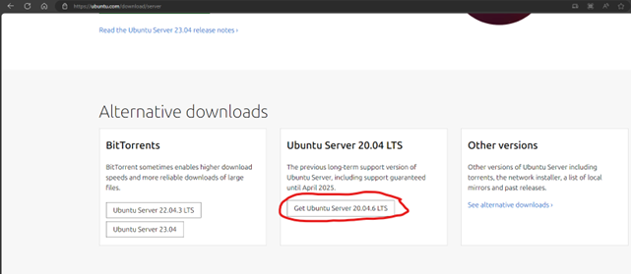

1. After downloading the ISO, open VMWare Workstation pro 17 on a desktop or laptop with internet. If you do not have this, head to <https://www.vmware.com/products/workstation-pro/workstation-pro-evaluation.html>, and download the proper version for your operating system.
2. Open VMWare Workstation, and edit your Virtual network in VMWare
   1. Click **Edit > Virtual Network editor…**

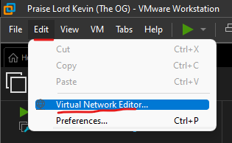

* 1. Ensure your settings match the below

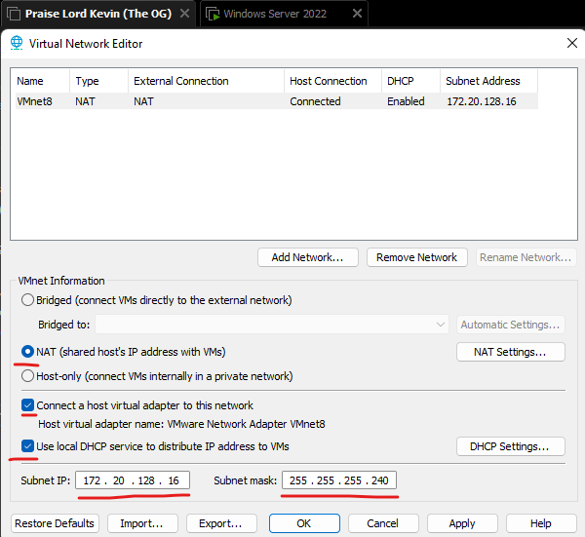

* 1. Click **NAT Settings…** to edit the virtual gateway

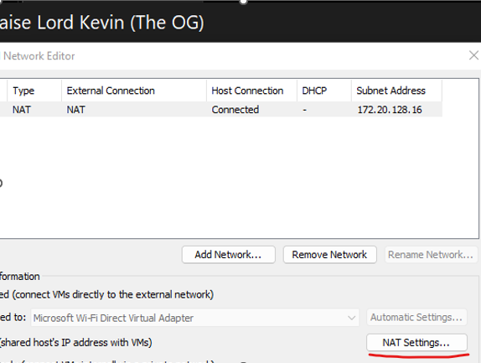

* 1. Edit the virtual gateway IP to be **172.20.128.21**

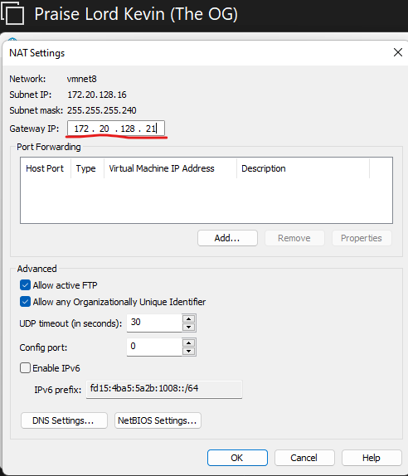

* 1. Apply the settings and click ok

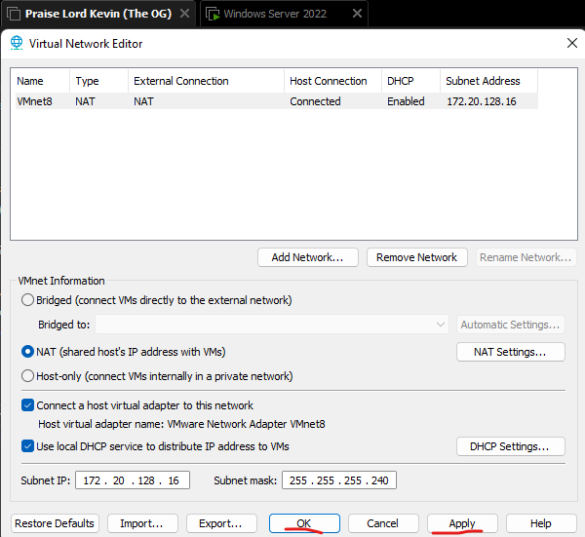

1. Click **Create a New Virtual Machine**

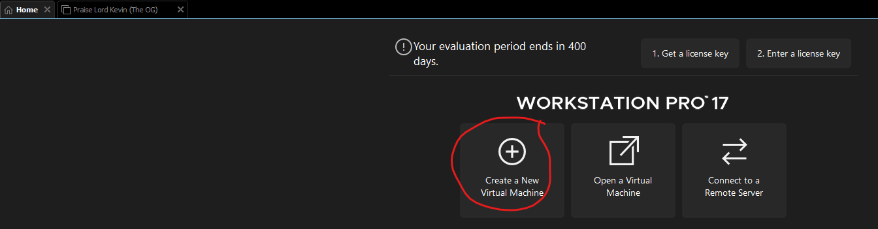

1. Select **Typical.**

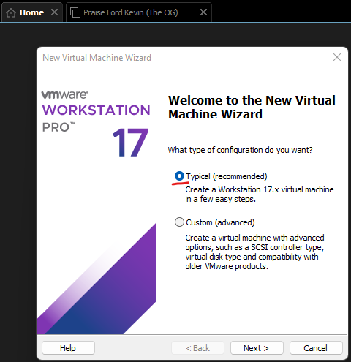

1. Select **Installer disc image file**, then, click **Browse...** and select the ISO downloaded previously.

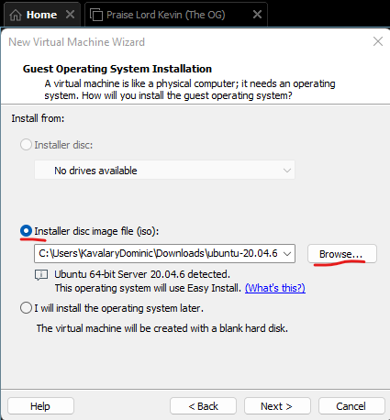

1. Enter the required information
   1. Full Name: **CNIT450Fa23grp2_Citadel**
   2. Username: **ubuntucitadel**
   3. password: any, in this case it will be **CNIT450grp2** for simplicity

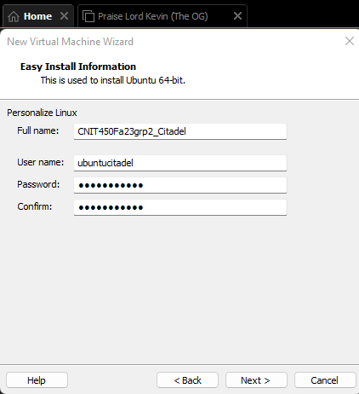

1. Choose an install location, and give the VM a name, for this case, it will be the Full Name given before

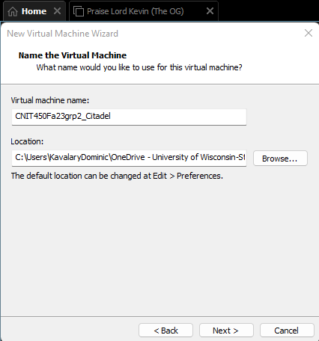

1. Give the VM **15 GB** of space and **split the disk into multiple files.**

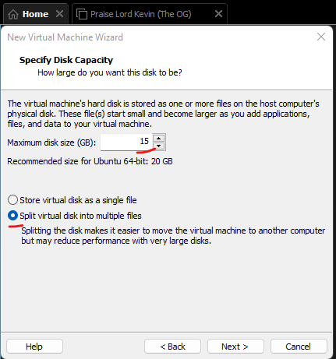

1. Ensure the information matches the below. If it does not, explore the “**Customize Hardware…**” button

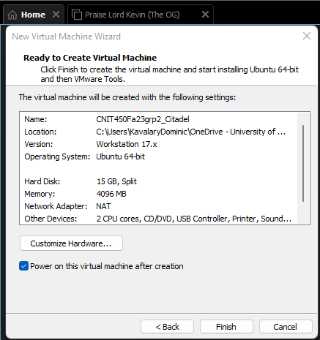

1. Once the machine boots up, you may use the up and down arrow keys to move your selection. select English and hit enter to continue.

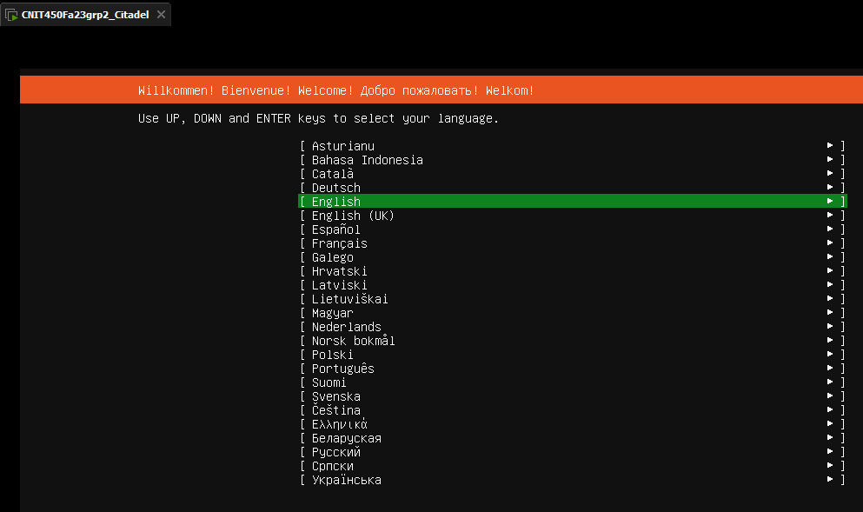

1. If you are asked to select a keyboard layout, **leave the defaults** and continue.

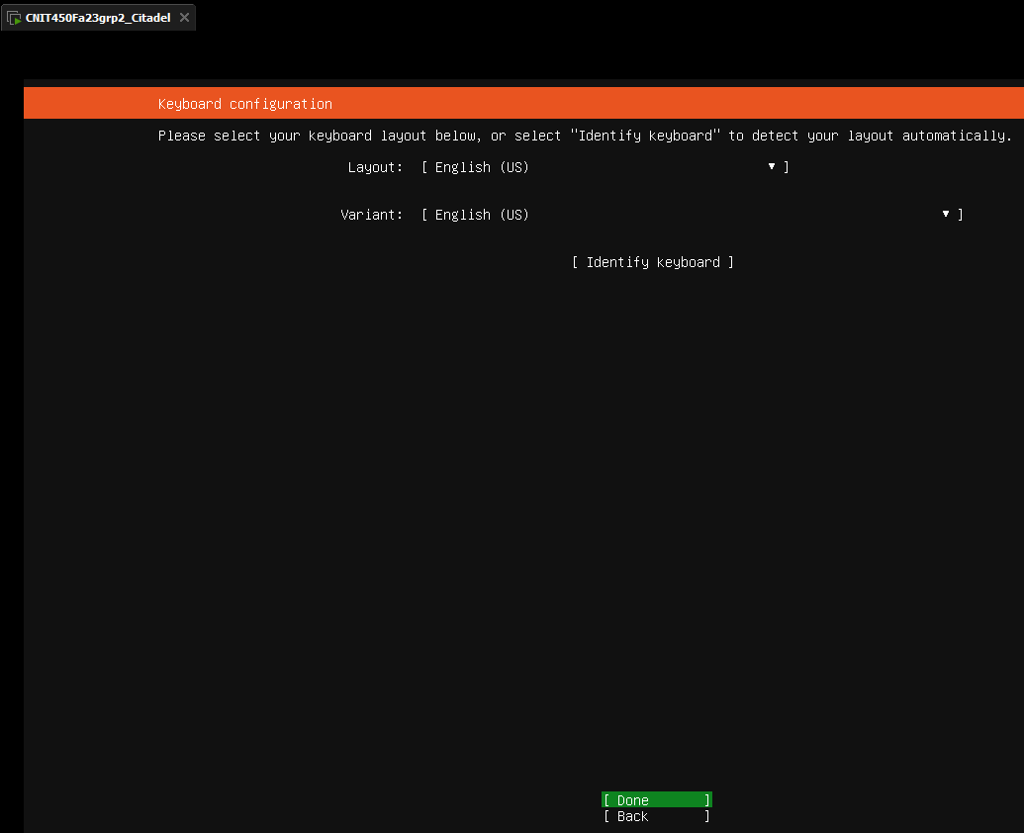

* 1. Tab over to the network adapter name and click enter on it to edit it. Tab over to **Edit IPv4** and hit enter

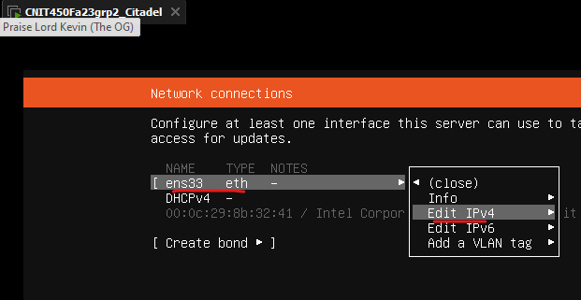

* 1. Hit the **DHCP** option displayed by default and change it to **Manual**

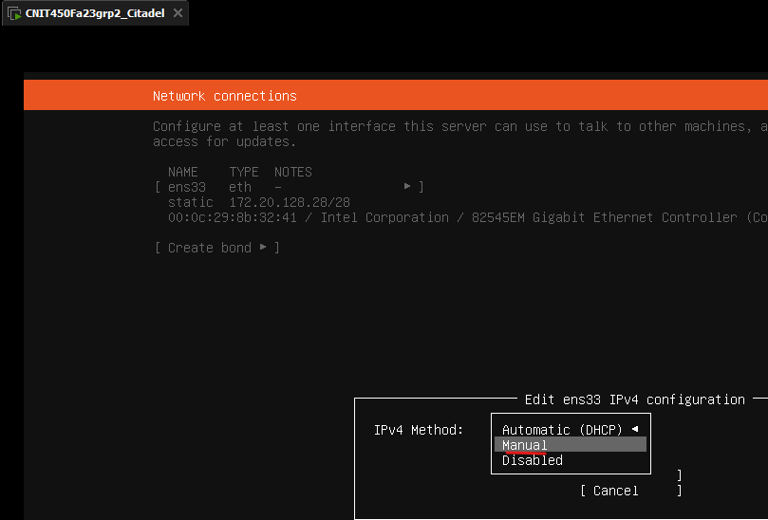

* 1. Ensure configuration matches below, then save and continue
     1. Subnet: **172.20.128.16/28**
     2. Address: **172.20.128.28**
     3. Gateway: **172.20.128.21**
     4. Name Servers: **8.8.8.8**

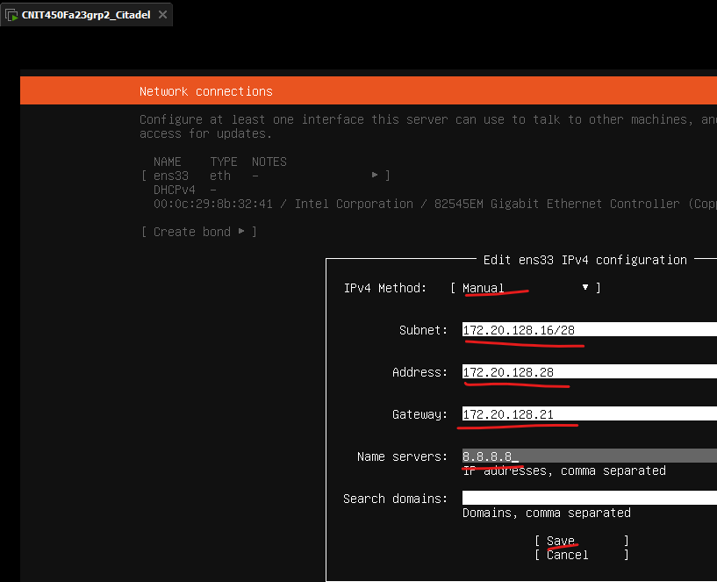

1. If it asks if the server requires a proxy address, **leave it blank and continue**.

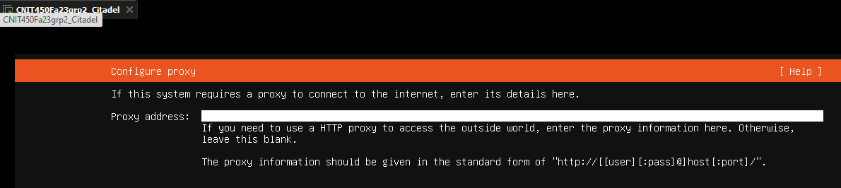

1. If it asks to configure and archive mirror, **leave the default and continue.**

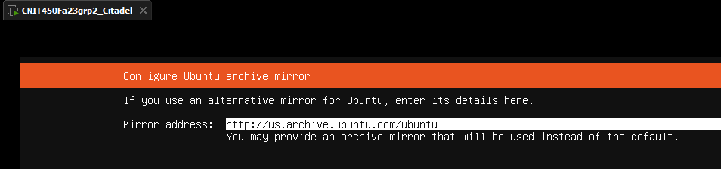

1. If promoted regarding an installer update, **continue without updating**

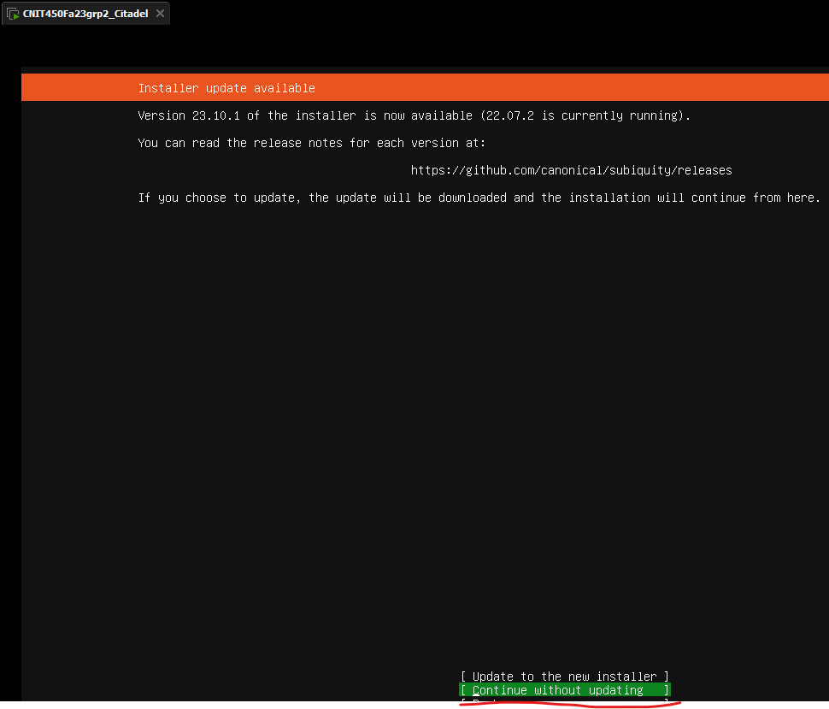

1. When asked to configure a guided storage layout, **leave the defaults and continue**.

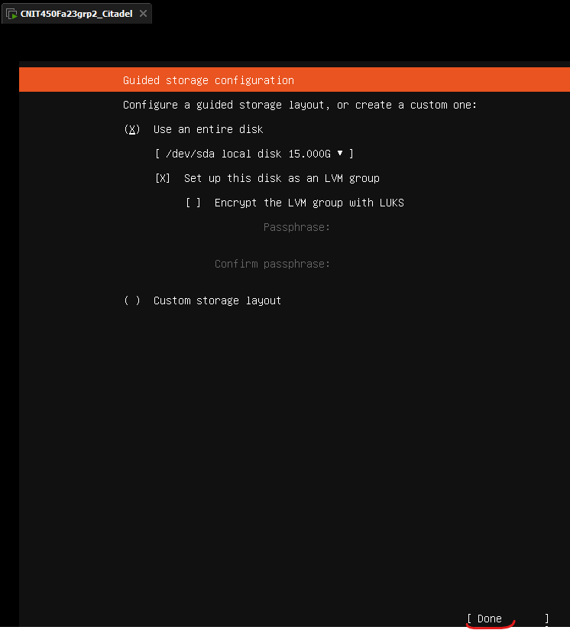

1. Select **done** to confirm the file system summary

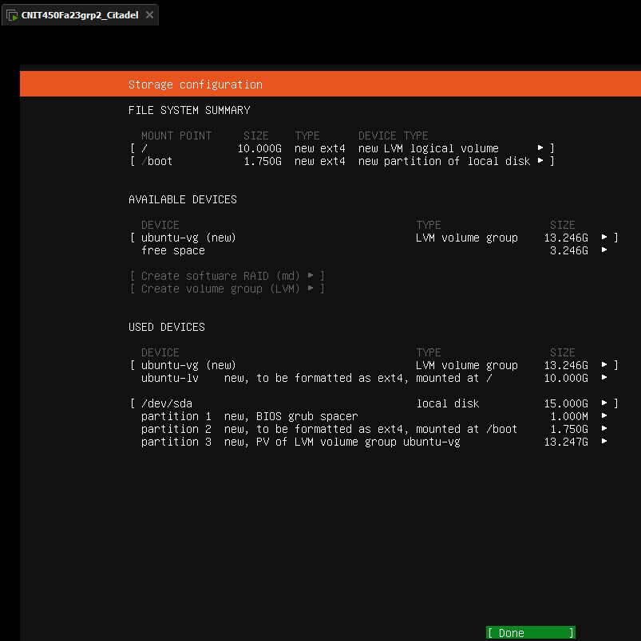

1. Confirm the action of formatting the disks and **continue**.

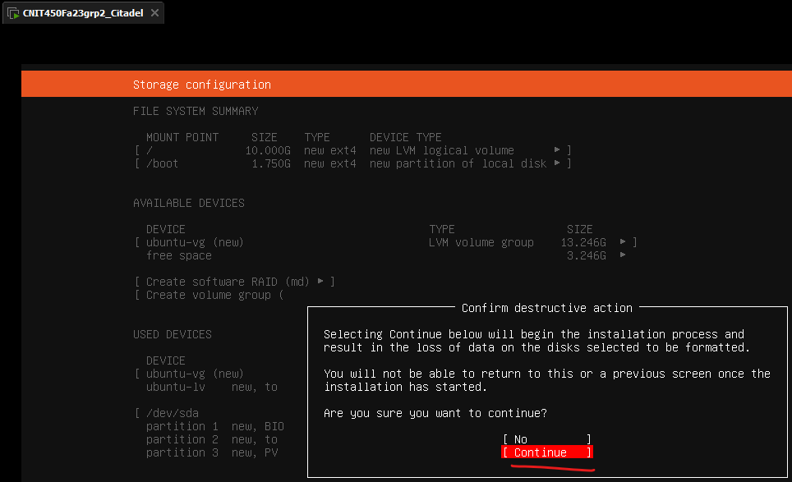

1. Enter the following profile details. The username and password can be the same as created earlier.
   1. Your name: **CNIT450Fa23grp2_Citadel**
   2. Server Name: **cnit450fa23grp2_citadel**
   3. Username: **ubuntucitadel**
   4. Password: **CNIT450grp2** for simplicity

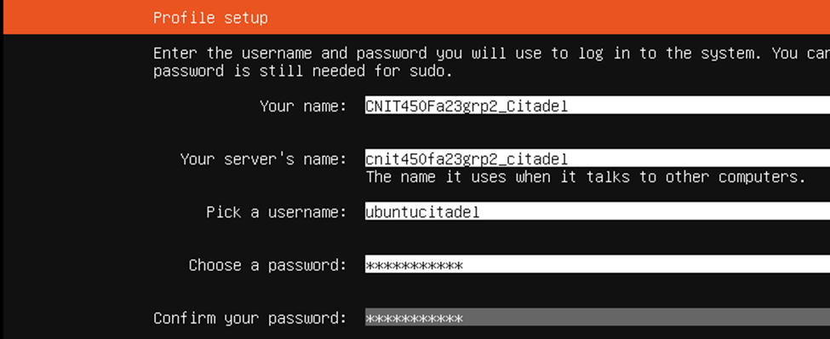

1. Install OpenSSH server to allow for secure remote access, **do not** import an SSH Identity.

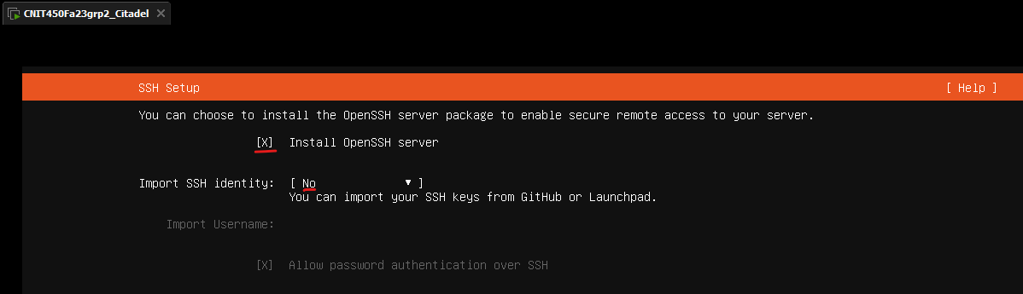

1. Ignore installing popular snaps and **keep none selected** before continuing

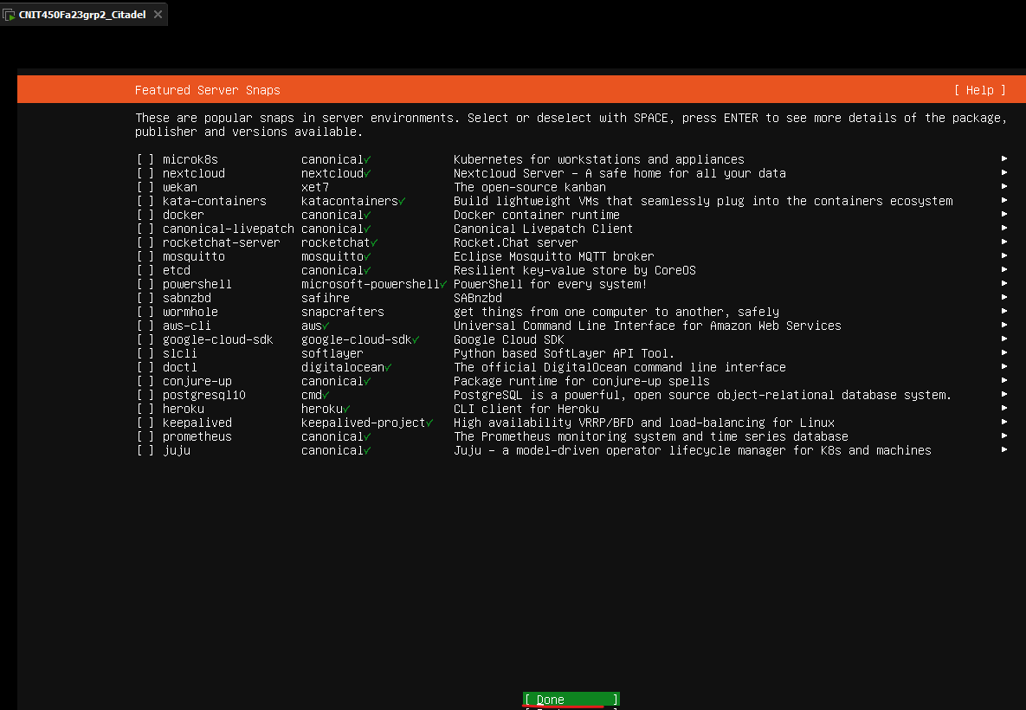

1. Wait until the server is done updating and installing. The bottom text says “**reboot now**” instead of “cancel update and reboot” when finished.

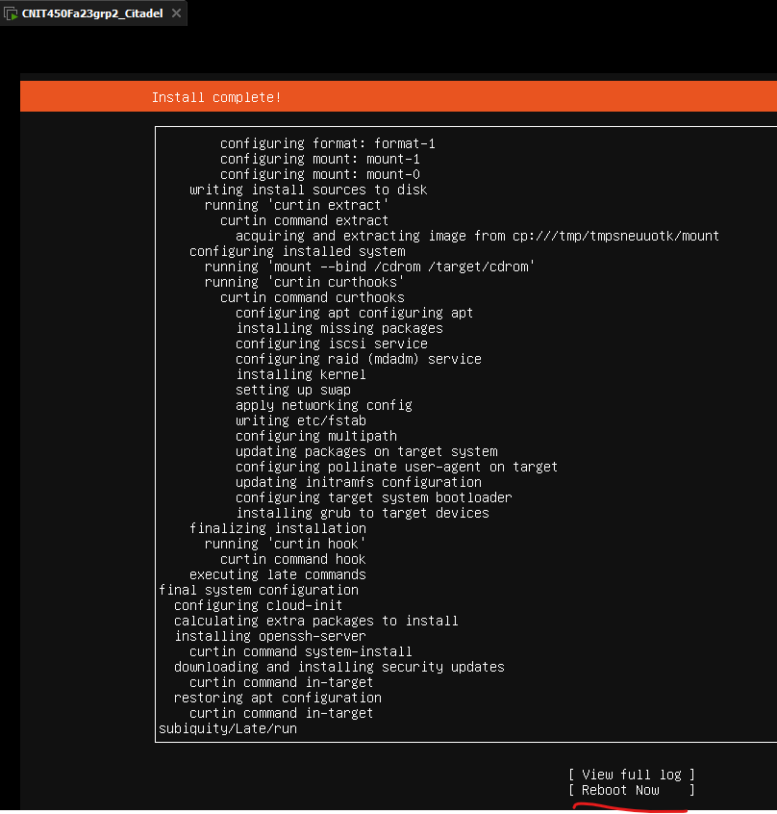

1. Once the server reboots, login with the created ubuntucitadel user’s credentials. You may need to hit enter to prompt the login.

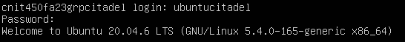

1. Confirm IP addressing using “**ip a**”

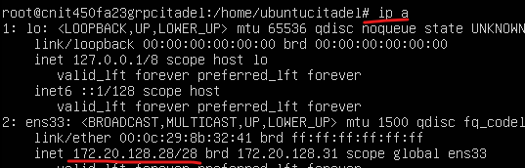

1. Ping 8.8.8.8 to confirm connection to the internet

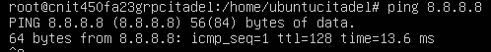

1. Run the command “**sudo apt update && sudo apt upgrade -y**”. If prompted for a password due to using sudo, enter your password.



* 1. If there are errors in resolving such as in the photo below, a fix is to type “**sudo nano /etc/resolv.conf**” and change the name server to **8.8.8.8**. These errors are not likely to come up, but may if the nameserver 8.8.8.8 was not specified on installation.

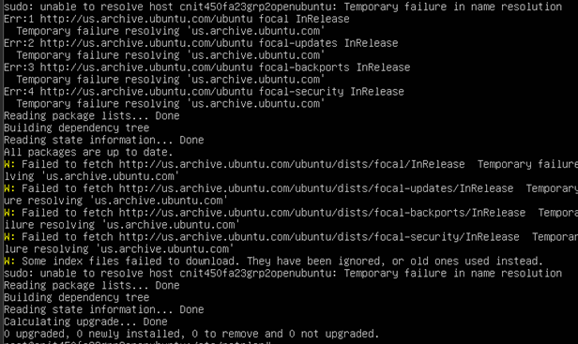

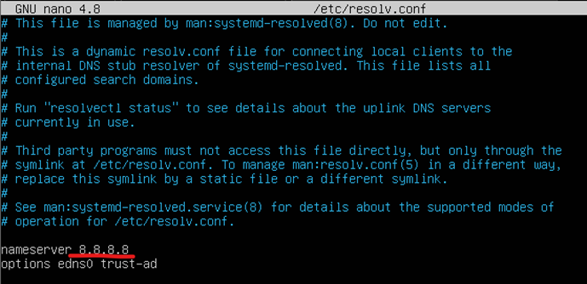

1. One it is done updating and upgrading, the initial server installation for Citadel is complete. Next up, Citadel easy Installation and configuration
2. Taking a snapshot of your VM is recommended currently to prevent loss of data.

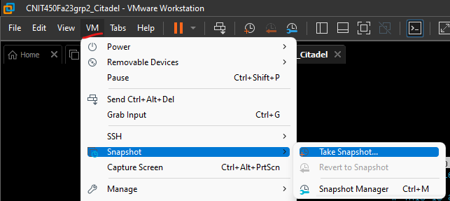

1. For Citadel to be installed there are a few prerequisites
2. Active Directory is configured and reachable by devices in the lab network
3. A bind user must be created in Active Directory with the first name of **Bind**, last name of **User**, logon of **binduser,** and password of **CNIT450Fa23grp****2!**. Its password must not be set to change at the next login. The password should not be able to expire. Reference Active Directory documentation to do this. **This account is also used for the bind user in Asterisk and LibreNMS. If this has already been completed there is no need to complete it again.**
4. A user must be created in Active Directory with the **first name and display name** of **CitAdmin** and **no last name**, logon of **CitAdmin,** and password of **CNIT450Fa23grp****2!**. Its password must not be set to change at the next login. It is preferable that the password is not able to expire. Reference Active Directory documentation to do this.
5. Internet Connection
   1. You must be connected to the internet for the first part of the initial install so that the VM can reach where the citadel installation files are located. After the initial install command, you will be instructed when to disconnect from the internet, and connect into your lab network
6. An open connection into the lab network. **Do not connect into it yet, wait until instructed.**
   1. This example will use a connection into the **MSP site Users VLAN.** Ensure when instructed, that you have an ethernet connection into the lab network on a switchport in the MSP site under **VLAN 340**, the Users VLAN.
   2. If DHCP is not available, your adapter should be configured with the following: IP address of **172.20.134.55**, Subnet of **255.255.255.0**, Gateway of **172.20.134.11.**
7. To begin the installation, become the root user and type “**curl** [**https://easyinstall.citadel.org/install**](https://easyinstall.citadel.org/install) **| bash**” and hit enter. You may need to enter your password to log into root



* 1. Proceed to type “y” and continue through dialog prompts. Examples are shown below. Once the prompts have been answered, the download may take several minutes to complete.

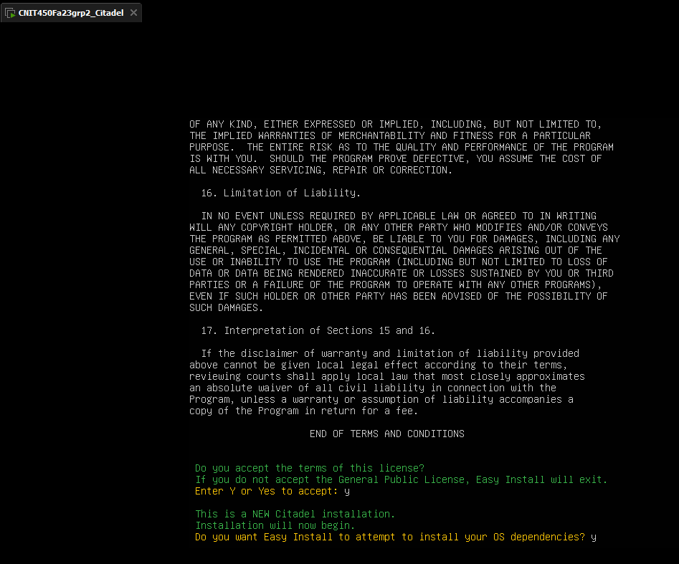

1. When prompted, enter a username for the administrator account. In this instance it will be the CitAdmin account name created earlier.

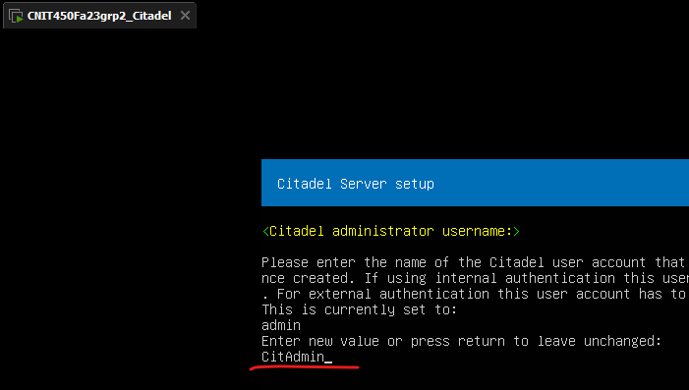

1. When prompted, enter the password for the CitAdmin account. In this case it will be **CNIT450Fa23grp2!**

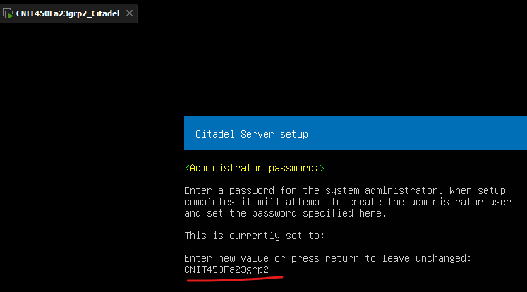

1. When prompted set the citadel user ID to **citadel**

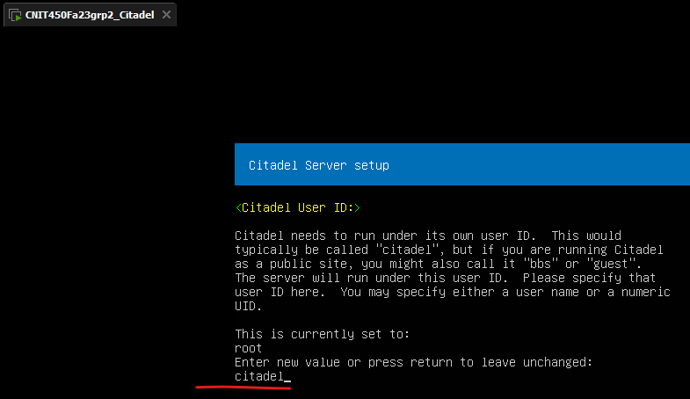

1. Set the listening address to the **172.20.128.28** address created on the server.

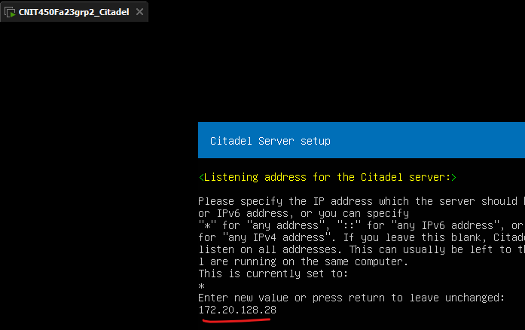

1. Leave the server port as **default** and hit enter

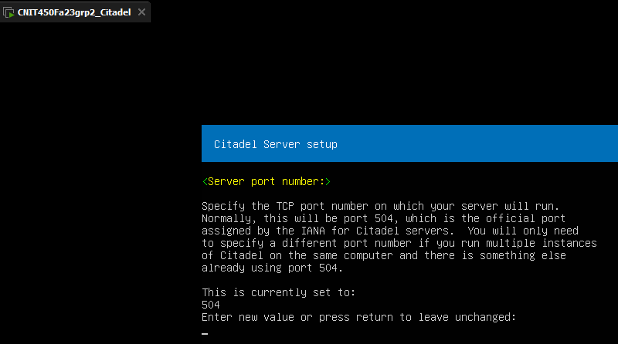

1. **BEFORE YOU SELECT ANYTHING ON THE NEXT PROMPT.** 
   1. Turn off your laptop Wi-Fi
   2. Connect to the lab network using an ethernet adapter with the settings described in the requirements.
   3. Use your host computer’s command prompt to ping the Active Directory server at **172.20.0.24** to ensure the citadel server will be able to reach it.
      1. If your laptop cannot reach the Active Directory server, troubleshoot connectivity between the host device and the server.
   4. Enter 3 to set the authentication method to **3: Microsoft Active Directory**
      1. If you take too long to proceed to the next step it may cause you to start over the installation, in this case revert to the previous snapshot and try the install again.

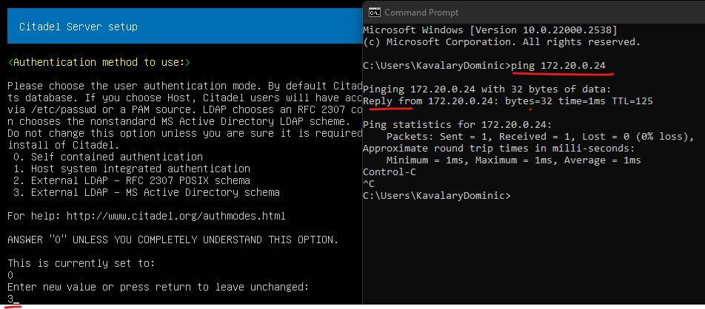

1. Set the LDAP host as the address of the AD server, in this case **172.20.0.24**

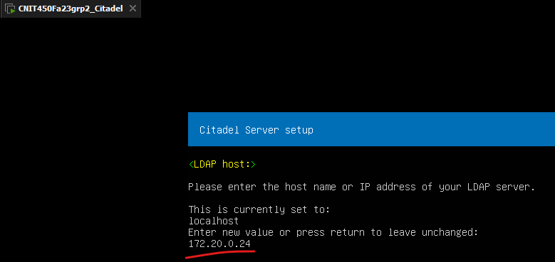

1. Leave the default LDAP port number as the **default value**

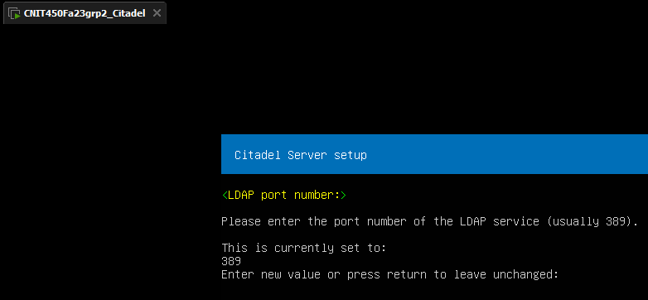

1. For the base DN, enter “**dc=CNIT450Fa23grp****2,dc=com**”

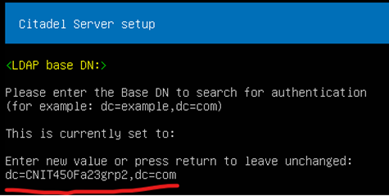

1. For the bind account, enter “**cn=Bind User,cn=Users,dc=CNIT450Fa23grp****2,dc=com**”

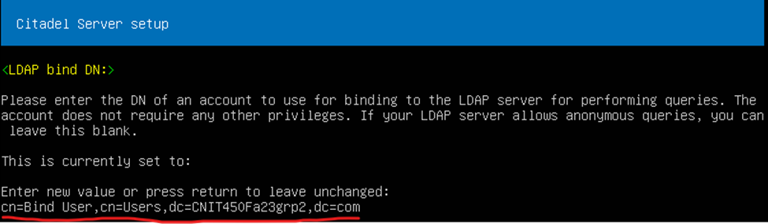

1. Enter bind password, in this case we had set it to **CNIT450Fa23grp2!**

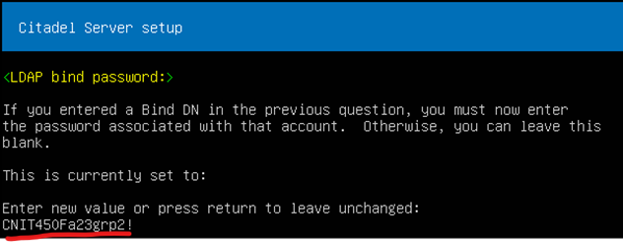

1. Wait for server to restart

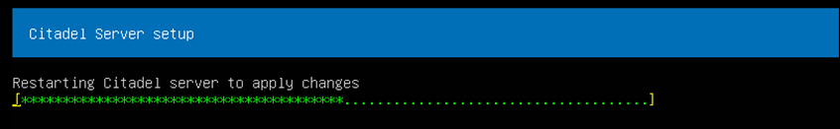

* 1. If the server gets hung up on this step, you may have made a mistake during this installation process. Revert to your screenshot and attempt the installation again.
     1. Things that may be wrong include specifying the Admin username incorrectly, not creating the bind user properly, still having the “change password at next login” feature selected, not being able to reach the Active Directory Server, having the CitAdmin be named something else at some point, etc. You may also attempt to use **Bind User** as the full DN for the bind account with nothing else.

1. Configure to use the typical ports 80 and 443

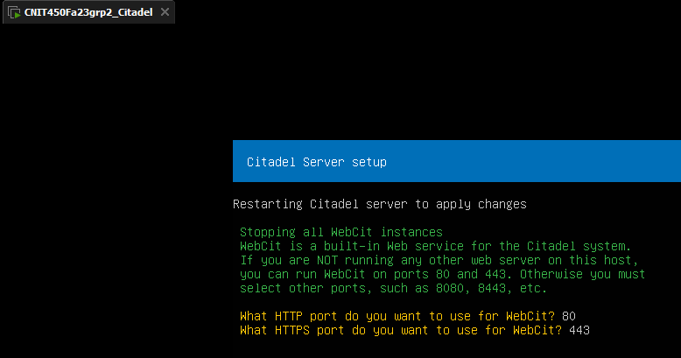

1. Once the server is set up, you should see the message below



1. Connect to the citadel server through a web browser on your host device using **172.20.128.28**. Citadel may take a minute or two to properly start up and have its web server running.
   1. Log in with the CitAdmin credentials

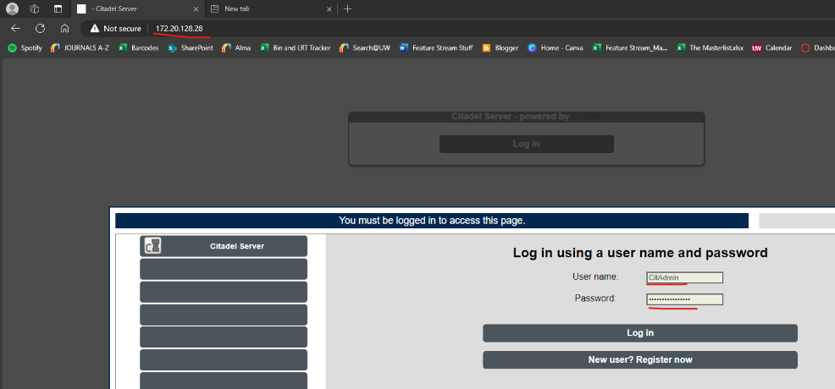

1. You should see the below

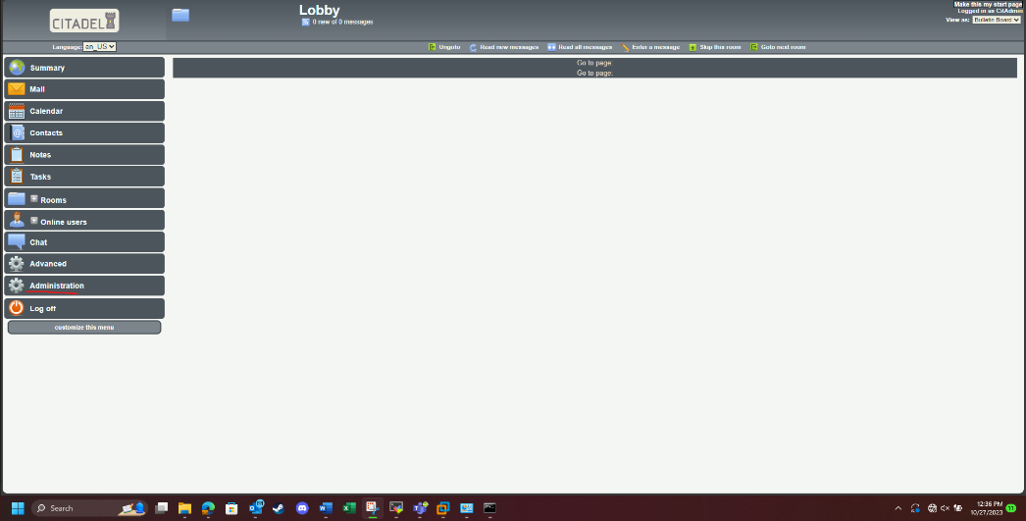

* 1. If you get a USER NOT FOUND error, confirm the initial easy install has completed, and that the Active Directory users have been configured properly. Confirm you can reach the Active Directory server via ping from your Citadel server, and that your Wi-Fi is turned off. Confirm the CitAdmin user only has CitAdmin as its first name, logon, and display name, and that the password was correct.
  2. If a mistake was made along the way, revert your VM to the snapshot after the initial server creation and attempt the curl command again

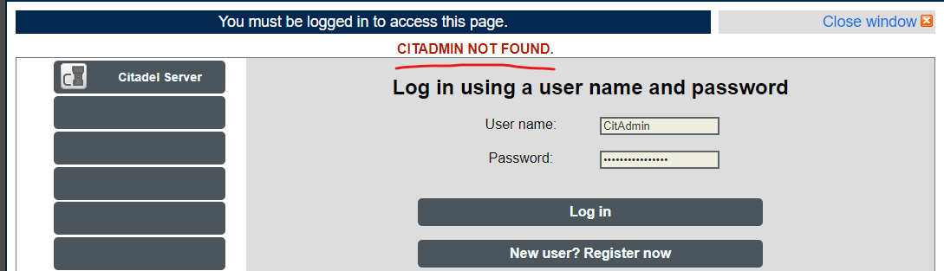

1. Click on Administration > Edit Site Wide Configuration

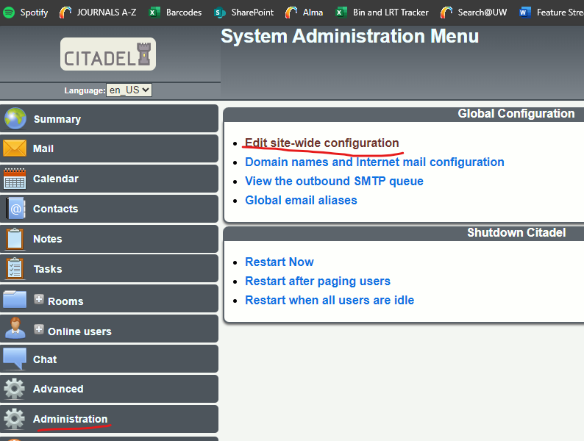

1. Edit General Site Configuration to have a Fully Qualified Domain Name of **CNIT450Fa23grp2.com**

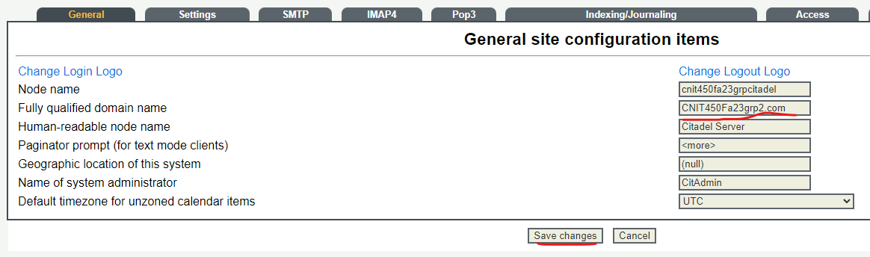

1. It’s recommended to take a snapshot of your VM at this point so that you can avoid loss of data.
2. Now to Export the VM and Import it in ESXi. In order to export the VM, it must be shut off
   1. Power off the VM with a “**shutdown now**” command.



1. Export to OVF by clicking **File > Export to OVF…**

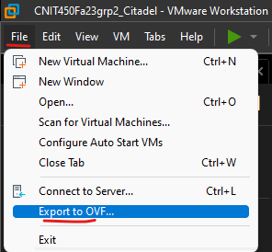

1. Make a folder called CNIT450Fa23grp2_CitadelOVF to store the OVF in. Enter into that folder and save the OVF

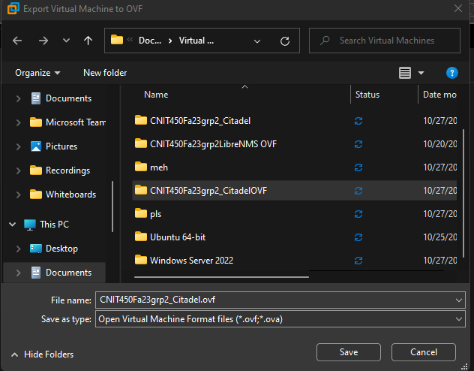

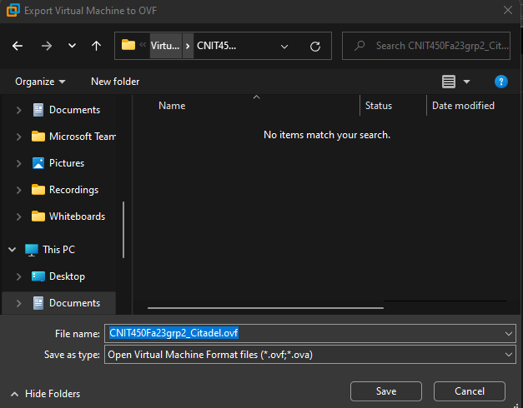

1. Connect your host computer to the ESXi lab network.
2. Next, connect to the ESXi device that will store the Citadel server. The MSP branch uses 10.33.7.103 for their ESXi device, enter this in a browser on your host computer.

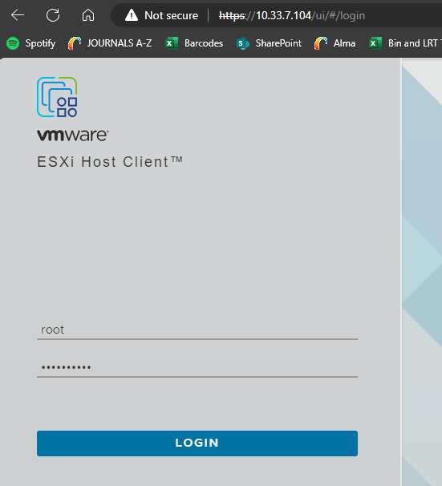

1. Follow **Appendix B: Server Datastore Allocation** to create a datastore with 60GB of storage called CNIT450Fa23grp2_UbuntuServ. You should be able to see it under **Storage. This step is also completed during LibreNMS installation. If it already has been completed do not do it again.**

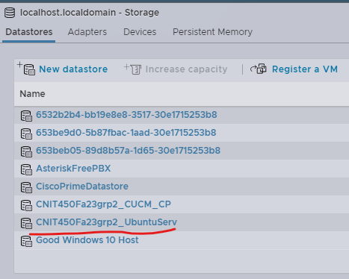

1. Go to **Virtual Machines > Create/Register VM**

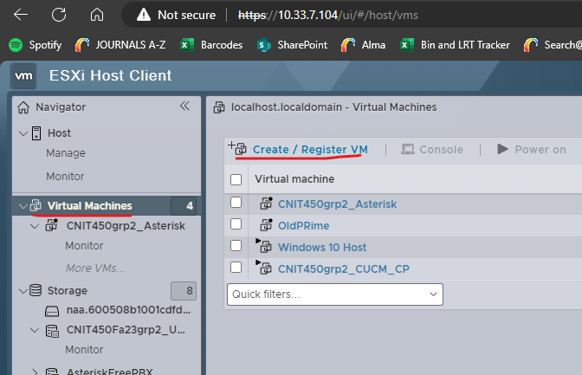

1. Select **Deploy a virtual machine from an OVF or OVA file**

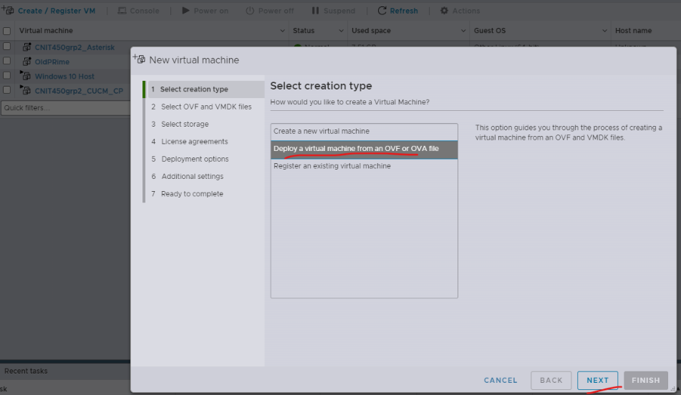

1. For a name, enter **CNIT450Fa23grp2_Citadel**

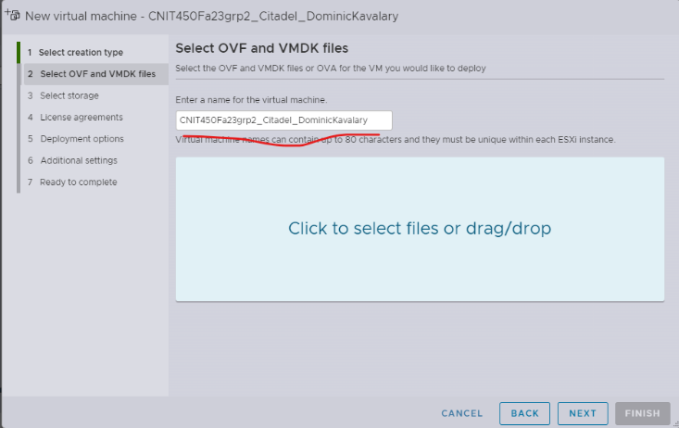

1. On the same page, click “**Click to select files or drag/drop**”

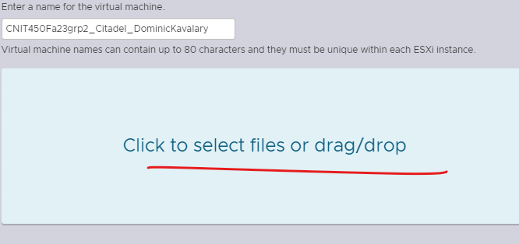

1. Select the vmkd, iso, and ovf files and click open

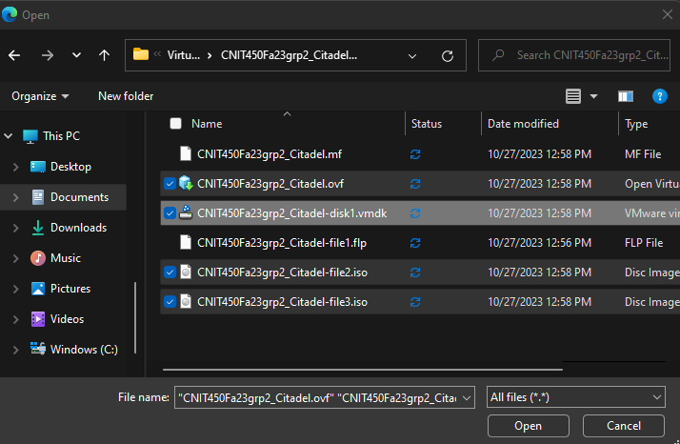

* 1. They should appear as below, then click next

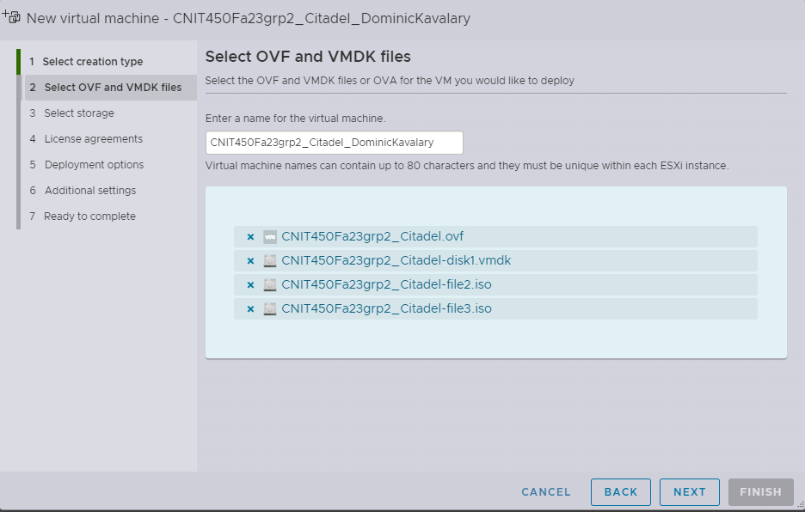

1. Select the datastore made previously

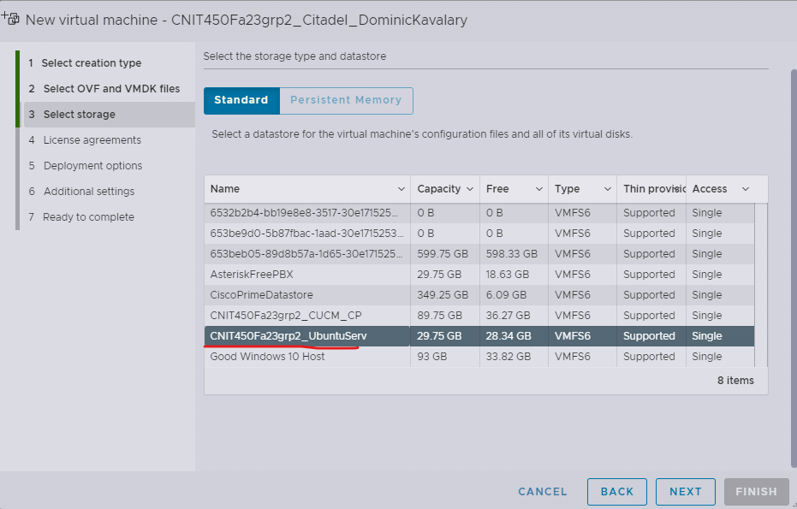

1. Select the **MSP CNIT450Fa23grp2** port group created in ESXI, ensure disk provisioning is **thin** and it will power on automatically

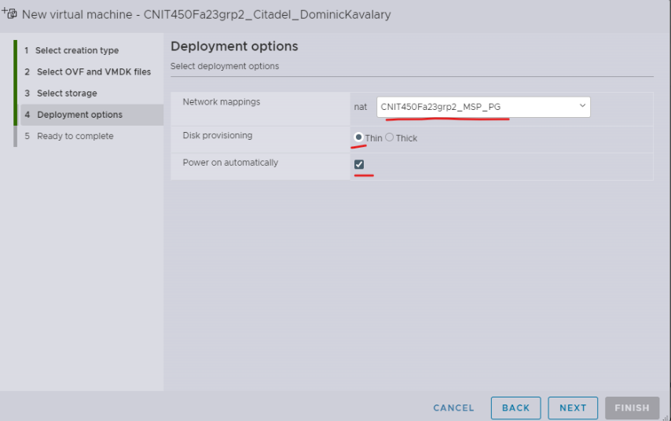

1. Ignore any warnings about a required disk image and click finish

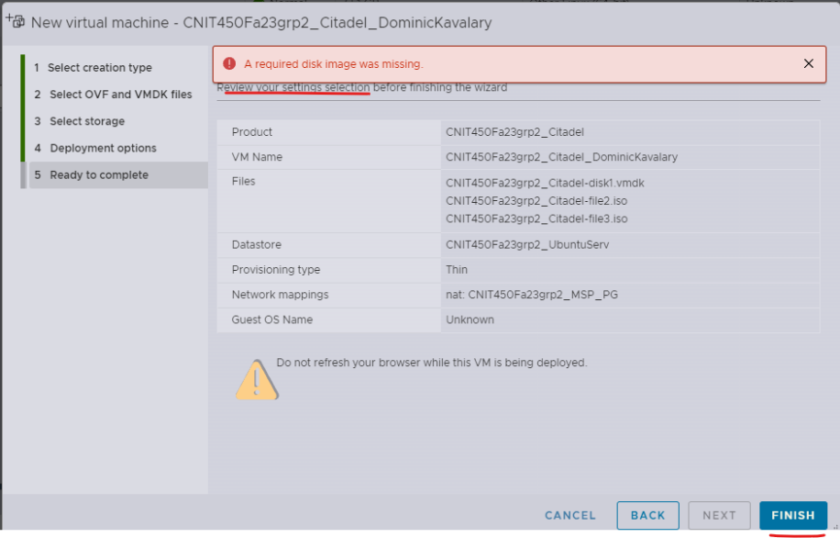

1. Go to **Host > Monitor** to observe progress of importing the VM to ESXI. Wait until these are completed

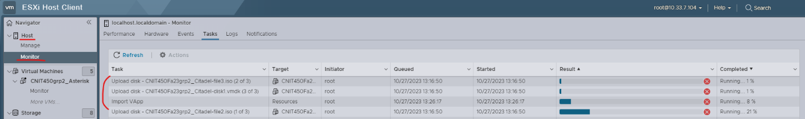

1. Once the uploading has been completed, go to **Virtual Machines > CNIT450Fa23grp2_Citadel**
   1. Click on the monitor display near the bottom to enter the CLI

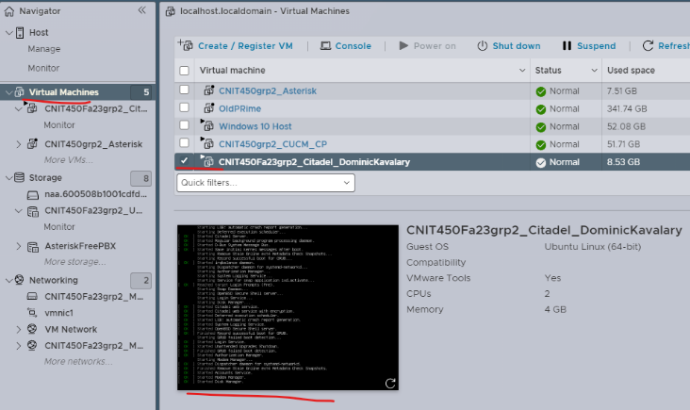

1. Log into the VM.
2. Edit the netplan config file using sudo nano, which can be found under /etc/netplan

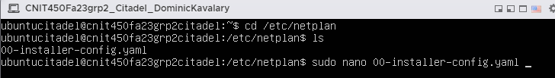

* 1. Edit the nameservers from the 8.8.8.8 addresses to include one or more of the two domain controllers like **172.20.0.24** as shown below. This will allow the machine to access company resources by hostname as well as internet resources.

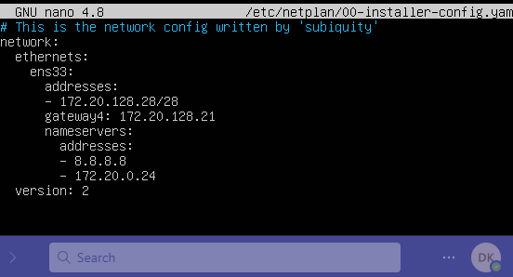

1. Ensure the machine can ping the domain controllers

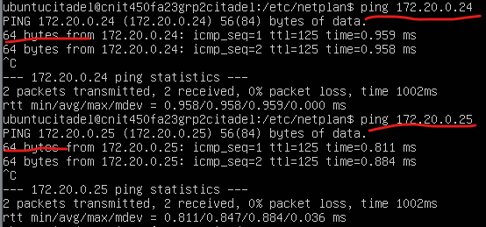

1. It is recommended to take a snapshot at this point

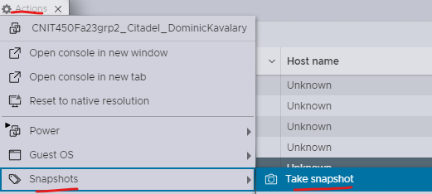

1. Disconnect your computer from the ESXI lab network and place your computer back onto the Users VLAN in the MSP site referencing earlier instructions from the initial citadel setup with active directory.
2. Attempt to connect to the server through IP again and log in using a non CitAdmin user account

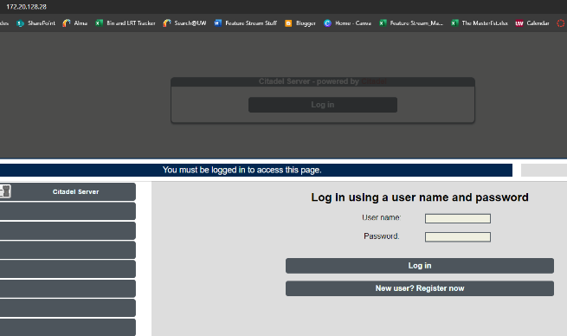

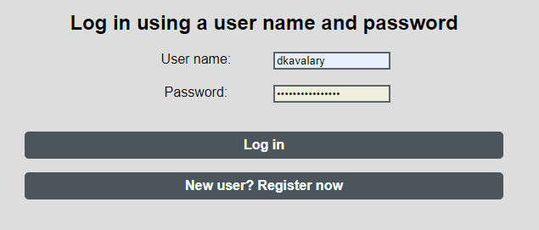

1. The below screen should appear

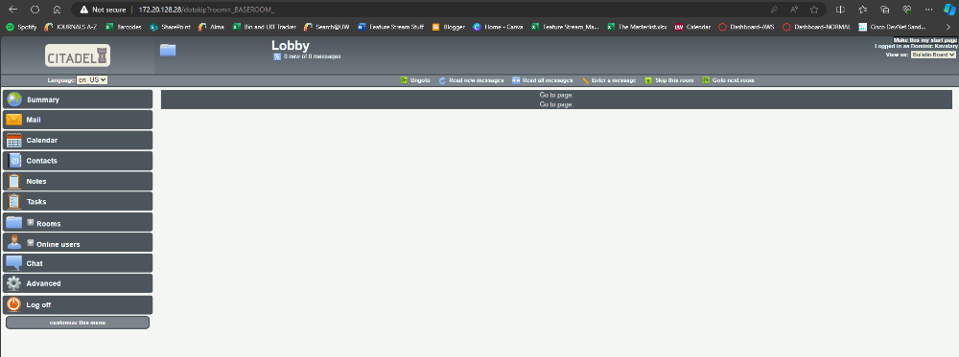

1. You have successfully imported the Citadel server VM into ESXI, now we move on to examining some of Citadel’s features.

### CONFIGURATION INSTRUCTIONS

Now that Citadel has been installed, it is time to examine some of its features that allow for a team or individuals to increase productivity and have helpful features to assist in day-to-day work activities.

1. Go to **Mail**
   1. Click **Write Mail**

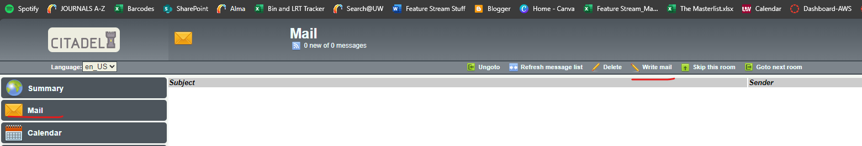

* 1. Examine that the email that was created conforms to the following schema:
     1. FirstName_LastName
     2. We will examine why this schema isn’t as rigid as it seems
  2. Write up two test emails to a user account, one with a name that fits the schema, and one with the logon name of the user account. We will use the bind user for this example but depending on Active Directory configuration this account may be blocked from user access

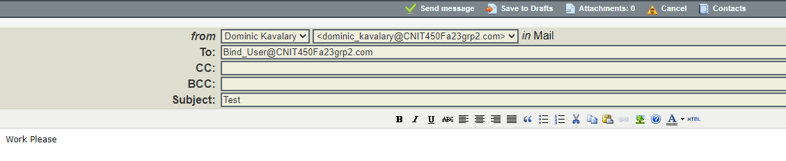

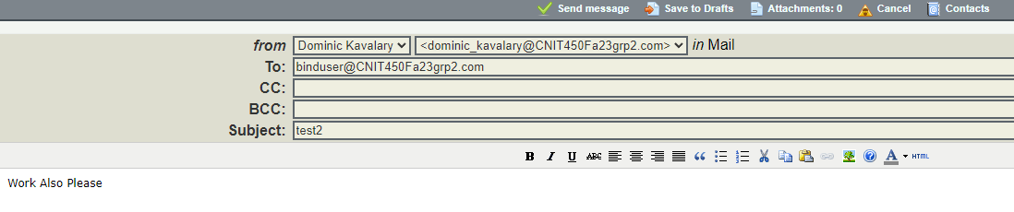

* 1. Log off and log in using the credentials of the user the email was sent to
  2. Go to **Mail** and view the received message. You will see that while the email displayed for the users is of one schema, the typical username can be used in place of FirstName_LastName

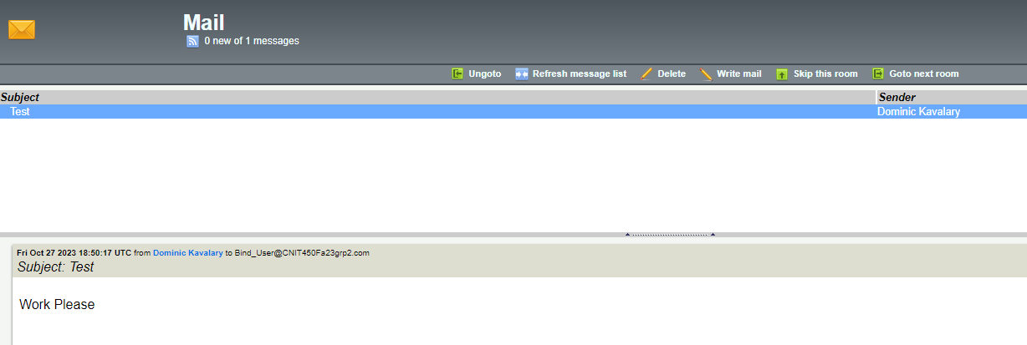

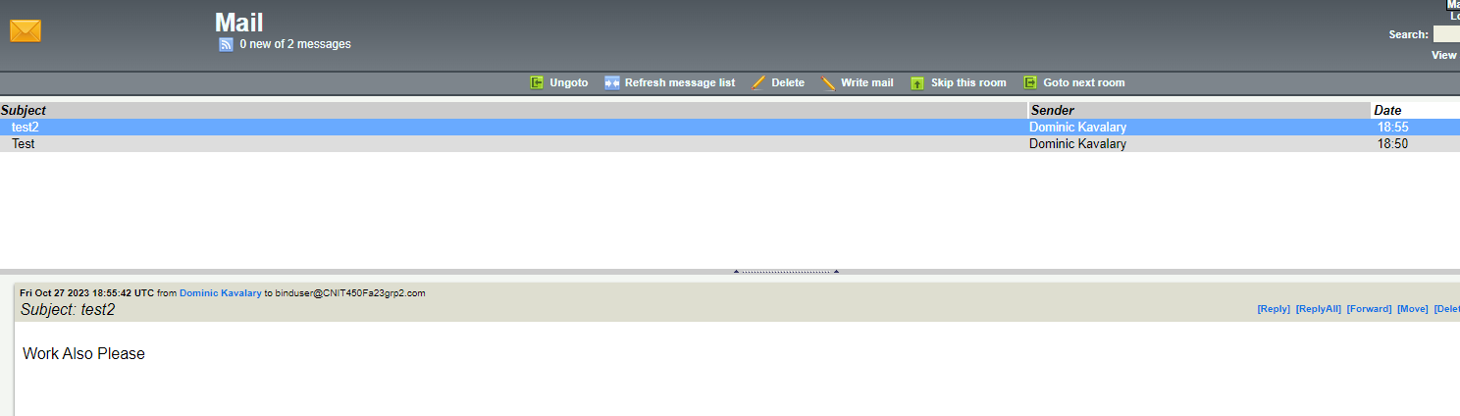

1. Log off and log back in as **CitAdmin**
2. Go to **Calendar**
   1. Click **Add new event**

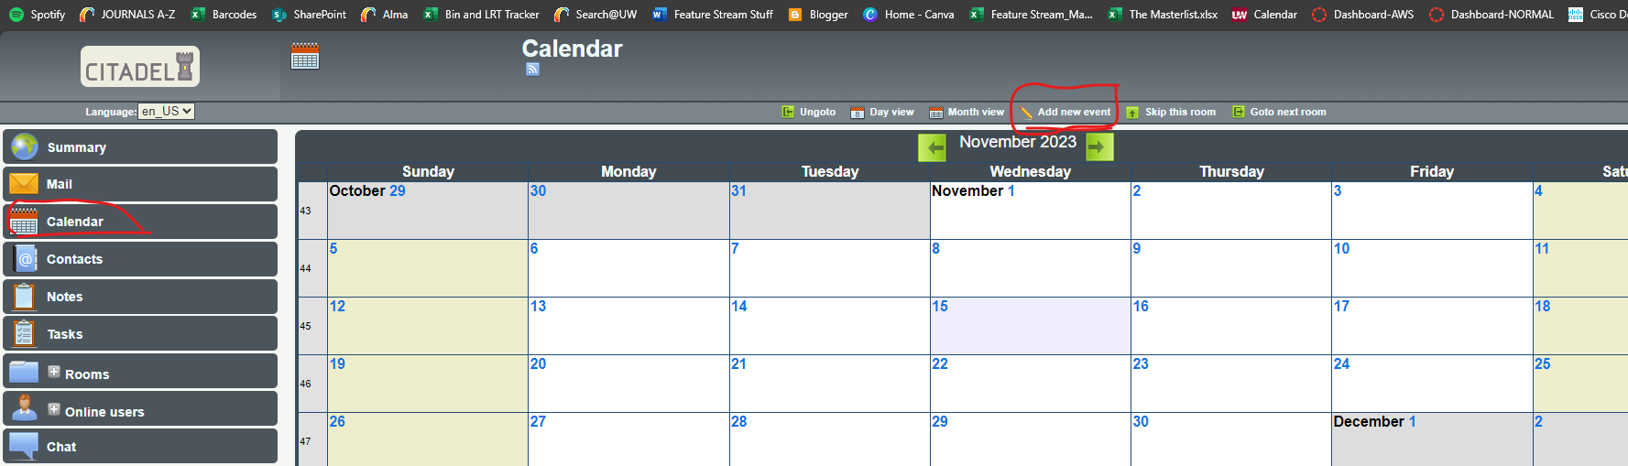

* 1. Under the **Event** tab, create a test evet that takes place sometime today

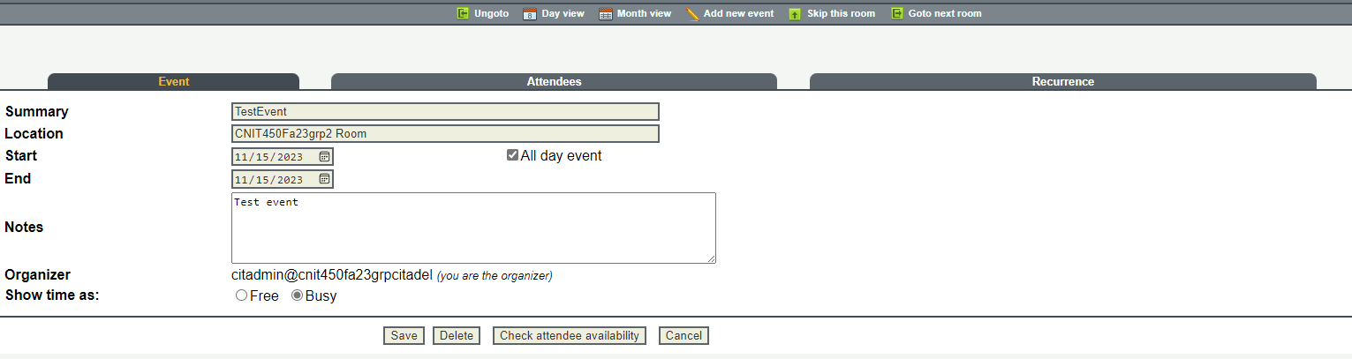

* 1. Under the **Attendees tab,** add the a user in the below ways; by display name, by display name with an underscore between first and last name, and by username. Also add a user that doesn’t exist. Then, click **Check attendee availability**
     1. This might bring you back to the **event** tab after clicked, move back to the **Attendees** tab after clicking the availability button
     2. This shows that Citadel can check Attendees through display name, email, and display name with an underscore. It also shows how it handles a user that doesn’t exist.
     3. Remove the availability text and just put the users email address.

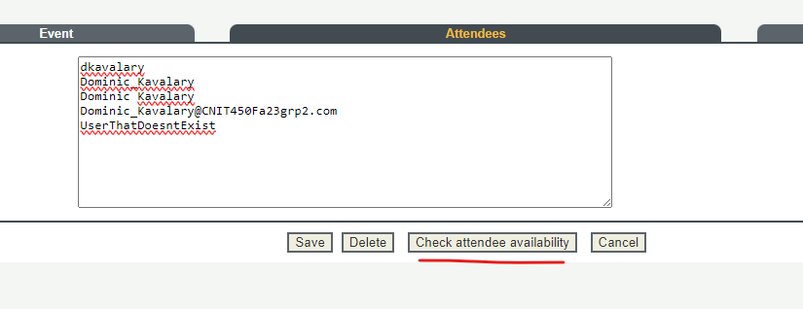

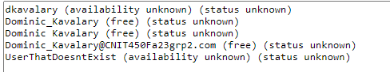

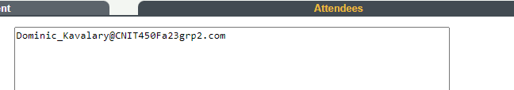

* 1. Click **Recurrence**, and check the recurring event box, and fill in some details.

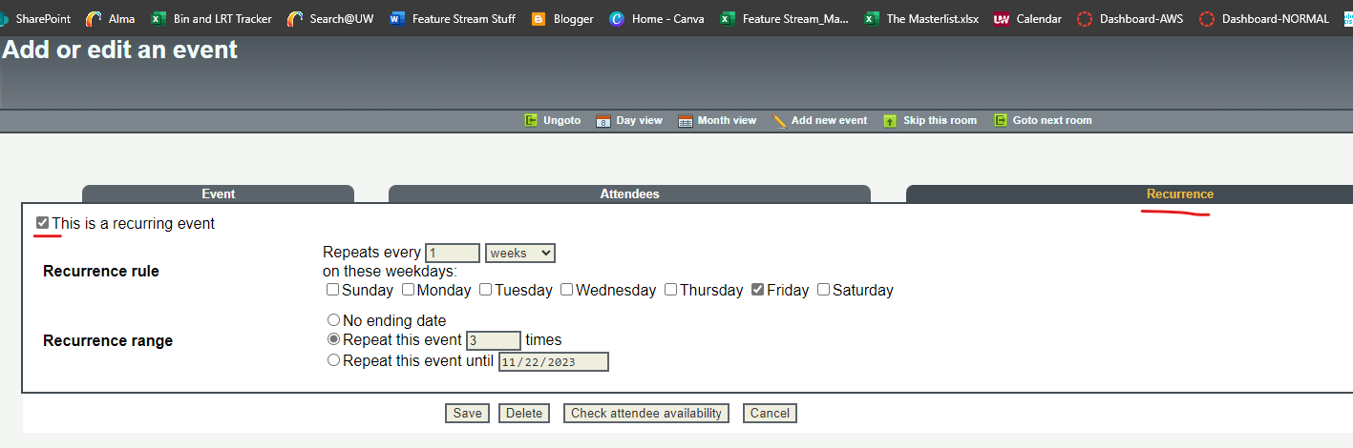

* 1. Click **Save** to save the event
  2. View the Calander, observe that an event has been created and is recurring

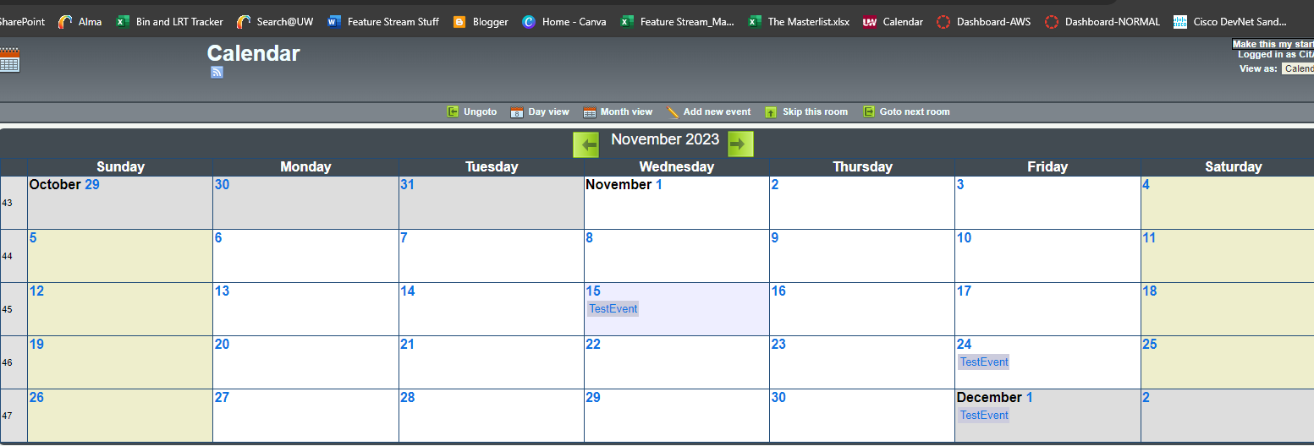

* 1. Log off CitAdmin and log back into the invited user to check their mail. Observe that they have received an email about the event they have been added to, with a form of the information about it and their response.

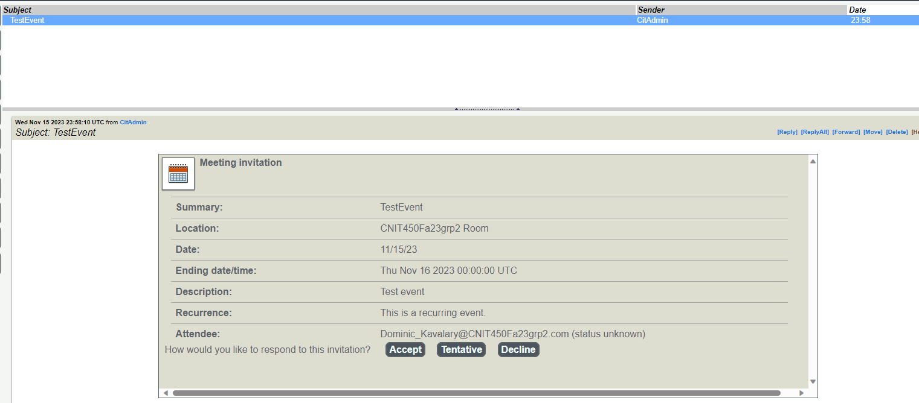

* + 1. By accepting, CitAdmin will receive a response message, and the item will be added to the user’s calendar.

1. Log back into CitAdmin and go to **Contacts.** This tab is used for keeping a list of contacts through your organization and onward.
   1. Click **Add new contact**

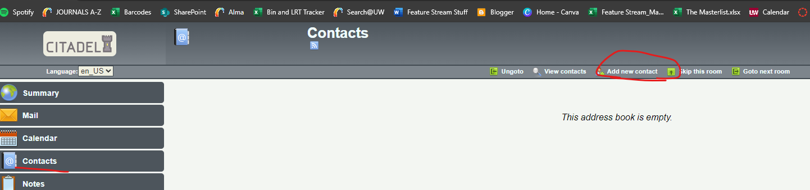

* 1. Enter in some User information and click **Save**

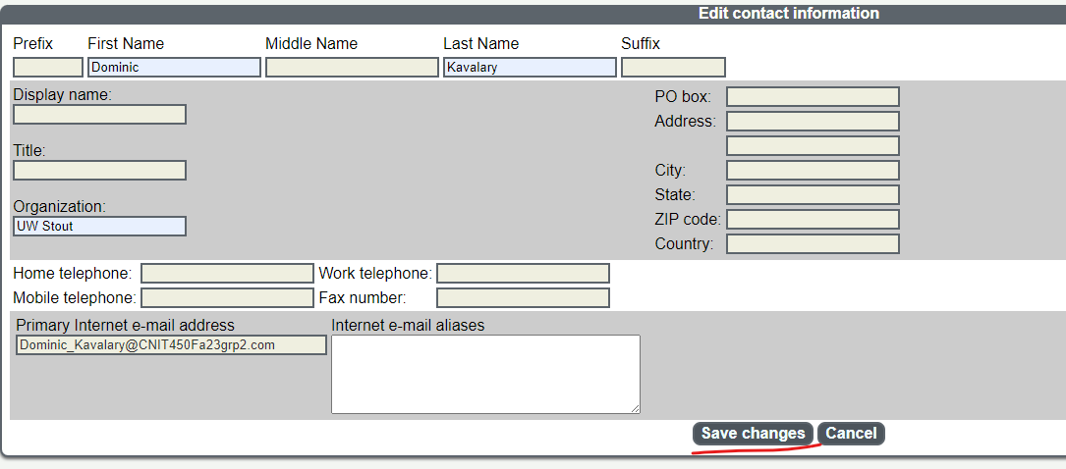

* 1. Go back to **Contacts** and view the created contact.

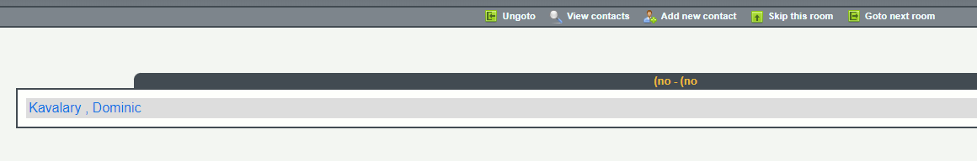

* 1. Now in **Mail,** you can click **Contacts** and see your recorded contacts to quickly enter their email information by selecting Contact and hitting the **To** button.

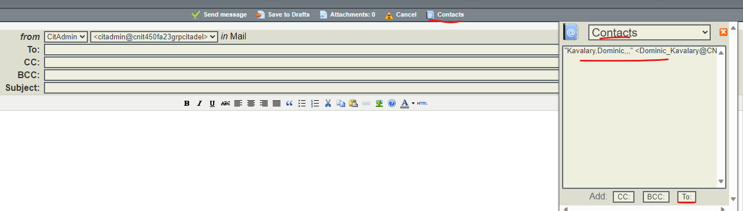

1. Go to **Notes.** This tab is useful for keeping quick notes to reference in the future.
   1. Click **Add new note** and a sticky note should appear

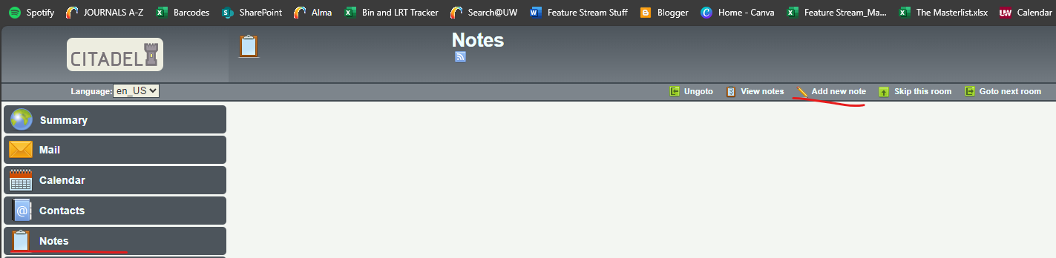

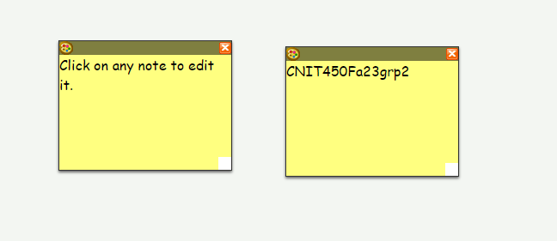

* 1. Clicking the **Paint Palette** icon can allow you to change the color of the note, clicking and dragging the **bottom right white square** can grow and shrink the size of the note

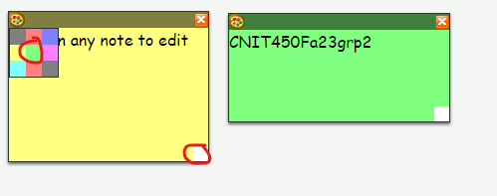

1. Go to **Tasks.** This tab assists in keeping an organized to do list.
   1. Click on **Add new task**

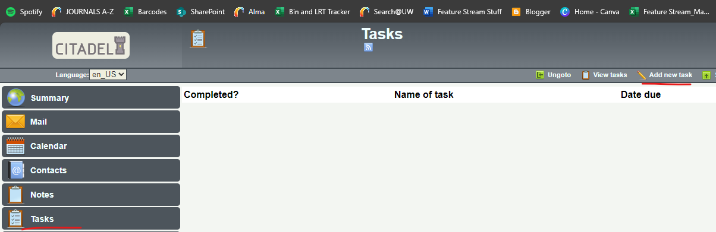

* 1. Edit the task information and click **Save** to create a new task

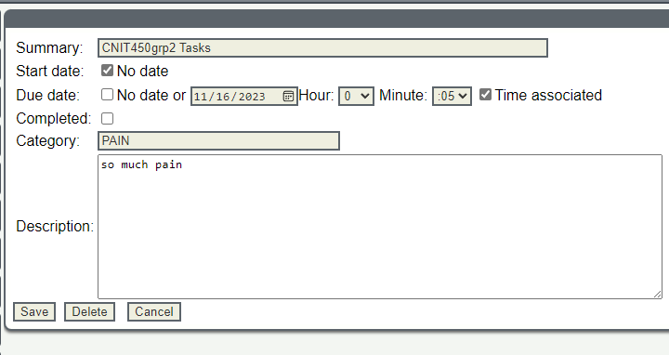

* 1. You can now view your created tasks, and even sort them by categories you define in the task

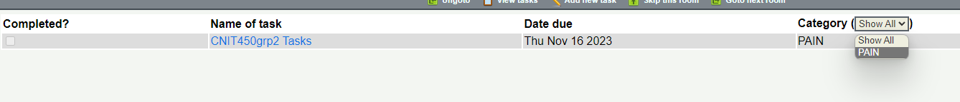

1. Go to **Rooms**
   1. This tab will allow you to quickly enter your personal folders as well as any global folders.

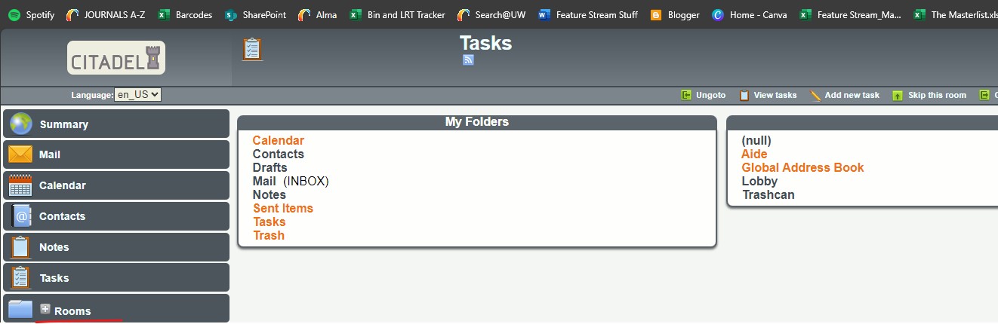

1. Go to **Online Users**
   1. This tab allows you to see the users currently browsing Citadel.

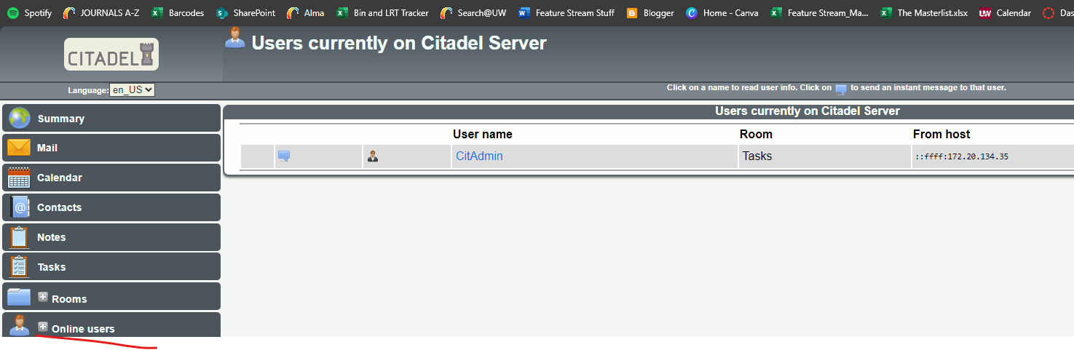

* 1. Go to the **Chat Button.** This is useful for more ad-hoc conversations with an online user.

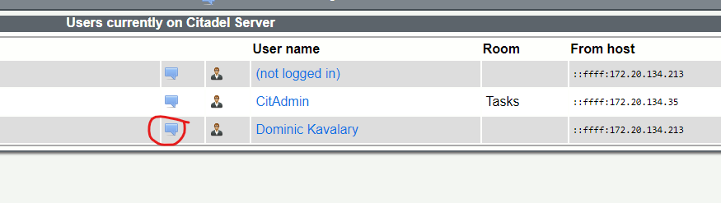

* 1. Send a message

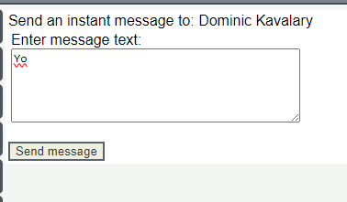

* 1. The user that had been sent the message will receive a popup window of their message, or a pop up asking to allow popups for the instant messenger.

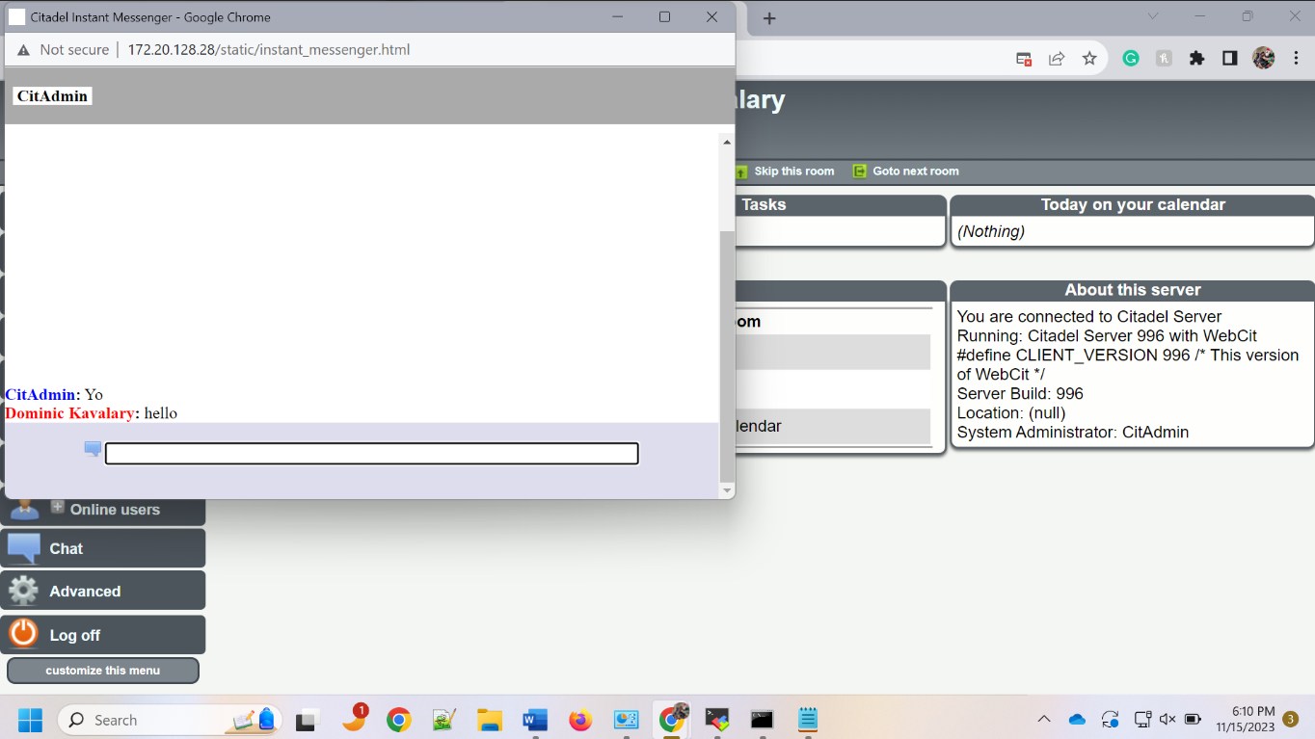

1. Go to **Rooms >** **Lobby.** Click **Enter a message**. This should bring you to where you can post a message on the Lobby message board. **Post a message** and note that you can add an attachment, perhaps a report for others to look over.

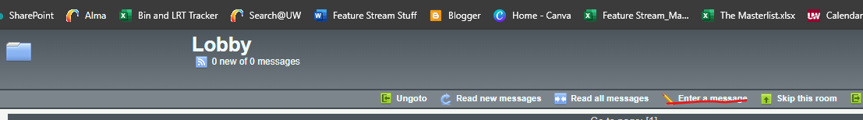

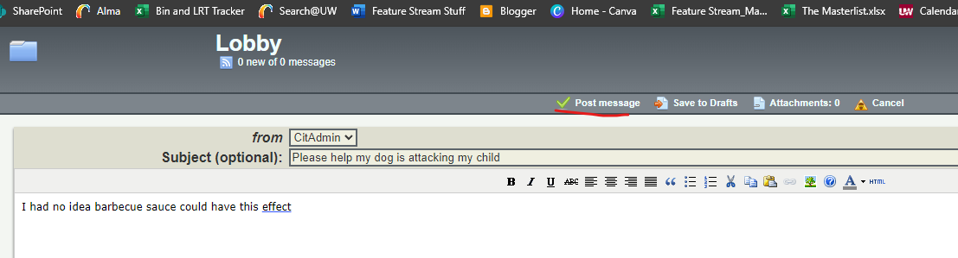

* 1. By clicking Read all messages, others can read and reply to posts made in the Lobby.

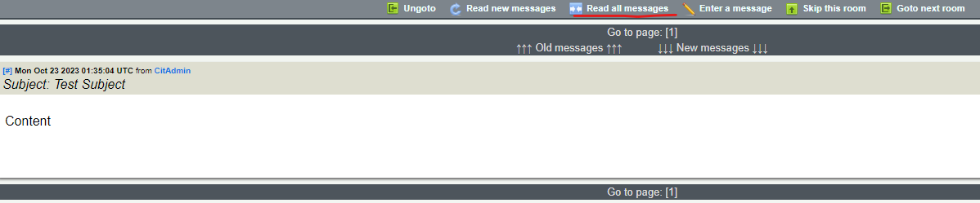

* 1. Log off of CitAdmin and log in to another user, go to **Rooms > Lobby**. They will be able to see the message posted and reply.

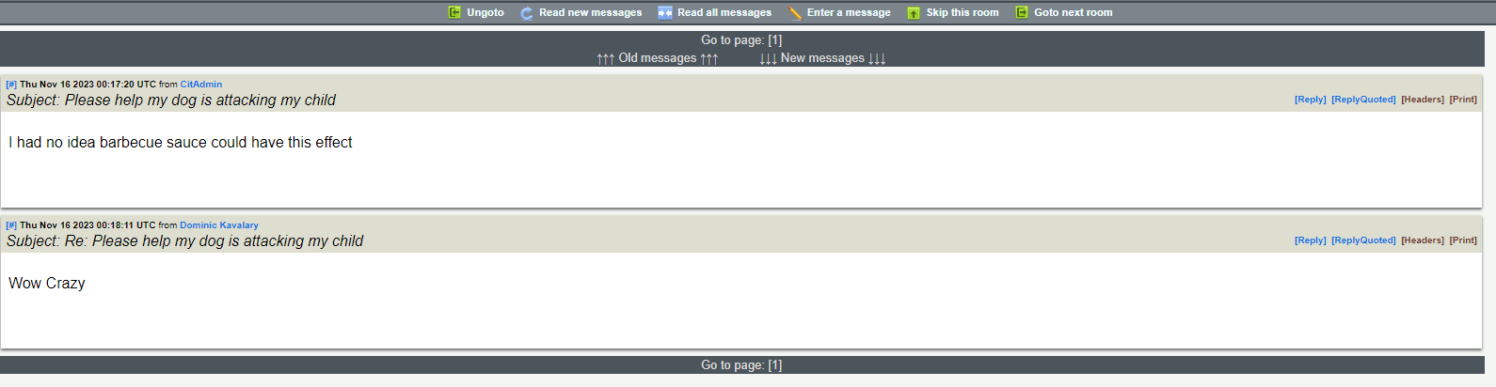

1. Go to **Advanced**
   1. This tab allows for advanced information settings about yourself, as well as some options to create and modify rooms. Many of the room specific commands depends on the room someone was in before they clicked the **Advanced** tab

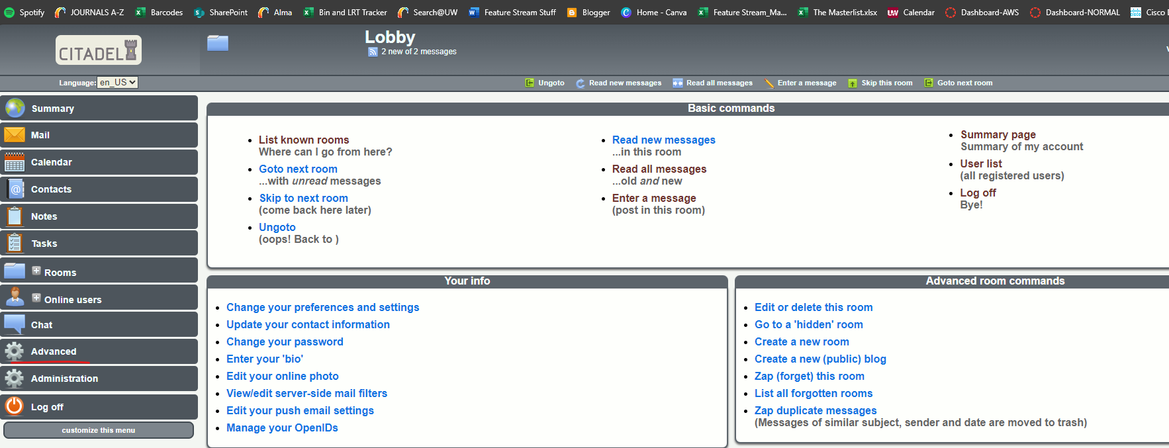

1. Log back into CitAdmin and go to **Administration**
   1. This tab is for **Admin users only.**
   2. Many of the links here have wide reaching effects on the server; such as restarting the server, editing site wide configuration options, and editing user information
   3. Click **Add, change, delete user accounts**

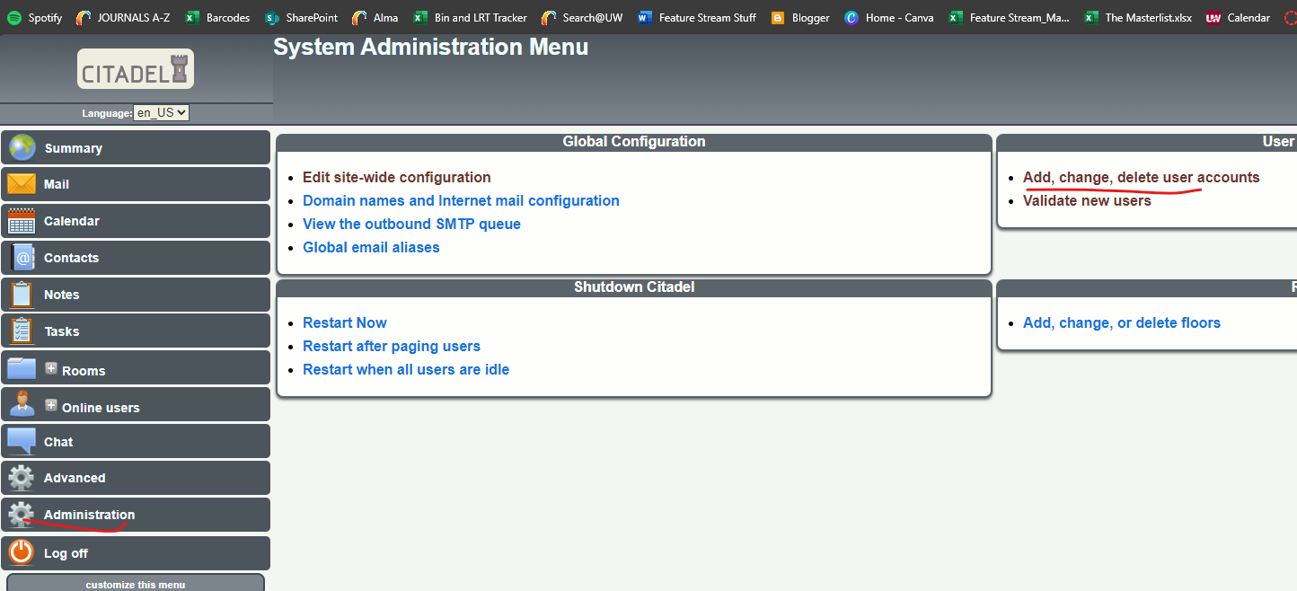

* 1. Select a user and click **Edit configuration**

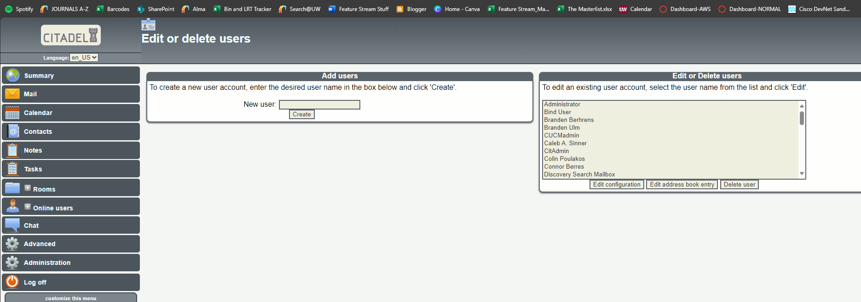

* 1. Here you can edit user related settings, the most important ones likely being the ability to send emails through the internet to domains outside of one's own, and setting the access level of accounts
     1. You may decide to modify an existing user to be given admin access level, and then delete the CitAdmin user from both Citadel and Active Directory. This is fine.

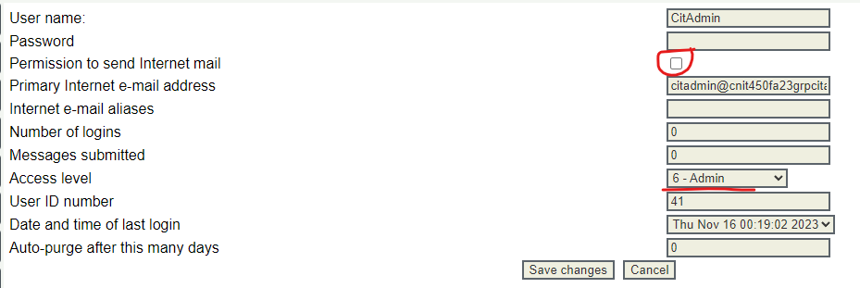

* 1. Go back to administration and click **Edit site wide configuration**.

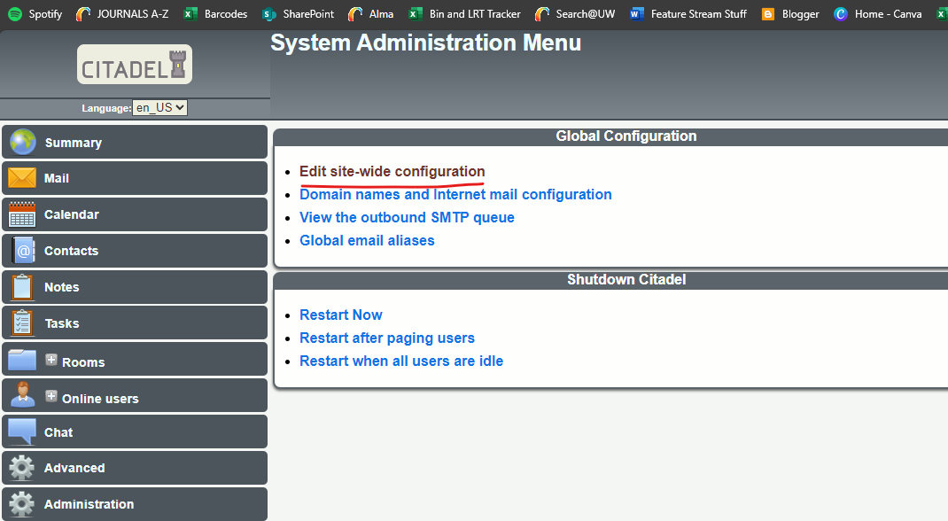

* 1. The three most important tabs in this group are **General, Access, and Directory**
     1. General: General site info, as well as the ability to change the FQDN, this will show up on any sent emails in the organization. For this case, the FQDN should be CNIT450Fa23grp2citadel.com. This will allow others to distinguish between what is sent to them from Citadel and from users on Citadel, rather than the Exchange server that will also be used in this lab.

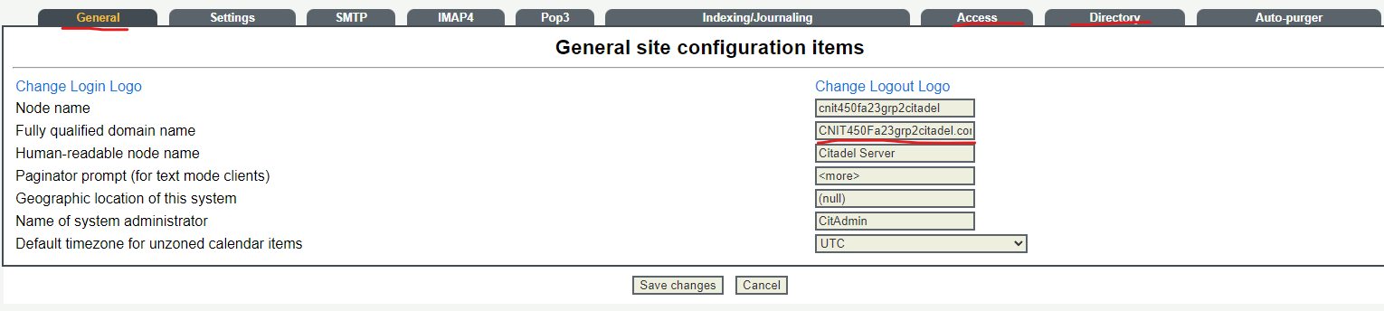

* + 1. Access: This tab displays access controls for things such as allowing guest access into Citadel, what permissions users start with, and whether or not users can void the login process and create a new user to access Citadel resources.

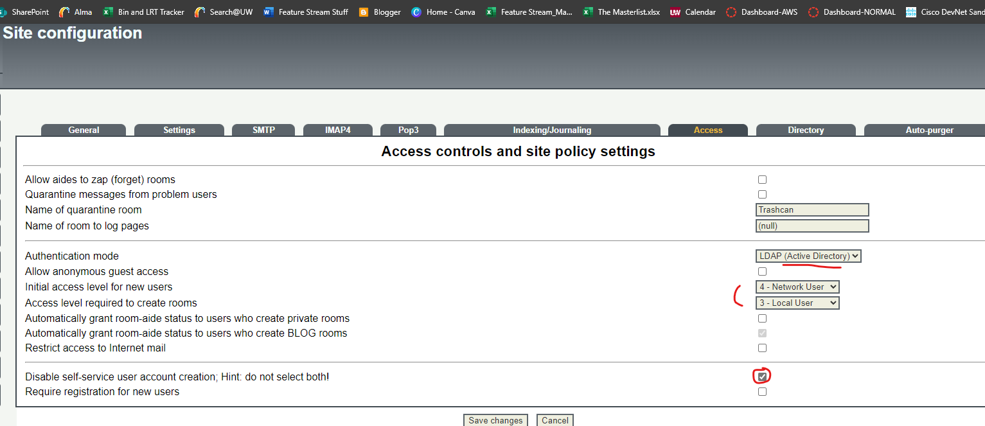

* + 1. Directory: This page is in relation to the directory services Citadel uses to authenticate with. IGNORE the note. The options will have an effect. DO NOT change the LDAP server.

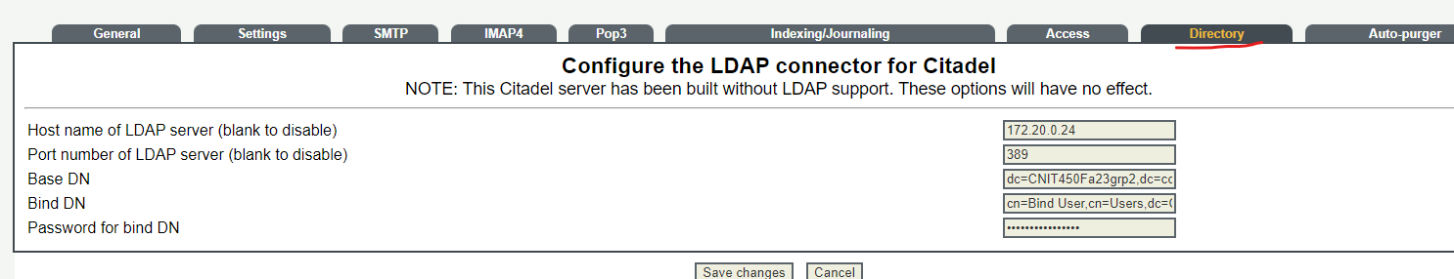

* 1. By logging into a standard user, you can see that they do not have the option to go into **Administration.**

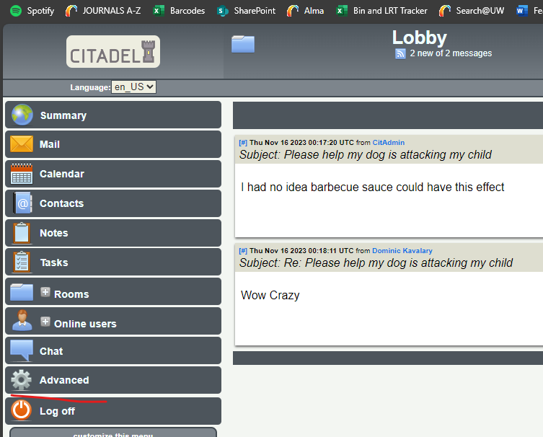

1. Go to **Summary**
   1. This is the Summary page. This will tell you how many messages your user has received, who else is online using Citadel, any relevant tasks you have created, and any calendar event you have going on that day.

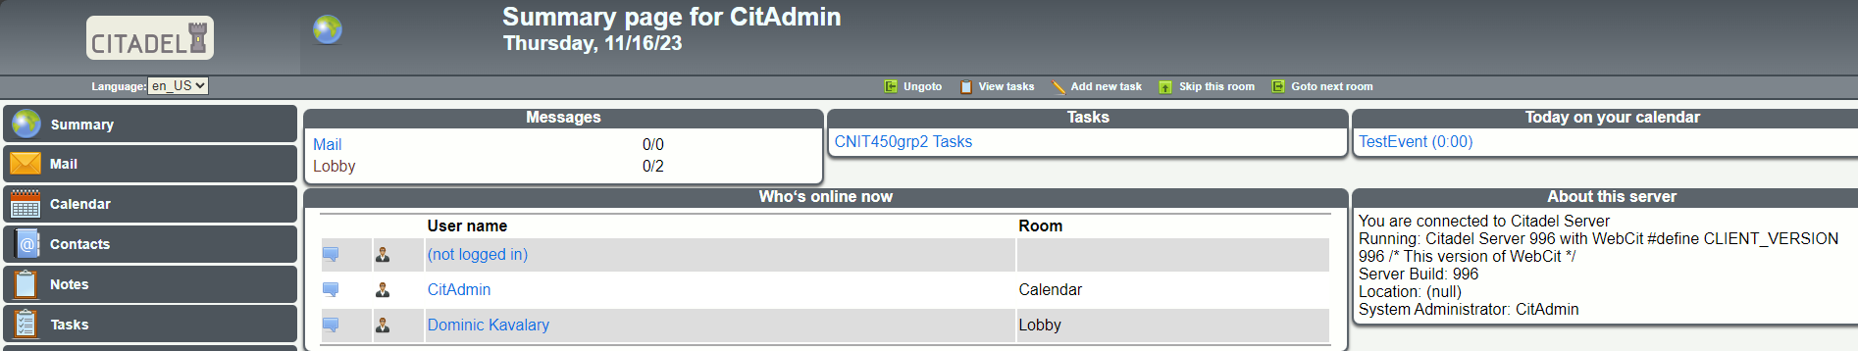

1. Now that we have explored the features of citadel, lets examine ways to more effectively email. It may irritate users to have to go directly to the Citadel login page every time they want to send an email through Citadel. Luckily, we can set up an outlook account and connect it to Citadel in order to email from our email client rather than the web server.
   1. First, in outlook, click **File**

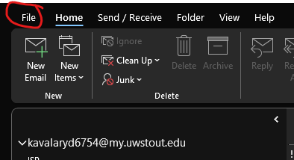

* 1. Click **Add Account**

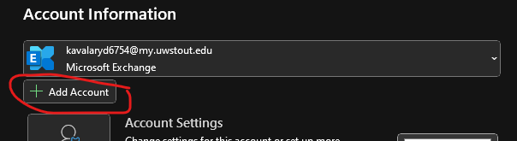

* 1. Enter your Citadel email. The format is lowercase first name, underscore, lowercase last name, @cnit450fa23grp2.com (the FQDN we set)

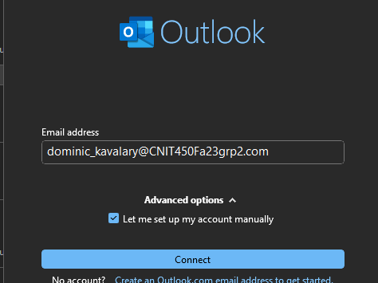

* 1. Choose **POP**

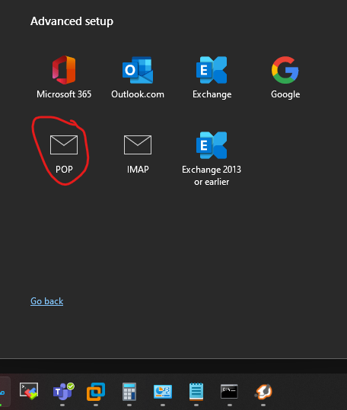

* 1. Set the incoming and outgoing mail addresses to **172.20.128.28**, the Citadel address

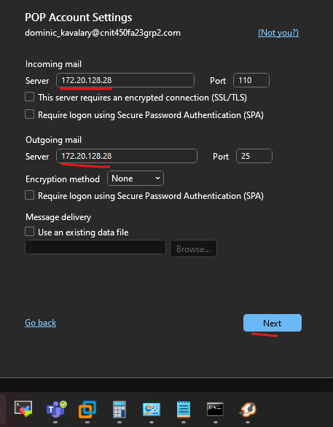

* 1. Enter the password for your account

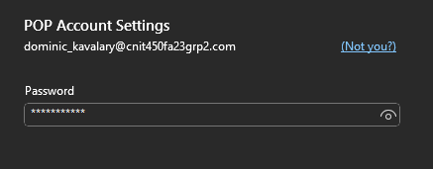

* 1. A window will pop up about account information. Modify the username from the one given to the **Active Directory username**

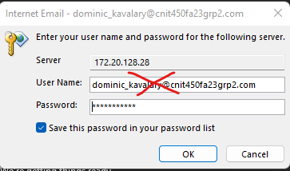

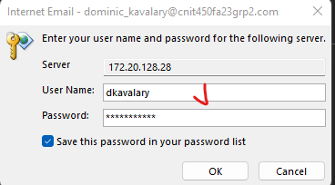

* 1. You should see the account being added

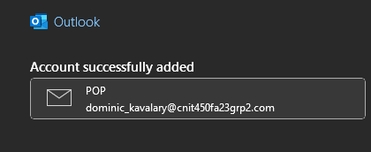

* 1. You can now send and receive emails from Citadel using the outlook client.

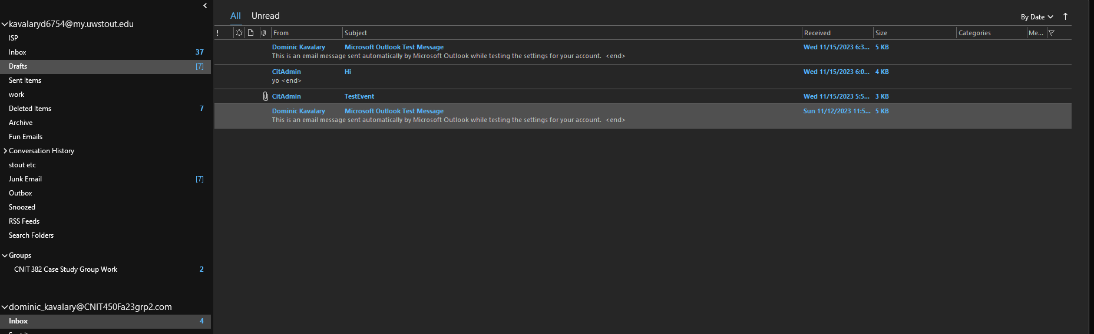

## **OPEN SOURCE ADDITIONAL SERVER, EMAIL MONITORING, ALERT WHEN DEVICE GOES DOWN : LIBRENMS**

LibreNMS is an open-source monitoring software that has extensive features to poll devices for information. It can notify users through email if a configured alarm triggers, such as when a device shuts off or is exceeding its baseline CPU usage. Network and service monitoring is crucial for any organization who wishes to keep services running with minimal downtime. This server will grant staff members the ability to monitor for problems in the network.

Prerequisite services

* Active directory is configured and reachable from the lab network
* ESXi 8 must be installed and configured on the desired server
* Email Server Citadel must be complete

### INSTALLATION INSTRUCTIONS

In order to install this server, the VM must have reachability to the internet. The following instructions will be given assuming there is no internet connection to the network yet. To install the server, first we will create the server VM on VMWare Workstation Pro 17 on a device with internet, and then export it to ESXi. These instructions can be modified to install directly onto the ESXi server if needed given the server has access to the internet.

If you have One-Drive or other cloud backup services turned on your device, **turn them off**. Cloud synching can corrupt VMs while running.

1. In order to install Ubuntu Server, head to <https://ubuntu.com/download/server> and download the 20.04.06 ISO from “**Alternative downloads**”. This may take several minutes to half an hour depending on the current internet speed.
2. After downloading the ISO, open VMWare Workstation 17 Pro on a desktop or laptop with internet. If you do not have this, head to <https://www.vmware.com/products/workstation-pro/workstation-pro-evaluation.html>, and download the proper version for your operating system. In this case we will be using windows.
3. Open VMWare Workstation, and edit your Virtual network in VMWare
   1. Click **Edit > Virtual Network editor…**



* 1. Ensure your settings match the below



* 1. Click **NAT Settings…** to edit the virtual gateway



* 1. Edit the virtual gateway IP to be **172.20.128.21**



* 1. Apply the settings and click ok



1. In VMWare Workstation 17 Pro, click “**Create a New Virtual Machine**”

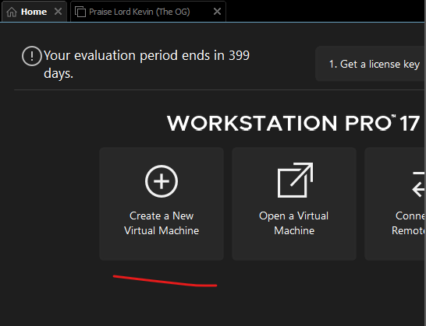

1. Select “**Typical”** and then **“Next”**

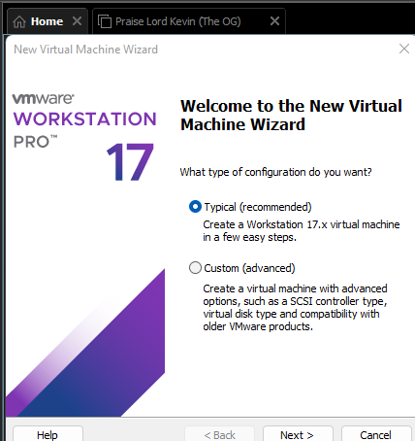

1. Select “**Installer disc image file**”, then select the ISO downloaded previously.

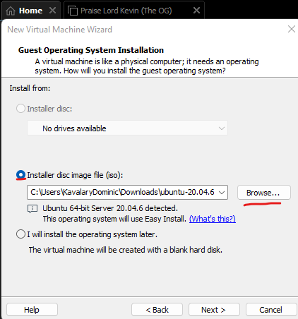

1. Enter the required information:
   1. Full Name: **CNIT450Fa23grp2_LibreNMS**
   2. User name: **ubuntulibre**
   3. password: any, in this case it will be **CNIT450grp2** for simplicity

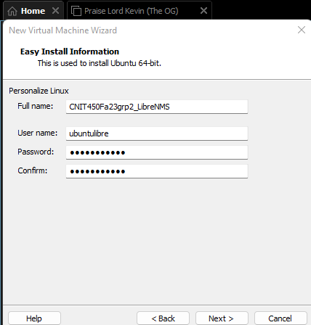

1. Choose an install location, and give the VM a name, for this case, it will be the Full Name given before.

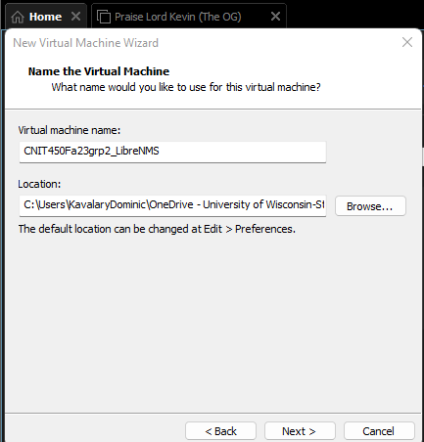

1. Give the VM **15 GB** of space and split the disk into **multiple files**.



1. Ensure the information matches the below. If it does not, explore the “**Customize Hardware…**” button

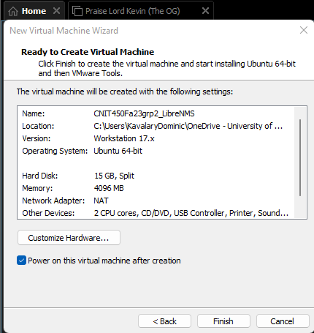

1. Once the machine boots up, you may use the up and down arrow keys to move your selection.
2. Select **English** and hit enter to continue.

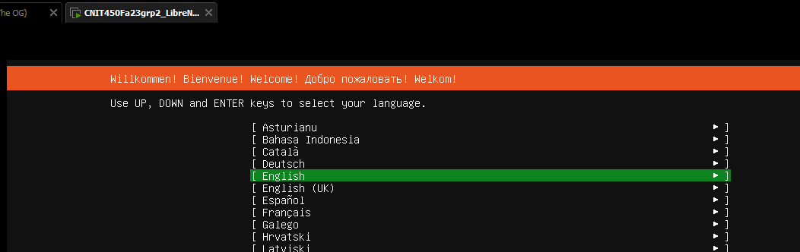

1. If you are asked to use a new installer, select **continue without updating** and hit enter

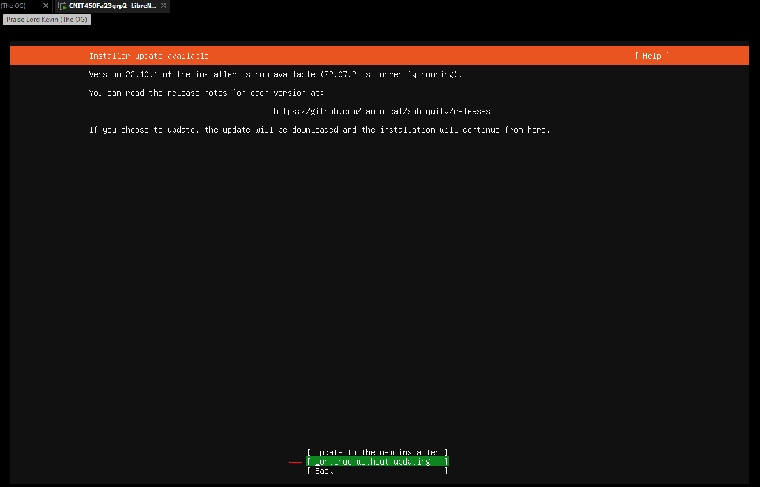

1. If you are asked to select a keyboard layout, leave the defaults and **continue**

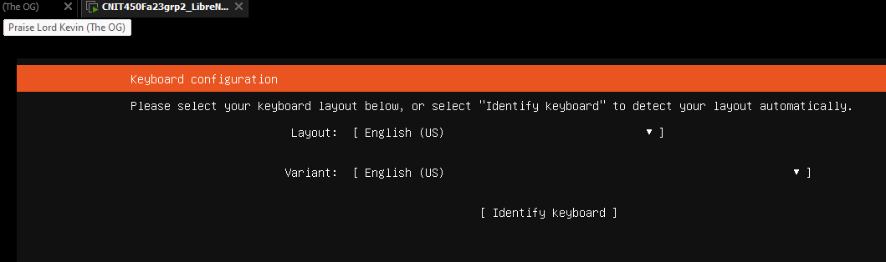

1. Set a static IP address
   1. Select the **network interface**, and then select **Edit IPv4**

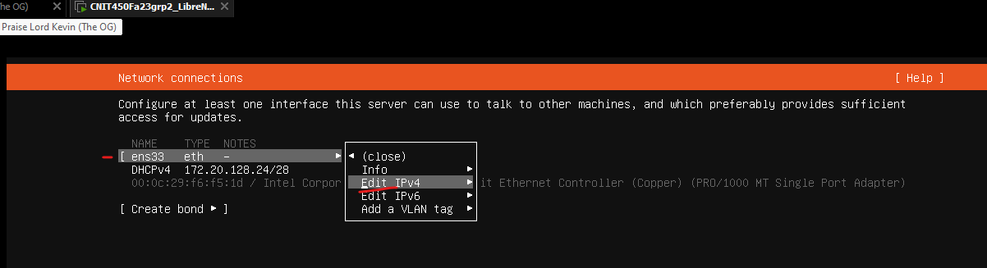

* 1. Select **Manual** as the method

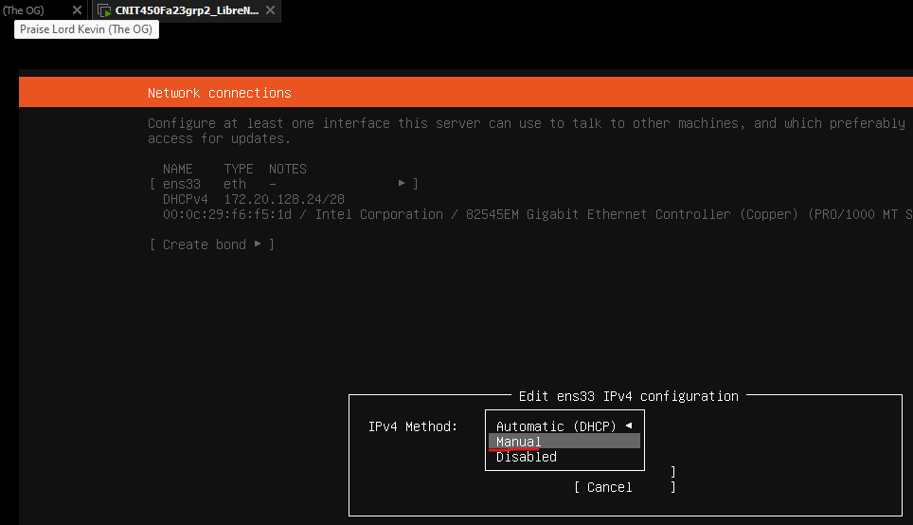

* 1. Enter the below information, and hit **save**
     1. Subnet: **172.20.128.16/28**
     2. Address: **172.20.128.27**
     3. Gateway: **172.20.128.21**
     4. Name Servers: **8.8.8.8**

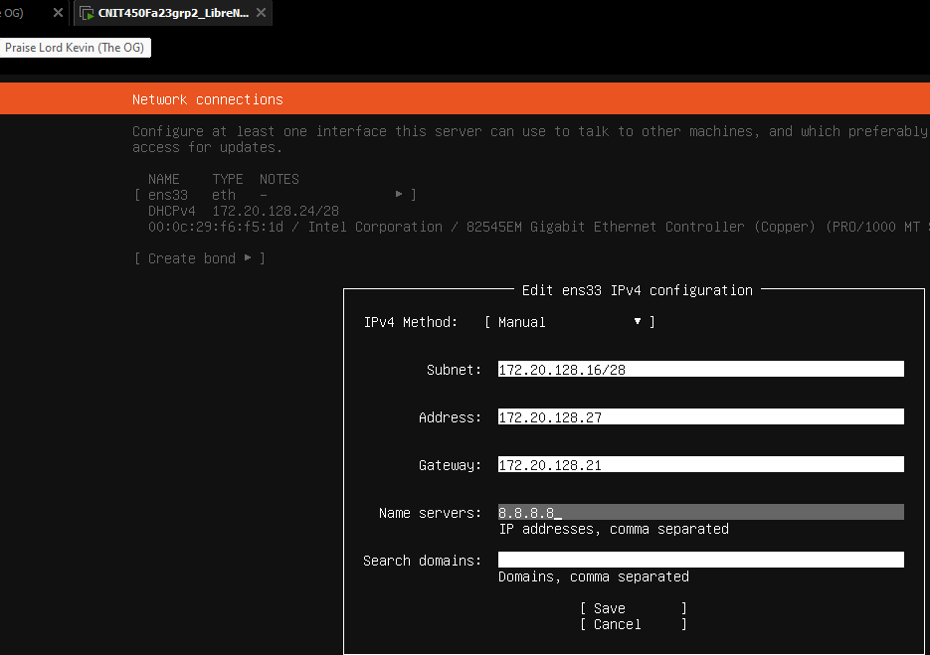

* 1. Select done to continue

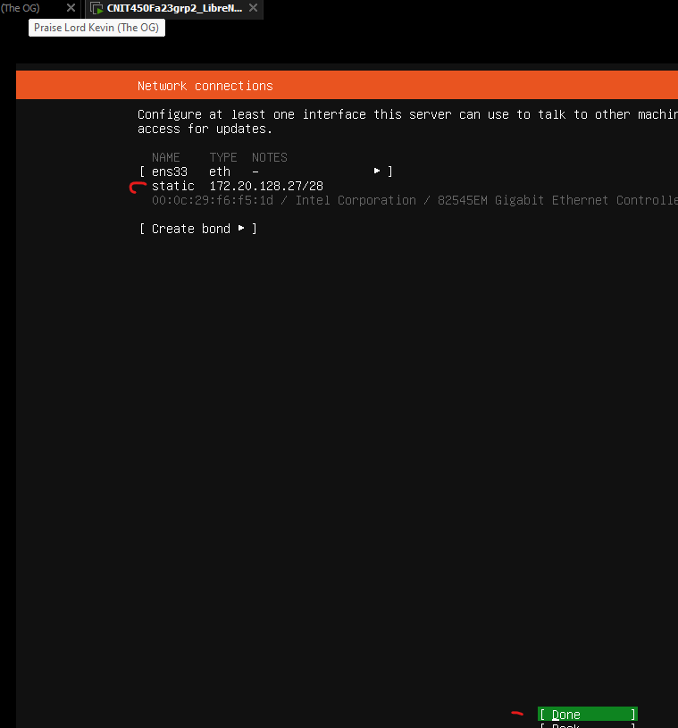

1. If it asks if you require a proxy address, don’t enter anything and **continue**

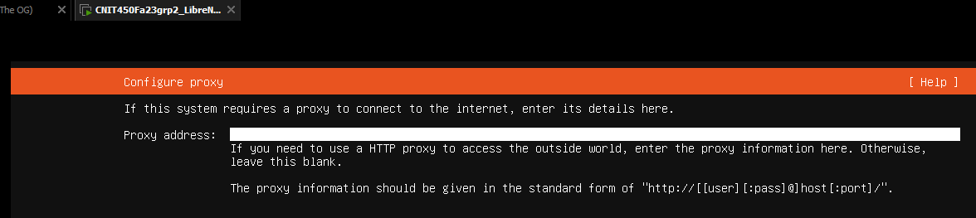

1. If it asks to configure and archive mirror, leave the default and **continue**

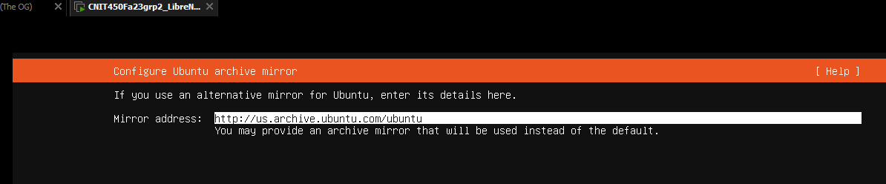

1. When asked to configure a guided storage layout, leave the defaults and **continue**

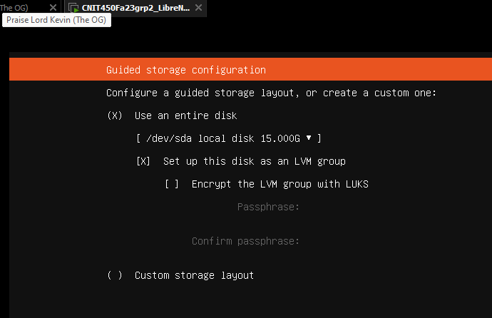

1. Select D**one** to confirm the file system summary

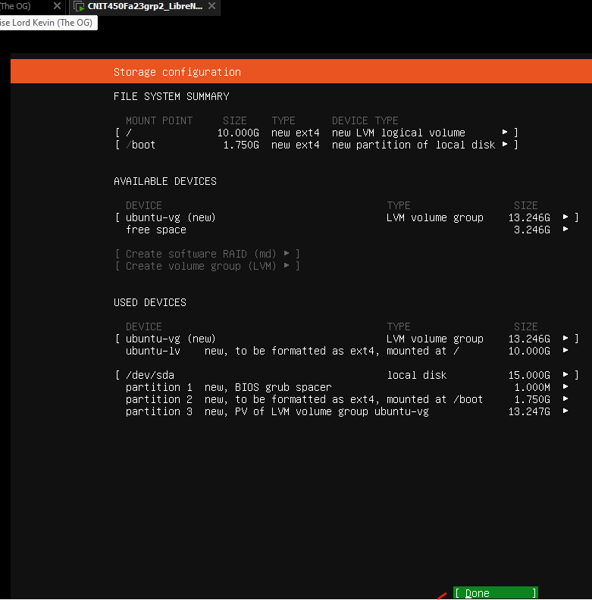

1. Confirm the action of formatting the disks by selecting **Continue**

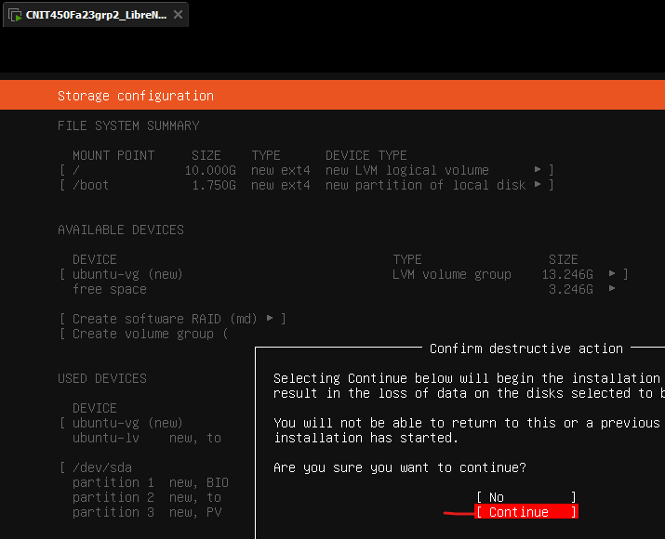

1. Enter the following profile details. The username and password can be the same as created earlier.
2. Your Name: **CNIT450Fa23grp2_LibreNMS**
3. Your Server’s Name: **cnit450fa23grp2_librenms**
4. Username: **ubuntulibre**
5. Password: **CNIT450grp2**

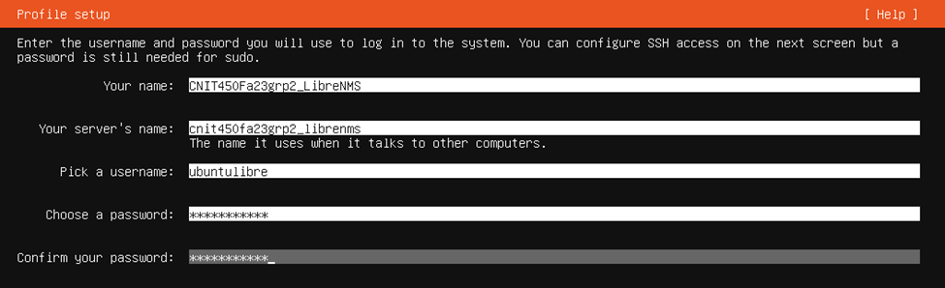

1. **Install OpenSSH** server to allow for secure remote access, do not import an SSH Identity

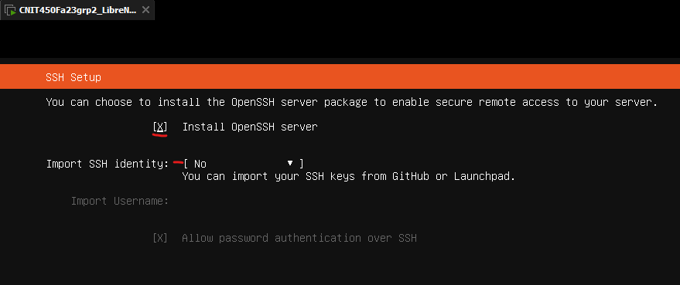

1. **Ignore** installing popular snaps and keep none selected before **continuing**

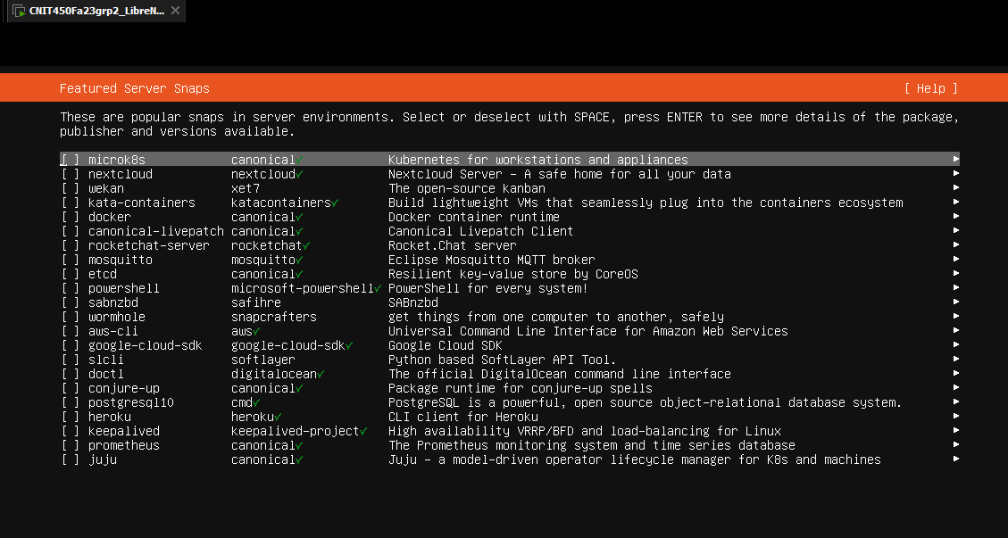

1. Wait until the server is done updating and installing. The bottom text says “**reboot now**” instead of “cancel update and restart” when finished.

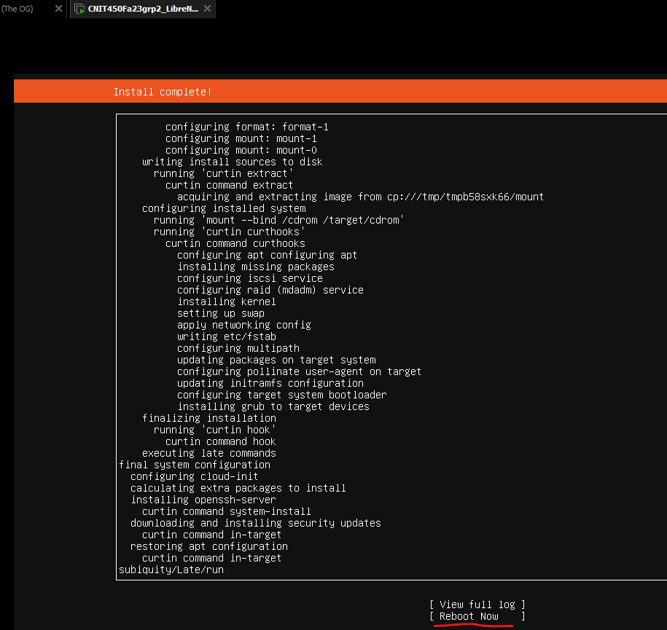

1. Once the server reboots, login with the created ubuntulibre user’s credentials. You may need to hit enter to prompt the login.

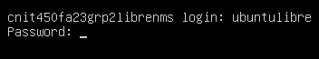

1. Confirm addressing by using the “**ip a**” command

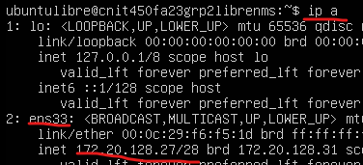

1. Attempt to ping google.com to confirm connection to internet

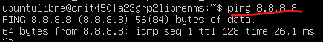

1. Run the command “**sudo apt update && sudo apt upgrade -y**”. If prompted for a password due to using sudo, enter your password.



* 1. If there are errors in resolving such as in the photo below, the fix is to type “s**udo nano /etc/resolv.conf**” and change the name server address to **8.8.8.8**. These errors may crop up multiple times if the nameserver 8.8.8.8 was not specified on installation







1. One it is done updating and upgrading, the initial server installation for LibreNMS is complete. Next up, LibreNMS Installation and configuration
2. Taking a snapshot of your VM is recommended at this time to prevent loss of data. It also allows for a simple way to revert to the server install if needed.
3. Type the below commands one at a time to prepare your machine to download LibreNMS. Do not paste them as chunks. It is okay if the first 2 commands after becoming root have no effect and say they are already installed.
   1. **sudo su** (enter password if prompted)
   2. **apt install software-properties-common**
   3. **add-apt-repository universe**
   4. **add-apt-repository ppa:ondrej/php** (press enter when prompted)

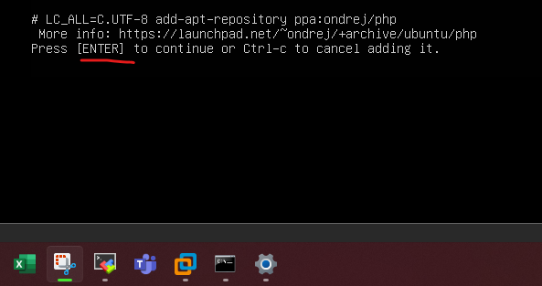

* 1. **apt update**
  2. **apt install acl curl fping git graphviz imagemagick mariadb-client mariadb-server mtr-tiny nginx-full nmap php-cli php-curl php-fpm php-gd php-gmp php-json php-mbstring php-mysql php-snmp php-xml php-zip rrdtool snmp snmpd unzip python3-pymysql python3-dotenv python3-redis python3-setuptools python3-systemd python3-pip whois -y**
     1. If this command doesn’t work, attempt to type it manually (trust me, sometimes when word files are saved the – symbol gets modified)



1. Add a librenms user to the system with the command “**useradd librenms -d /opt/librenms -M -r -s "$(which bash)"** ”



1. Add a password to the librenms user account using “**passwd librenms**”. In this instance the password will be CNIT450grp2.

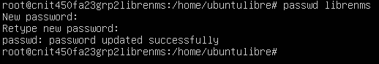

1. Download LibreNMS from the github repository with the below commands.
2. **cd /opt**
3. **git clone** [**https://github.com/librenms/librenms.git**](https://github.com/librenms/librenms.git)



1. Set permissions. Enter the commands one at a time, do not paste as a bunch.
2. **set permissions**
3. **chown -R librenms:librenms /opt/librenms**
4. **chmod 771 /opt/librenms**
5. **setfacl -d -m g::rwx /opt/librenms/rrd /opt/librenms/logs /opt/librenms/bootstrap/cache/ /opt/librenms/storage/**
6. **setfacl -R -m g::rwx /opt/librenms/rrd /opt/librenms/logs /opt/librenms/bootstrap/cache/ /opt/librenms/storage/**

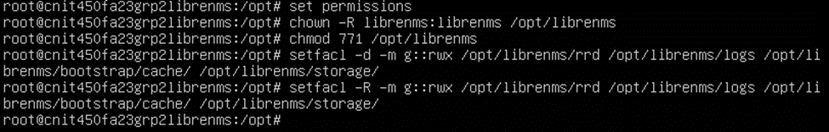

1. Install php dependencies by entering the following commands.
2. **su - librenms**
3. **./scripts/composer_wrapper.php install --no-dev**



1. **exit** (to log out of librenms user)
2. Configure the time zone in the below files to “**America/Chicago**”. To find the text more easily, type ctl+w when in the text editor and enter “date.timezone”.
3. Type “**nano /etc/php/8.2/fpm/php.ini**” to edit the first file required.

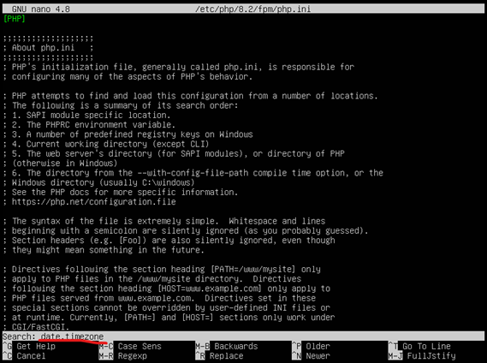

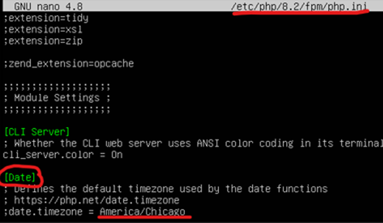

1. Type “**nano /etc/php/8.2/cli/php.ini**” to edit the second file required.

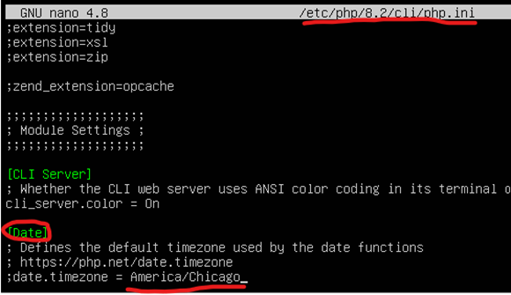

1. Type “**timedatectl set-timezone Etc/UTC**” into the command line



1. Configure MariaDB with the following changes and commands.
2. Type “**nano /etc/mysql/mariadb.conf.d/50-server.cnf**” in the terminal to edit the configuration



1. Under [mysqld], type the below lines
   * 1. **innodb_file_per_table=1**
     2. **lower_case_table_names=0**

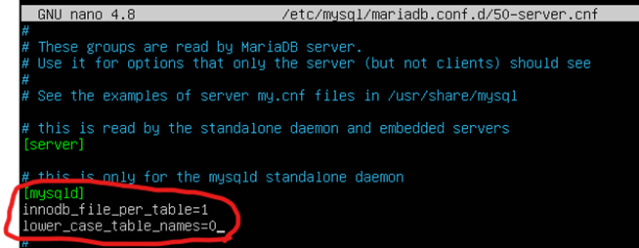

1. Enable MariaDB and ensure it is running by entering the below commands into the terminal
2. **systemctl enable mariadb**
3. **systemctl restart mariadb**
4. **systemctl status mariadb** (you may need to hit ctl+c twice to exit the status view)

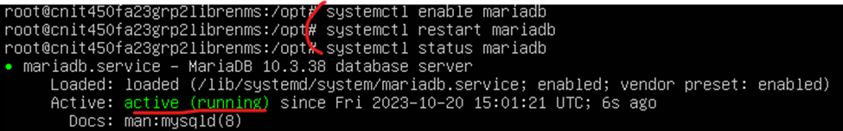

1. Start the MariaDB client with the below commands to create a database user called **librenms** with a password of **CNIT450grp2**. Take note of the password for later.
2. **mysql -u root**
3. **CREATE DATABASE librenms CHARACTER SET utf8mb4 COLLATE utf8mb4_unicode_ci;**
4. **CREATE USER 'librenms'@'localhost' IDENTIFIED BY 'CNIT450grp2';**
5. **GRANT ALL PRIVILEGES ON librenms.* TO 'librenms'@'localhost';**
6. **exit**

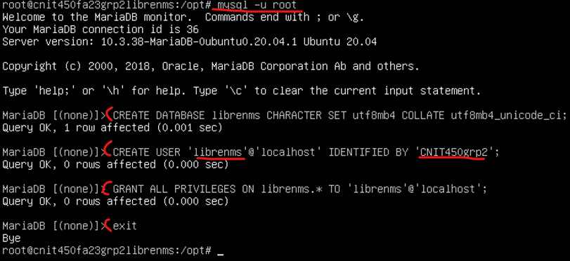

1. Configure PHP-FPM
2. Type “**cp /etc/php/8.2/fpm/pool.d/www.conf /etc/php/8.2/fpm/pool.d/librenms.conf**”



1. Type “**nano /etc/php/8.2/fpm/pool.d/librenms.conf**”
2. Change “[www]” to “**[librenms]**”
3. Change **user** and **group** values both to “**librenms**”

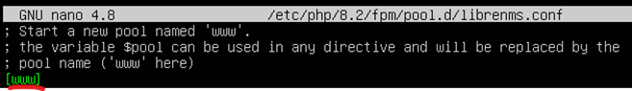

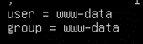

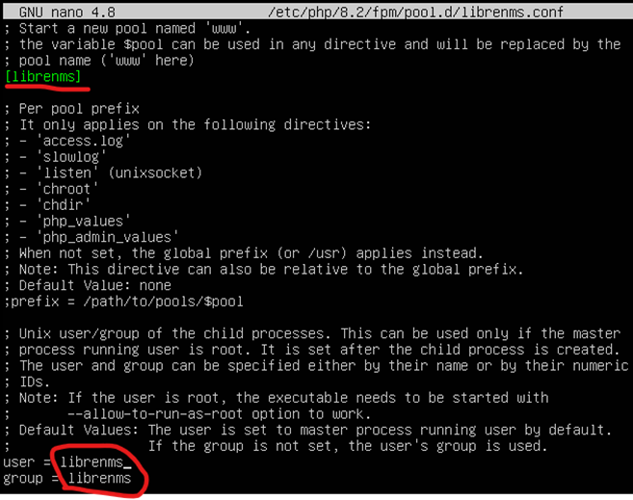

1. Scroll down and change the listen value to “**/run/php-fpm-librenms.sock**”

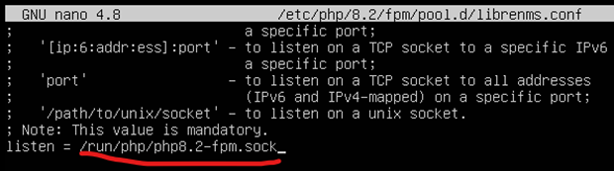

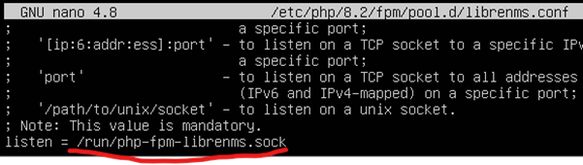

1. Configure the web server so that you can configure and finish setup using a GUI at address **172.20.128.27**
2. Enter “**nano /etc/nginx/conf.d/librenms.conf**”



1. Paste in the below configuration. If needed, you can paste into VMs using VMware Workstation by clicking **Edit > Paste.**

**server {**

**listen 80;**

**server_name 172.20.128.27;**

**root /opt/librenms/html;**

**index index.php;**

**charset utf-8;**

**gzip on;**

**gzip_types text/css application/javascript text/javascript application/x-javascript image/svg+xml text/plain text/xsd text/xsl text/xml image/x-icon;**

**location / {**

**try_files $uri $uri/ /index.php?$query_string;**

**}**

**location ~ [^/]\.php(/|$) {**

**fastcgi_pass unix:/run/php-fpm-librenms.sock;**

**fastcgi_split_path_info ^(.+\.php)(/.+)$;**

**include fastcgi.conf;**

**}**

**location ~ /\.(?!well-known).* {**

**deny all;**

**}**

**}**

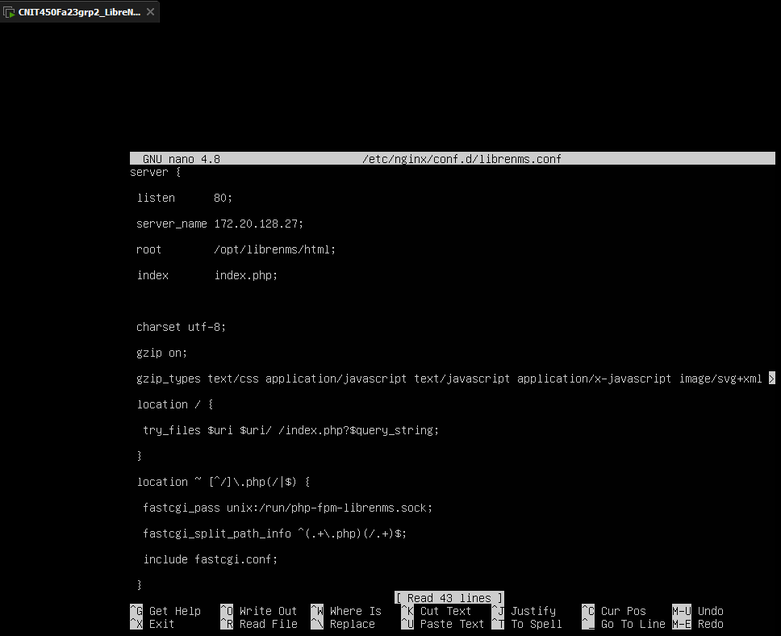

1. Remove the nginx default site, and restart nginx and php with the below commands
2. **rm /etc/nginx/sites-enabled/default**



1. **systemctl restart nginx**
2. **systemctl restart php8.2-fpm**
3. **Confirm the services are running**
4. **systemctl status nginx**
5. **systemctl status php8.2-fpm**

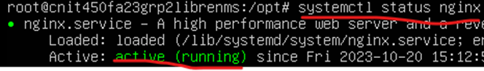

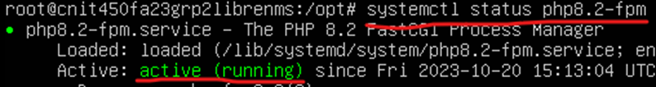

1. Enable lnms command completion (Essentially tab completion) with the below commands
2. **ln -s /opt/librenms/lnms /usr/bin/lnms**
3. **cp /opt/librenms/misc/lnms-completion.bash /etc/bash_completion.d/**



1. Configure snmpd by following the commands below
2. **cp /opt/librenms/snmpd.conf.example /etc/snmp/snmpd.conf**



1. **nano /etc/snmp/snmpd.conf**



1. Edit text that says "RANDOMSTRINGGOESHERE" and set own community string, for this example we will be using **CNIT450Fa23grp2String**

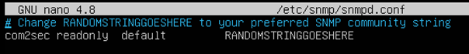

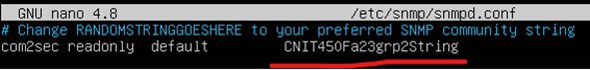

1. **curl -o /usr/bin/distro** [**https://raw.githubusercontent.com/librenms/librenms-agent/master/snmp/distro**](https://raw.githubusercontent.com/librenms/librenms-agent/master/snmp/distro)
2. **chmod +x /usr/bin/distro**
3. **systemctl enable snmpd**
4. **systemctl restart snmpd**

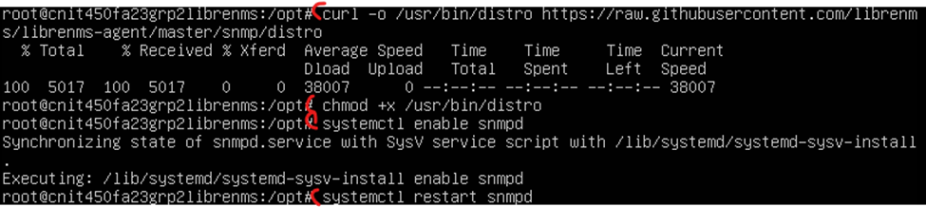

1. **systemctl status snmpd**

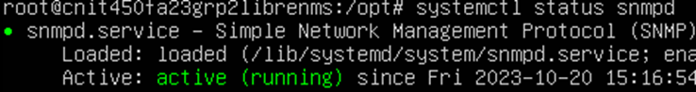

1. Configure a Cron job by following the below command
2. **cp /opt/librenms/dist/librenms.cron /etc/cron.d/librenms**



1. Enable the scheduler using the below commands
2. **cp /opt/librenms/dist/librenms-scheduler.service /opt/librenms/dist/librenms-scheduler.timer /etc/systemd/system/**
3. **systemctl enable librenms-scheduler.timer**
4. **systemctl start librenms-scheduler.timer**

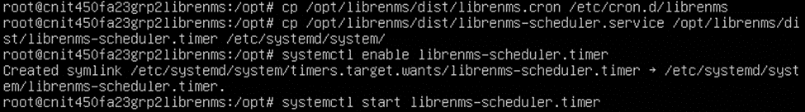

1. Copy the logrotate config to rotate out old logs.
2. **cp /opt/librenms/misc/librenms.logrotate /etc/logrotate.d/librenms**



1. Connect to the libreNMS web GUI by typing in the address associated with the server in a browser search bar on your host device. In this case the address we’ve associated with LibreNMS in the server config was 172.20.128.27.
2. If you cannot reach the server, or ping the address from your host computer, check your host device’s IP and search for your virtual network adapter.

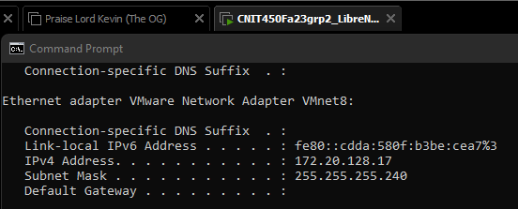

1. If the address is of the 169.X.X.X variety, confirm your DHCP is enabled on your virtual network and attempt to release and renew your VMWare virtual interface IP address on your host device

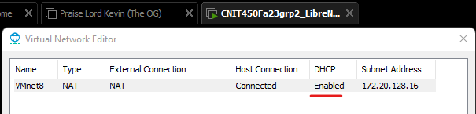

1. Otherwise, if that doesn’t work, confirm you’ve entered your addressing correctly in the ubuntu server and your virtual network settings.
2. If you can reach the server, it should look like the below image.
3. If all of the preinstall checks show green checks, click the second bubble which is dark blue in the below image.
4. If one of the items does not have a green check mark, troubleshoot, and try re-typing related commands.

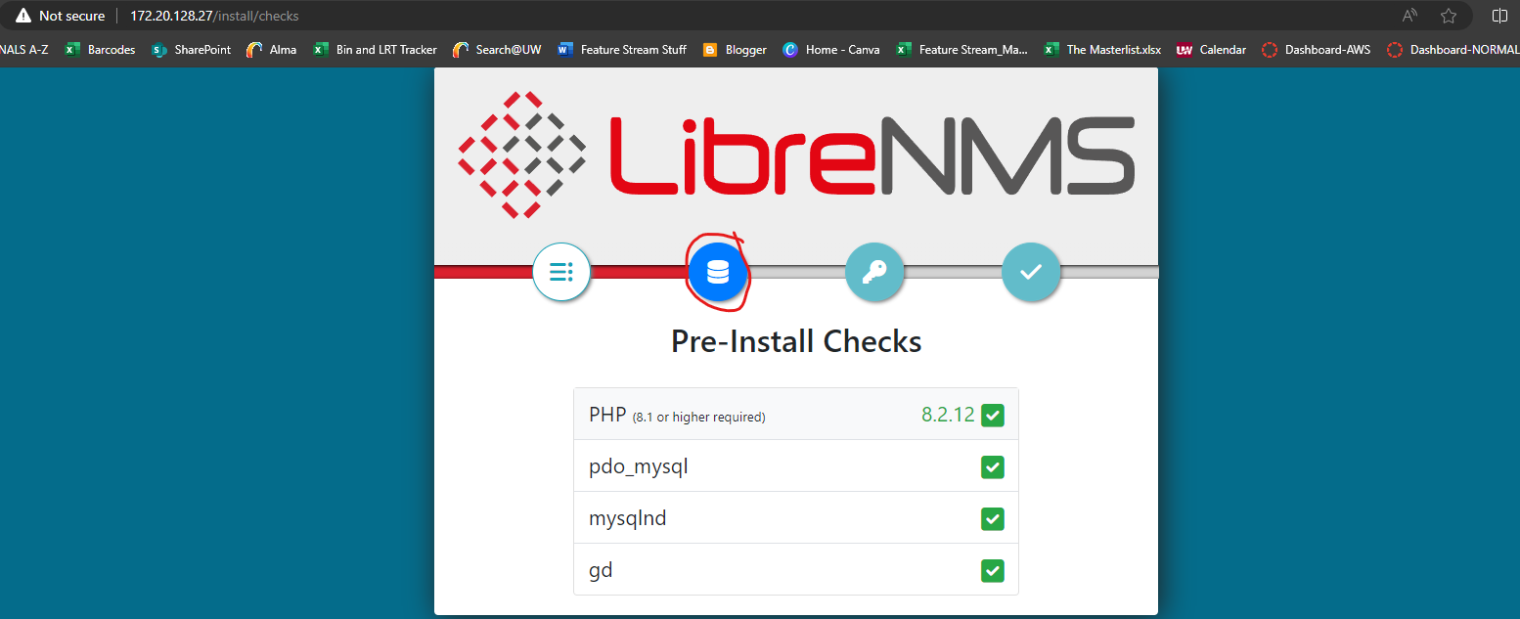

1. Enter the database username and password created earlier, then click “**Check Credentials”**.

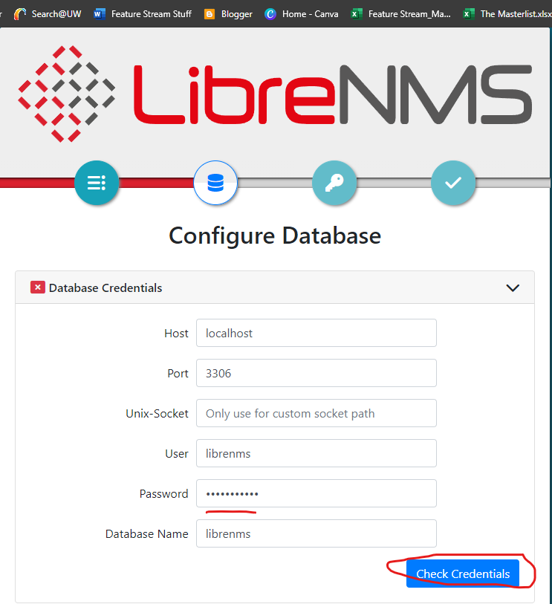

1. Once credentials have been confirmed, proceed to build the database by clicking the blue button labeled “**Build Database**”

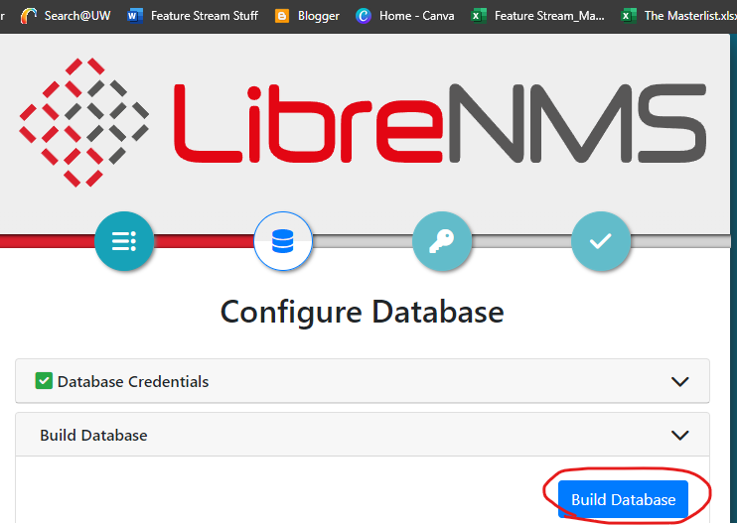

1. Once database credentials are checked and the database itself has been built, proceed to the next bubble

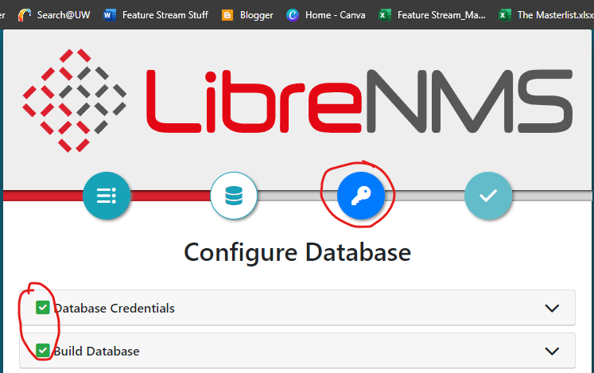

1. Create a LibreNMS admin account. For this example, use the below. This is not too important to be a good username and password, as we will be changing the authentication to be using Active Directory soon. Once the information is entered click “**Add User**”
2. Username: **LibreAdmin**
3. Password: **CNIT450grp2**
4. Email: [**LibreAdmin@cnit450fa23grp2.com**](mailto:LibreAdmin@cnit450fa23grp2.com)

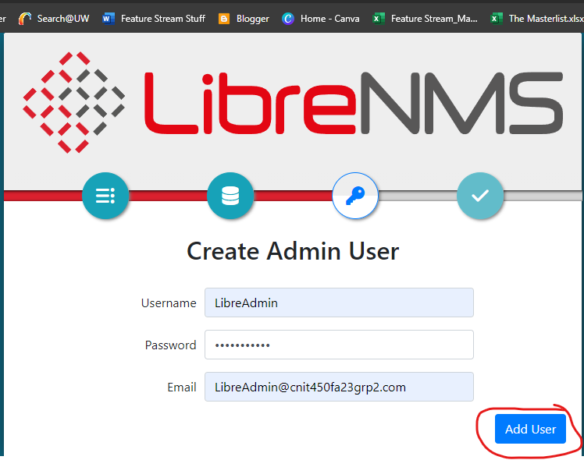

1. You should see that the admin user has been created. Proceed to the last bubble and confirm the installation.

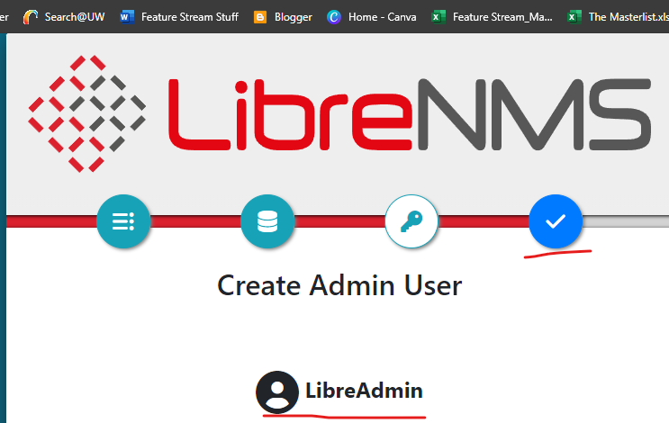

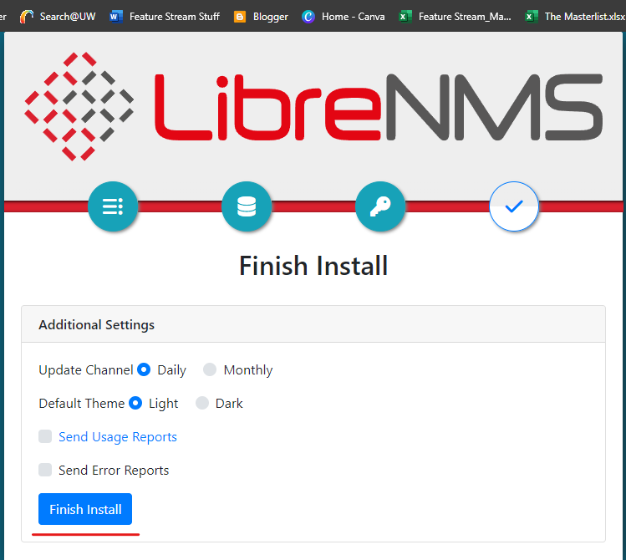

1. Click “**Validate install**” when it pops up. This should take you to a login page, which you can access using your created admin credentials.

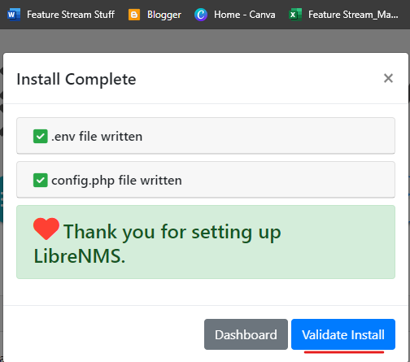

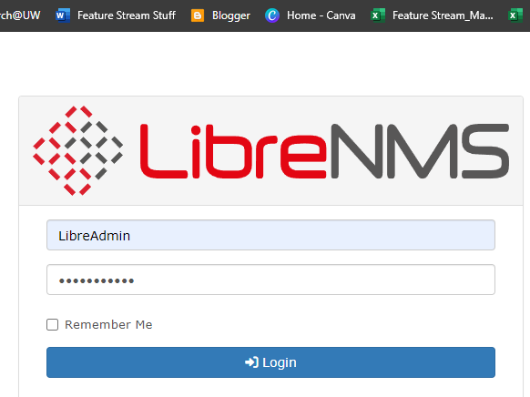

1. Browse through some of the validation checks. If something has failed it may provide a method to fix it. Wait a few minutes and try validating the install again, as some items may just not have finished loading yet.
2. One such example is with the **scheduler** tab, wait a few minutes and validate once again and it may show as OK

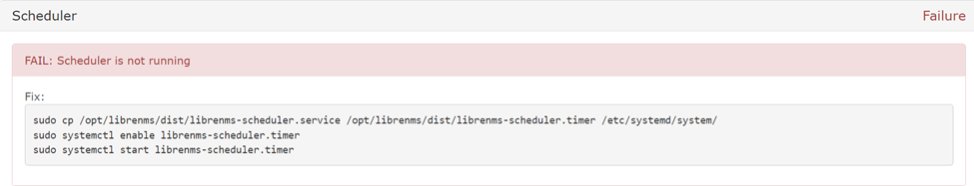

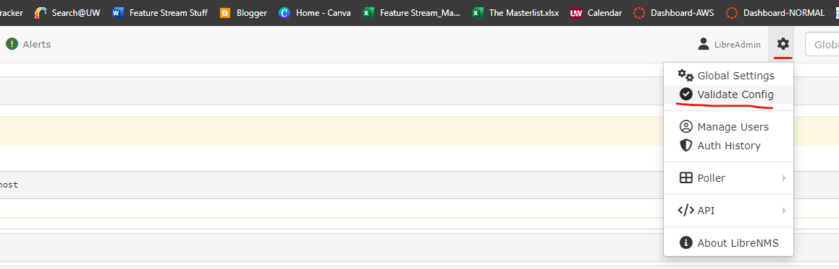

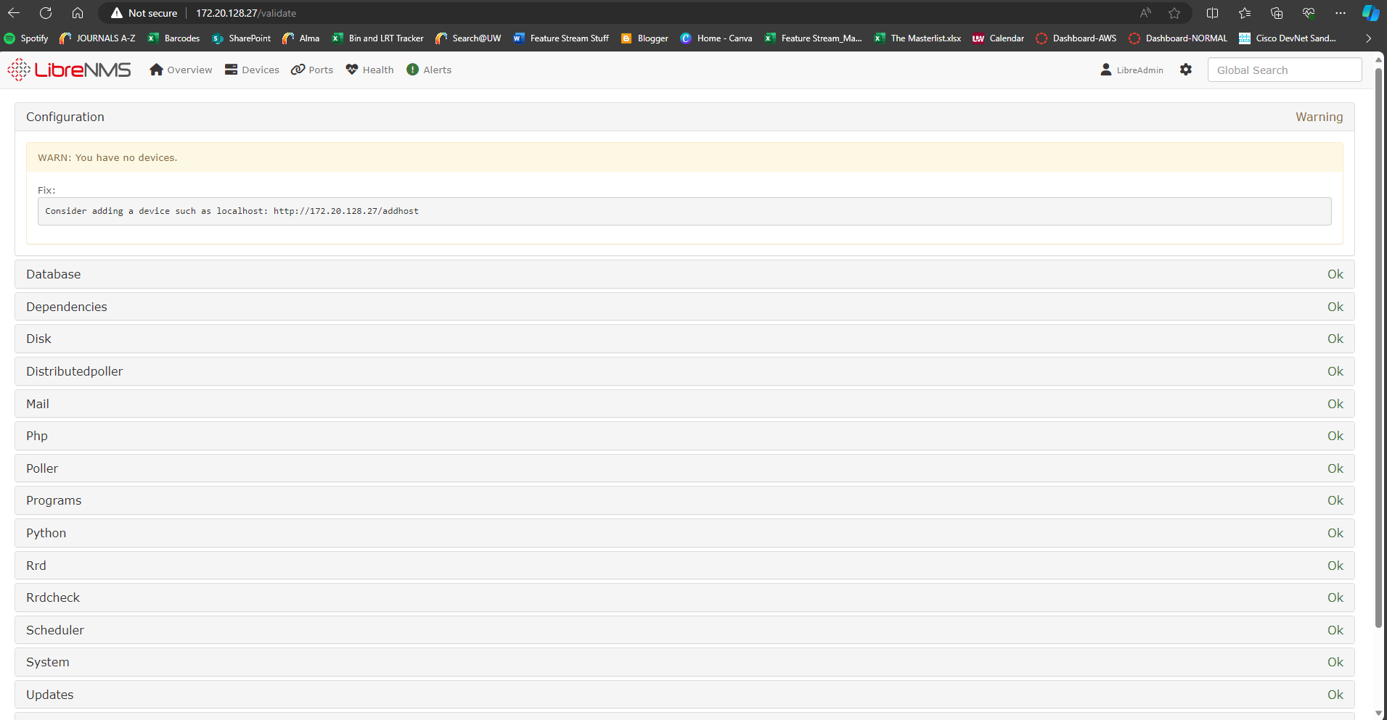

1. It is recommended to create a snapshot of the VM at this time
2. Next, now that the initial installation has been complete, we will integrate the server with Active Directory and begin configuration of the server

In order to integrate with Active Directory, a connection to the lab network must be available to use, and active directory must be reachable from the lab network. Do not connect into the lab network yet. **When asked during instructions:** connect an ethernet adapter into your laptop and if DHCP is not available modify its settings to have a static IP in the Users VLAN in any of the connected sites. For this example, we will be using the MSP site with our adapter connected to a switchport in VLAN 340, the Users VLAN in MSP. The address will be 172.20.134.55, its subnet mask will be 255.255.255.0, its gateway will be 172.20.134.11.

In Active Directory, a **LibreAdmins** and a **LibreUsers** user group **must** be created in Active Directory to assign users to. Reference Active Directory documentation to do this.

A bind user must also be created in Active Directory with the first name of **Bind**, last name of **User**, logon of **binduser,** and password of **CNIT450Fa23grp2!**. Its password must not be set to change at the next login. The password must not be able to expire. Reference Active Directory documentation to do this. **This account is also used for the bind user in Citadel and Asterisk, if this step has already been completed, there is no need to complete it again.**

1. To configure Active Directory as the authentication method for LibreNMS; first, php8.2-ldap needs be installed onto the ubuntu server.
   1. Type “**apt install php8.2-ldap**” with root permissions

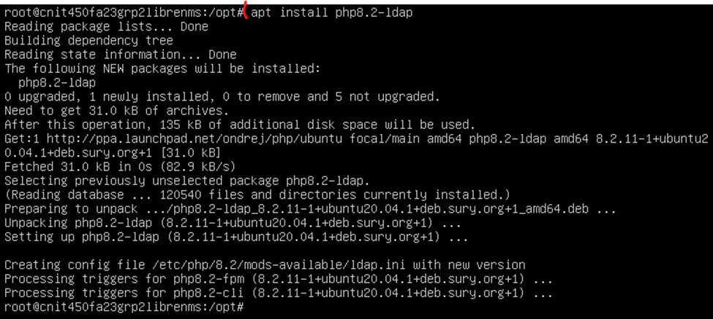

1. To configure LibreNMS to use Active Directory, enter the commands below as the librenms user in the terminal. We will not switch authentication methods yet so changes can still be made in the GUI as admin. There are several non-secure options chosen for the configuration, this is for simplicity of use and should not be replicated in a production environment.
2. **su librenms**
3. **lnms config:set auth_ad_check_certificates 0**
4. **lnms config:set auth_ad_url "ldap://172.20.0.24 ldap://172.20.0.25"**
5. **lnms config:set auth_ad_domain CNIT450Fa23grp2**
6. **lnms config:set auth_ad_base_dn dc=CNIT450Fa23grp2,dc=com**
7. **lnms config:set auth_ad_binduser binduser**
8. **lnms config:set auth_ad_bindpassword CNIT450Fa23grp2!**
9. **lnms config:set auth_ad_require_groupmembership true**

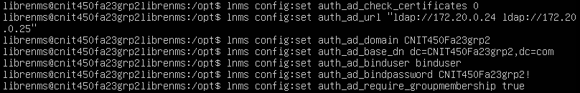

1. Switch back to libreNMS on your browser and head to **Global Settings > Authentication > Active Directory**. You should see your changes have been made, you may need to refresh the page.

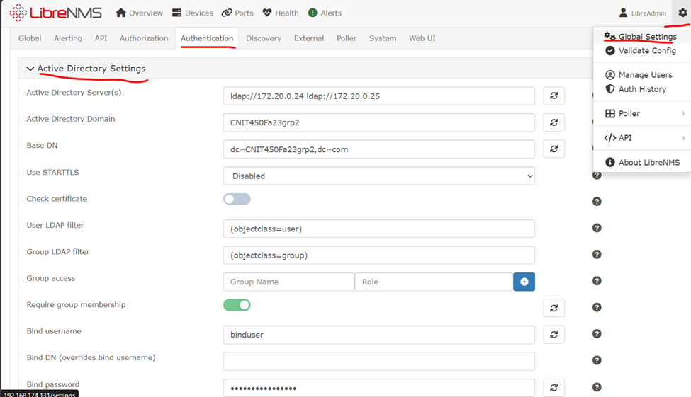

1. Edit group access to create a **LibreAdmins** group and a **LibreUsers** group based on the two groups created in Active Directory. The blue plus mark **must** be clicked after details are entered to confirm the groups.

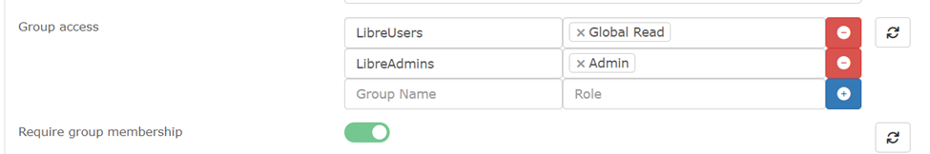

1. Place a user into the LibreAdmins group in Active Directory.
2. Instructions will not be shown, reference Active Directory documentation.
3. Connect your laptop to the lab network with an ethernet adapter and modify it as instructed in the requirements. In addition:
4. Disconnect your laptop from Wi-Fi
5. Ensure the port the laptop is plugged into is configured to use the right VLAN and isn’t administratively shut down
6. Ping one of the Active Directory server IPs to ensure connectivity. If you cannot ping, try the earlier steps mentioned in the requirements, shut off Wi-Fi, and troubleshoot connectivity between sites.

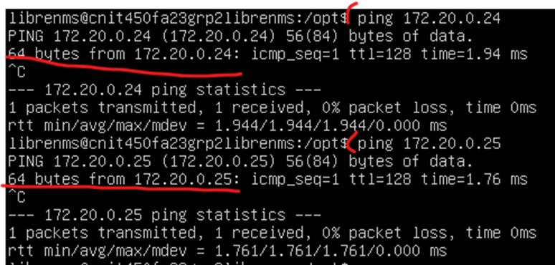

1. Enter the below command to confirm authentication moving from mysql to AD
2. **lnms config:set auth_mechanism active_directory**



1. IN THE EVENT you are unable to authenticate with Active Directory due to misconfiguration, or you had misconfigured the group names in LibreNMS, the below command should revert the authentication method and allow the old admin account to be used to fix whatever problems that have been created
   * 1. lnms config:set auth_mechanism mysql
2. Log out and log into the user account placed under the LibreAdmins Active Directory group to test that active directory settings worked.
3. If this does not work, ensure the LibreAdmins group has been created, the user moved into it, and if needed return to mysql authentication and ensure the user groups have been created

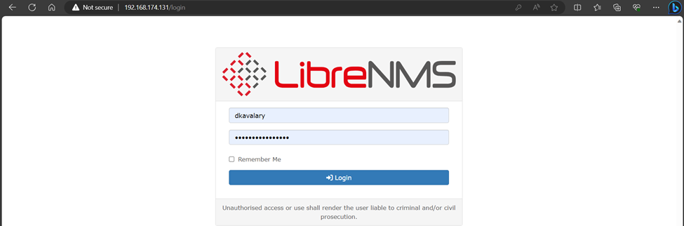

1. The user in the LibreAdmins group has properly been given admin permissions looking at the **Global Settings** tab.

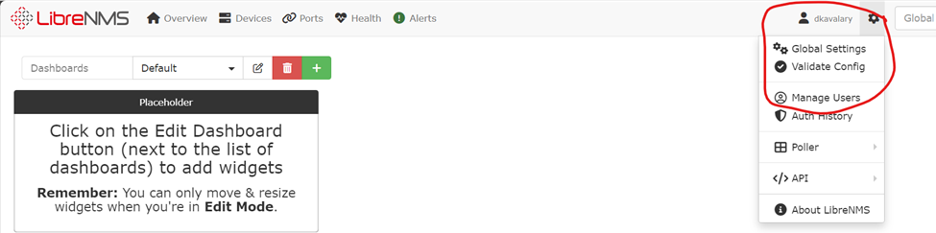

1. Remove the user from the **LibreAdmins** group and move them into the **LibreUsers** group. Log out and log in again and the permissions should now restrict the user to global-read only permissions.

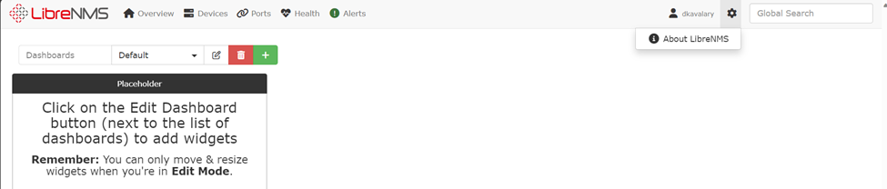

1. Move the user back into LibreAdmins to continue configuration
2. The LibreAdmin user is currently still available if LibreNMS is switched to use mySQL authentication. Go to **Settings > Manage Users**

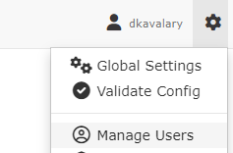

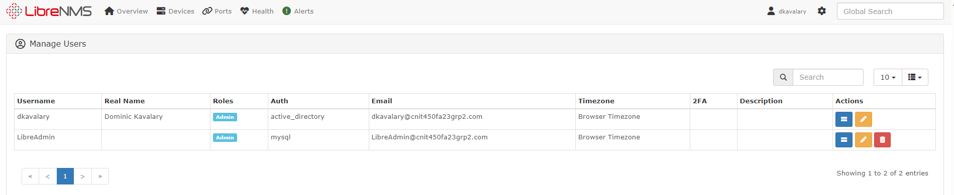

1. From this screen, the LibreAdmin user, and other users if needed, can be deleted or have their access to LibreNMS restricted.
2. It’s recommended a snapshot is created at this moment, as LibreNMS is installed and properly integrated with Active Directory. We will begin to export it and import it into ESXI Next.
3. Shut down the LibreNMS Ubuntu Server VM using the “**shutdown now**” command
4. Once the machine is powered down, export it to OVF.
   1. In VMWare, go to **File > Export to OVF...**

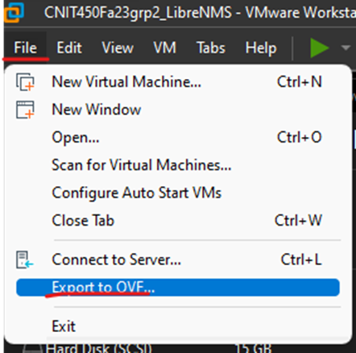

* 1. Make a new folder to store the OVF and save the OVF to it. You may need to click save again once in the folder.

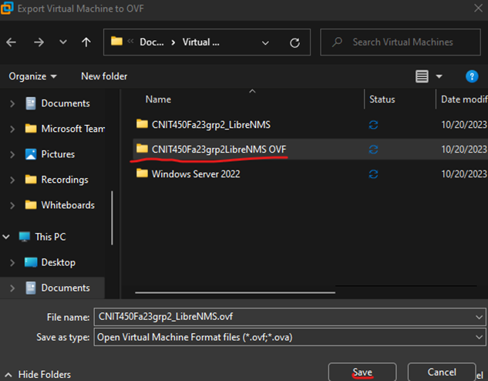

1. Use your network adapter and connect your laptop to the ESXI lab patch ports to reach the server. You will need to change your adapter settings to use **DHCP** instead of the static address from earlier.
2. Enter **10.33.7.103** (MSP ESXI) into your browser to connect to the ESXI server. Enter the ESXI credentials to log in.



1. To prepare to import your VM into ESXI, reference **Appendix B: Server Datastore Allocation** to create a datastore called **CNIT450Fa23grp2_UbuntuServ** with **60 GB** of storage. You should be able to see it under **Storage. This step is also completed during citadel installation. If it already has been completed do not do it again.**



1. Go to **Virtual Machines > Create/ Register VM**

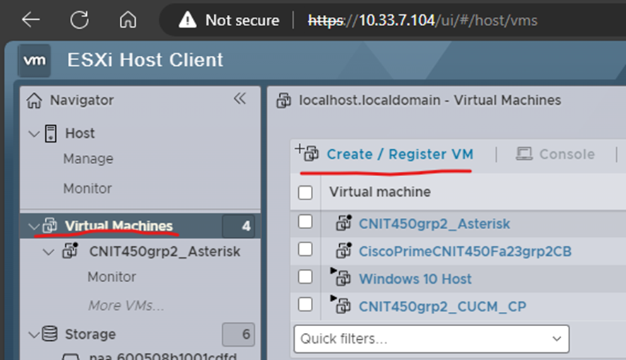

1. For creation type, select **Deploy from an OVF or OVA file**

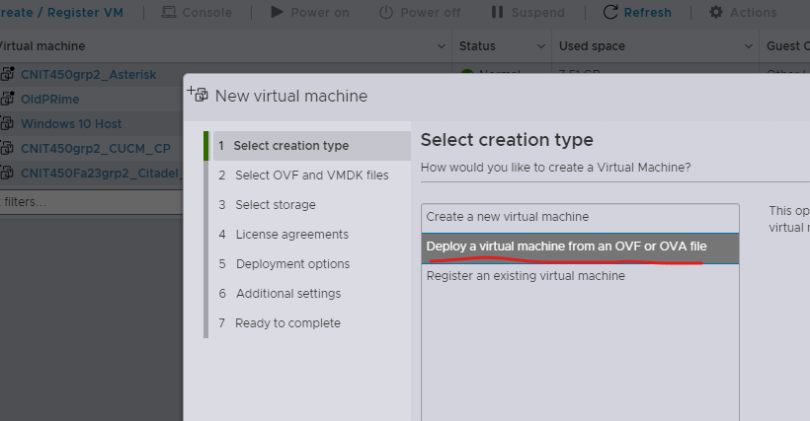

1. Enter a name for the VM, in this instance, **CNIT450Fa23grp2_LibreNMS_KavalaryD**. Next, click the blue box below the name.

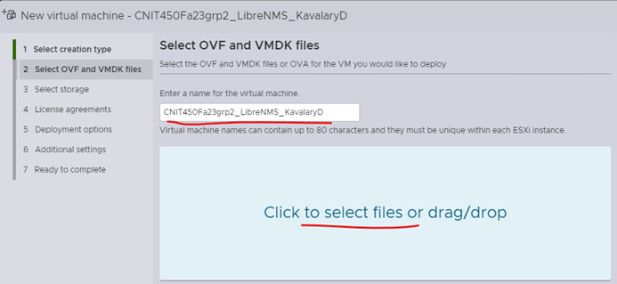

1. Select your OVF, VMDK, and ISO files in the folder you created earlier and upload them. Then click next.

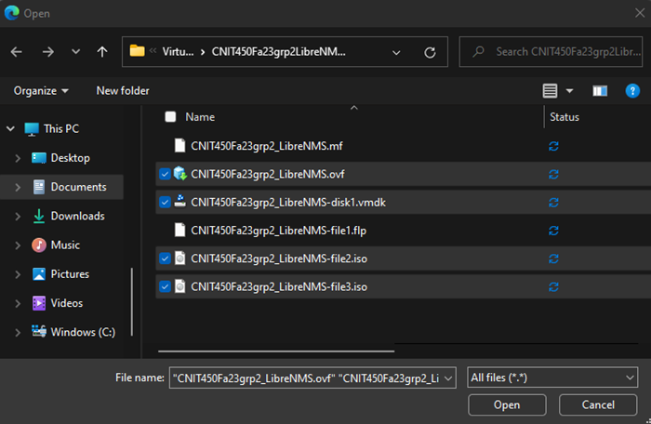

1. Under select storage, select the Datastore created earlier

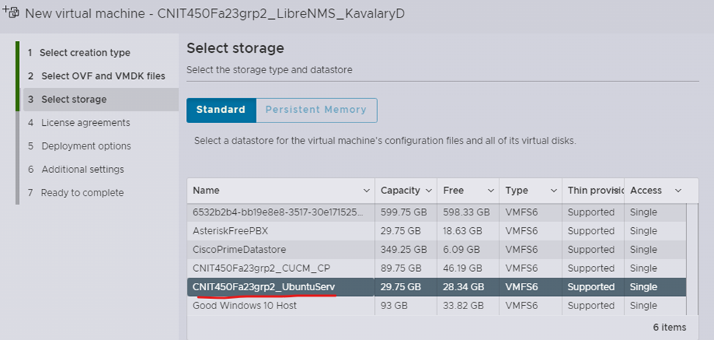

1. Select the **MSP port group** and ensure disk provisioning is set to **thin**

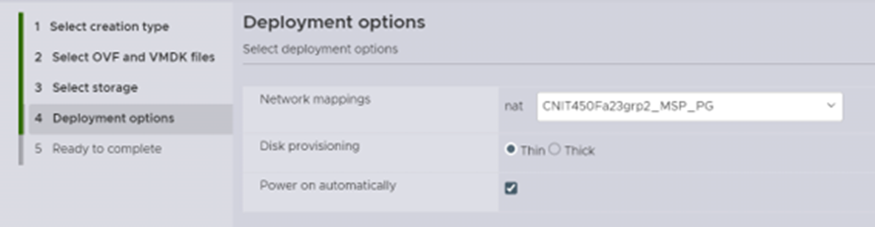

1. You may get an error that a required disk image was missing: Ignore this and click **finish.**

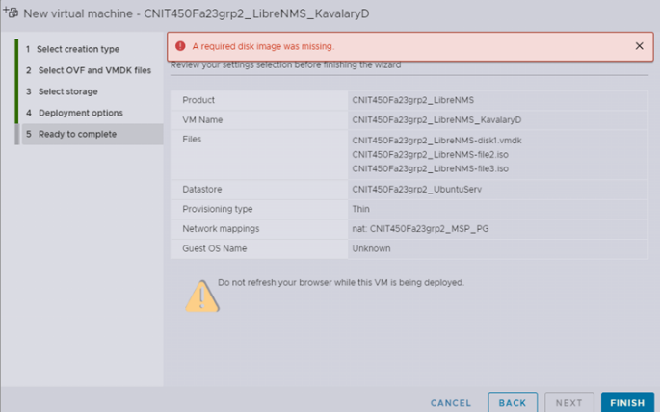

1. Go to **Host > Monitor**

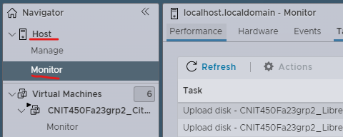

1. Here you will see your files uploading to ESXI. Wait for these to finish.



1. Go back to **Virtual Machines**, and select your VM and click the monitor display to open up the CLI. This should be powered on automatically but if it does not, click the **power on** button in the ribbon.

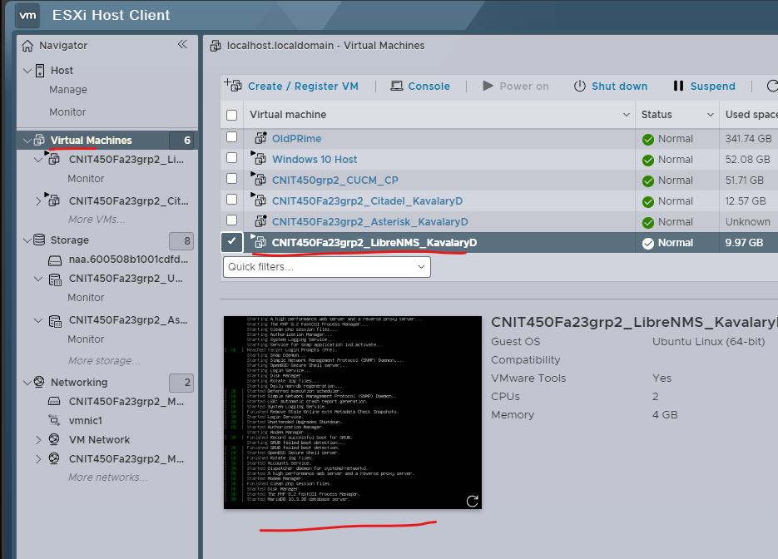

1. Edit the netplan yaml file with **sudo nano** to include both google’s dns server address as well as one of the domain controllers (also acts as dns server for internal resources)
   1. The file is under /etc/netplan

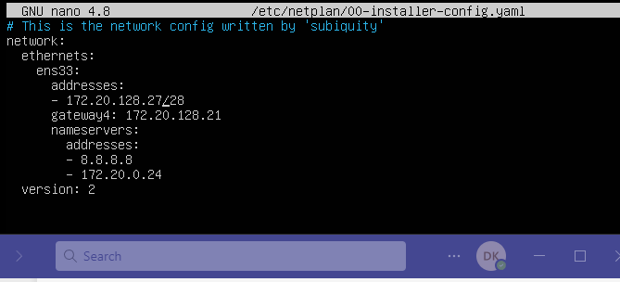

1. Restart nginx and php8.2
   1. **systemctl restart nginx**
   2. **systemctl restart php8.2-fpm**



* 1. Confirm the services are running
     1. **systemctl status nginx**
     2. **systemctl status php8.2-fpm**

1. It’s recommended to take a snapshot of the VM in ESXI

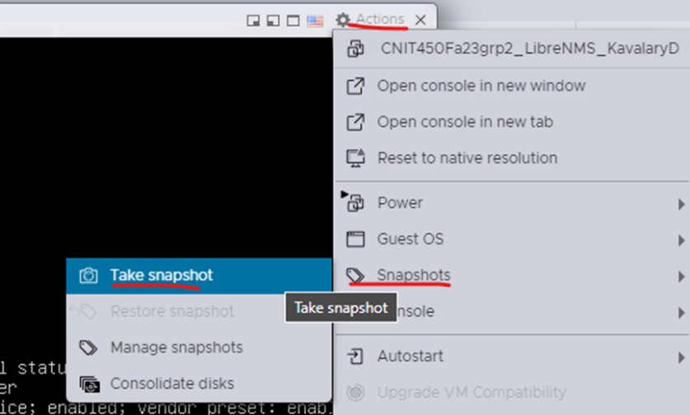

1. Disconnect your laptop from the ESXI patch and plug it back into a port connecting to your lab network through the Users VLAN again, use the same addressing settings mentioned earlier to put your PC on the Users VLAN in MSP.
2. Type **172.20.128.27** into the browser of your laptop to connect to LibreNMS. If this succeeds, then all is well.

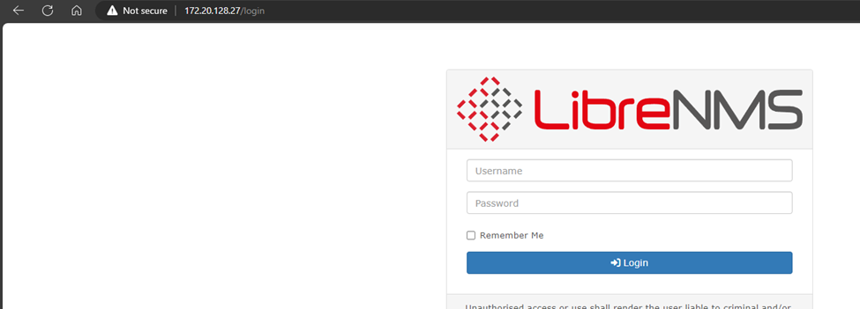

### CONFIGURATION INSTRUCTIONS

Now that the server has been installed and integrated with active directory, we will begin to complete the finishing touches and configure the device monitoring, email alerts, and custom dashboards.

For devices to be added with many details being monitored, they must be configured with an SNMP user. This should have been done for networking devices during the Cisco Prime Setup, but if it has not been done yet, review Prime configuration and apply the user to the devices. For other items such as windows or linux based servers, this differs greatly and will not be covered at length here. Look into how to install SNMP on each type of server if you wish to track a lot of information about those devices.

LibreNMS can gather information with SNMPv1-3, and if you do not wish to gather that much information on the device, it can also be monitored for just reachability using ping. This is done by disabling SNMP when adding a device.

1. In LibreNMS, go to **Devices > Add Device**

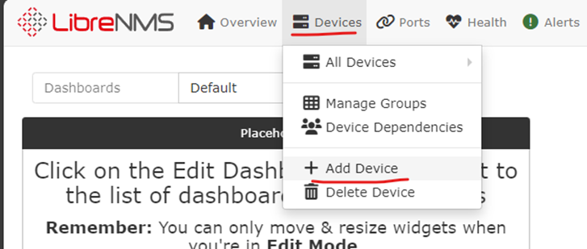

1. Add a network device through IP. Ensure the device has the SNMP configuration on the device before you attempt to add it. Make sure the device is reachable by ping. For this example, we will be using a router with the address of **172.20.192.45.**
   1. The snmp version will be **v3**
   2. The port should be **161** and **udp**
   3. The auth level should be **authPriv**
   4. Auth username is **Prime**
   5. Auth and crypto passwords are **CNIT450grp2**
   6. **SHA** and **AES** options for algorithms

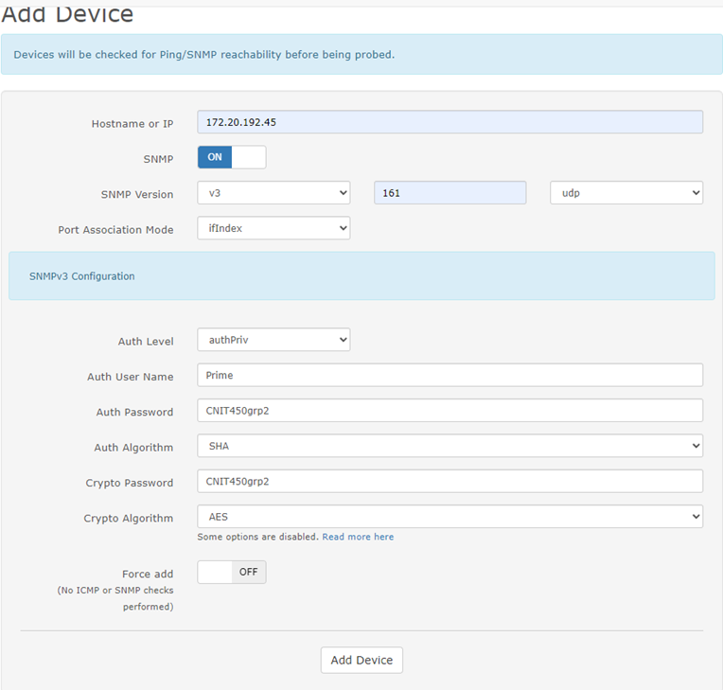

1. Go to **Devices > All Devices > Network** and you will see the added device.

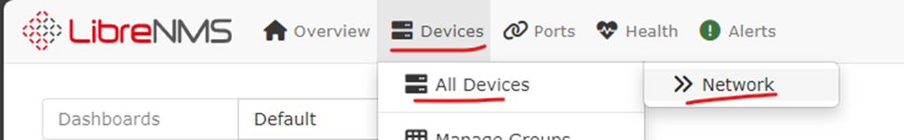

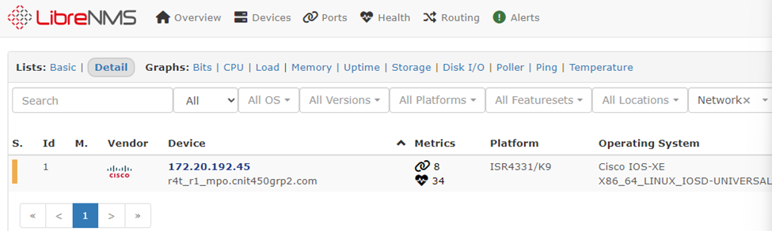

1. Go to the **Edit Device** icon to the right of the device and edit the display name to reflect the actual device’s hostname. Then hit **Save.**



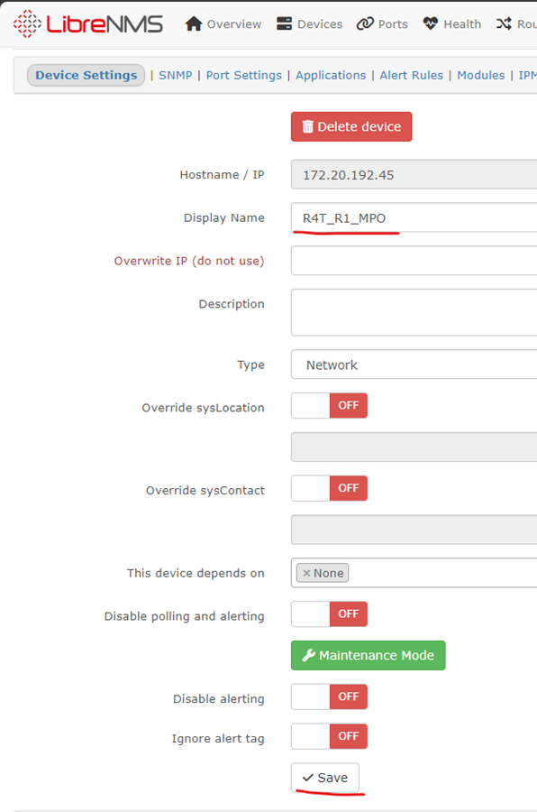

1. To increase the rate at which the device is polled to check its health and status, go to **Global Settings > Poller > RRD Tool**
   1. Change the step value to **60** seconds and the heartbeat value to **120** seconds for minute polling with a 2 minute heartbeat.

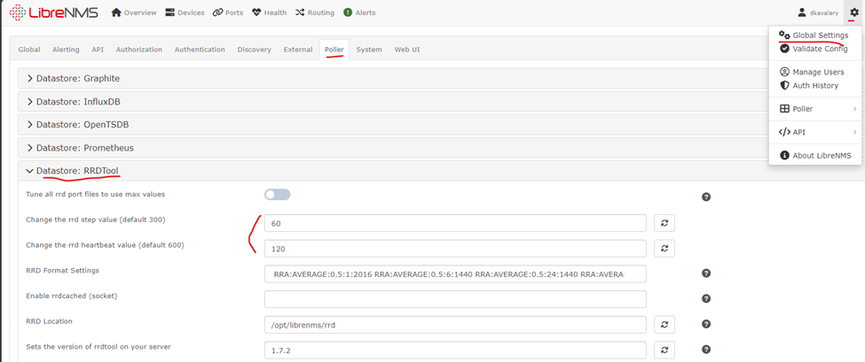

1. To add a device and only track reachability, disable SNMP when adding devices such as the below

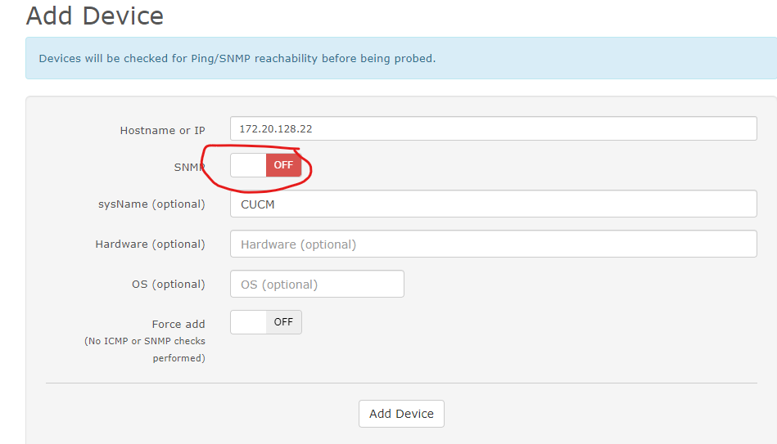

* 1. The device may not show up under devices since the server cannot tell what type of device it is through just ping. If it had been added with an SNMP user it may have been able to. Go to **Devices > Manage Groups**

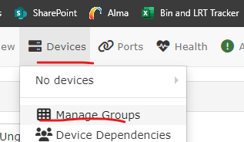

* 1. Go to **View Ungrouped Devices.** This is where ungrouped and unknown devices will typically be stored. You can create a new device group if you do wish to group like devices together for organization

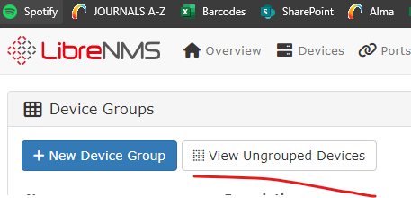

* 1. You should see CUCM appear below as reachable with a good status if you did not add it with SNMP. If it is not a good status it may be a minute or so before the device is polled.

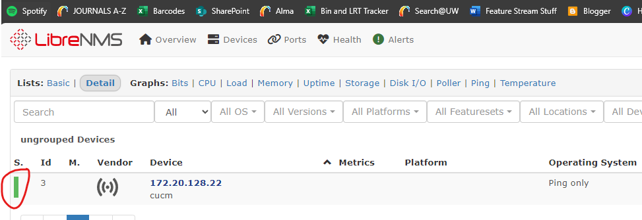

1. We must be able to be notified once a device shuts down unexpectantly. Go to **Global Settings > Alerting > Email Options** to begin to configure email alerts.
   1. Ensure your email settings match the below. **How to deliver mail** must be set to **SMTP** and the server address in this instance is the address of the Citadel email server setup in another part of the paper, though this can be any email other server you control. The SMTP authentication must be turned on and the user to authenticate with can generally be any, in this instance we will use the bind user’s credentials

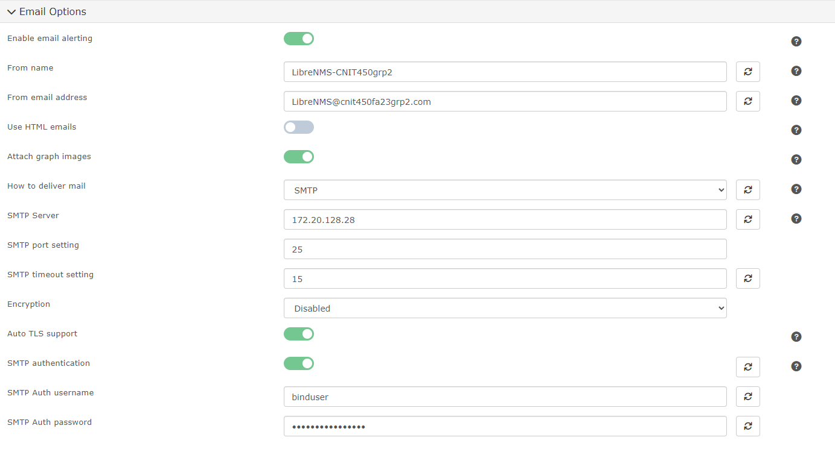

1. Go to **Alerts > Alert Transports.**

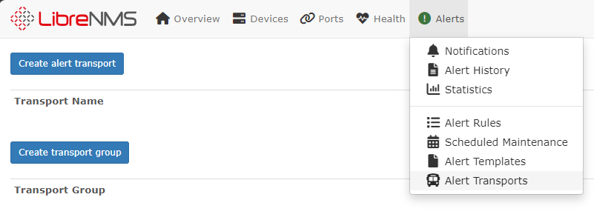

1. Click **Create alert transport.** 
   1. Enter the name of the transport item, we will call it **Admin**.
   2. Add details of a user you want notified when an alert goes off. In this case we will use the email **nathan_hammer@CNIT450Fa23grp2.com**

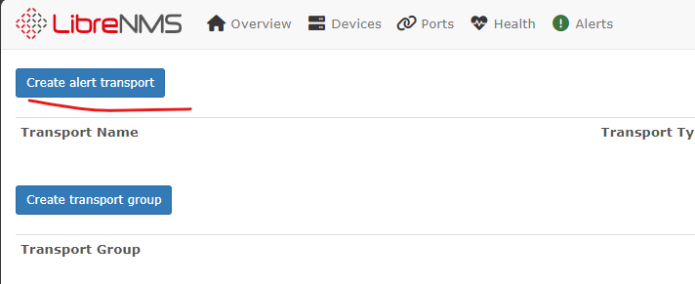

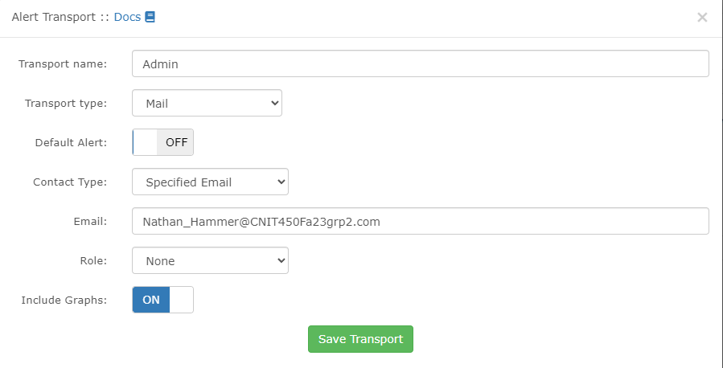

1. Click **Create transport group.** Then, add **Admin** to that group and call it **Admins.** You could make multiple alert transports to different individuals you want notified and group them all together in one transport group.

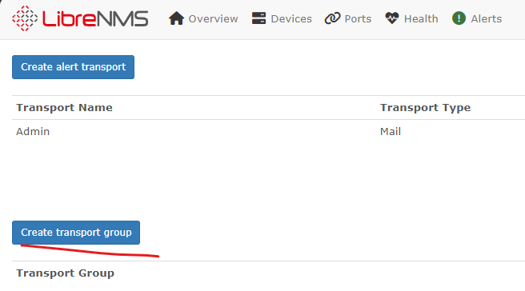

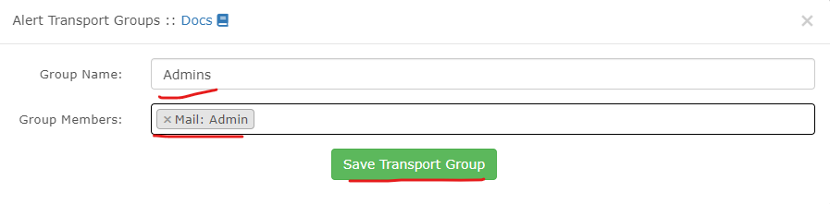

1. Go to  **Alerts > Alert Rules** and click **Create new alert rule**

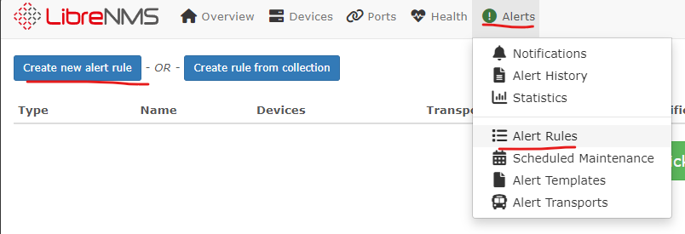

* 1. Call the rule **Devices Up/Down**
  2. Add the rule **macros.device_down equal yes**. This will trigger the alert when it detects that a device has gone down.
  3. Set Max alerts to **3**, delay of **1m**, and an interval of **1m.** This means the alert will take one minute to appear after it detects a device is down, it will alert 3 times in 1 minute intervals unless the device goes up again.
  4. Set transports to the **Admins** group that was created earlier. This will tell the alert to go through that transport group and notify anyone in it via the described method in the alert transports associated with them.
  5. Set Severity to **Critical,** this will make it so that when the alert triggers in librenms it is marked as mor important than warnings

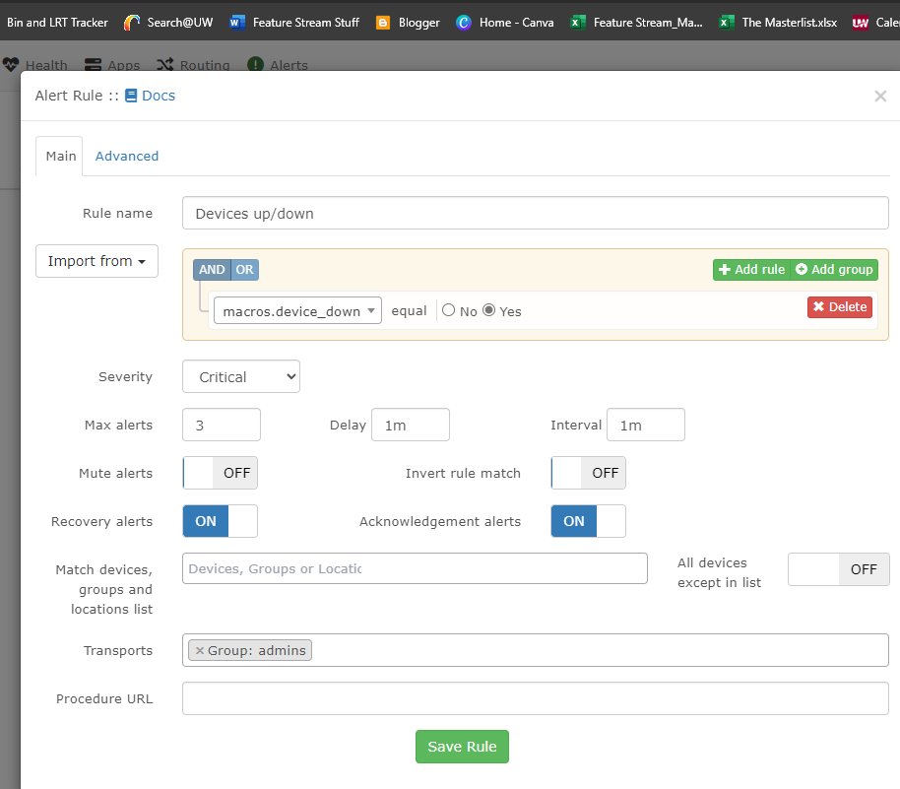

* 1. You should see the rule be created like the below

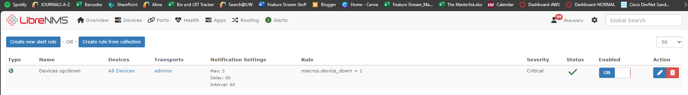

1. In this setup, there has been a test device added to the monitoring system. When it goes down, the alert should trigger the rule, which should send the alert through email to Nathan_Hammer on the citadel server via the authentication of the bind user

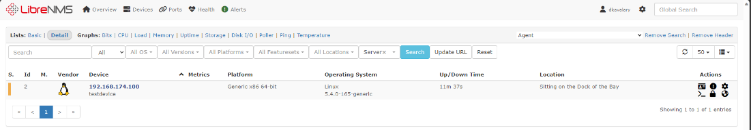

* 1. Take down the device, and watch as after a few minutes you shall receive an email at the designated Admin alert transport email. The sender shows as the bind user as that is what was used to authenticate with the server. If you want it to show as LibreNMS, The citadel settings should be configured to accept all from headers . If you bring the device back up, you should receive another email notifying you of such.

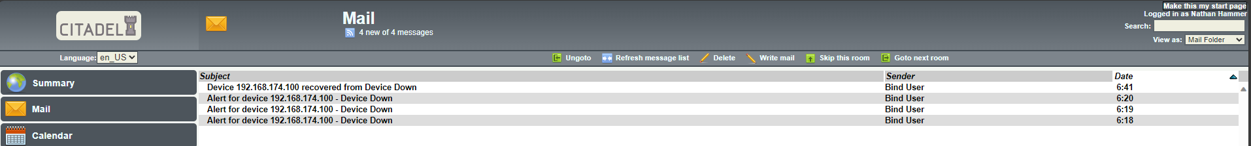

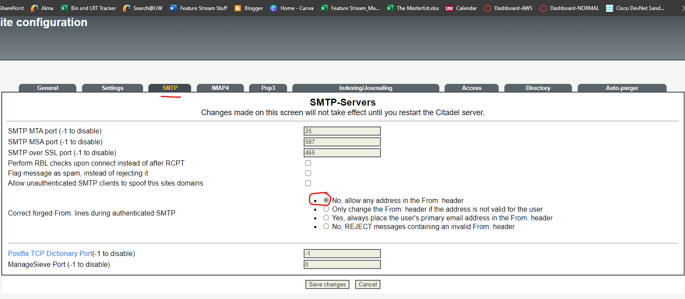



1. Go to **Overview > Dashboard** to configure a shared dashboard for your users.

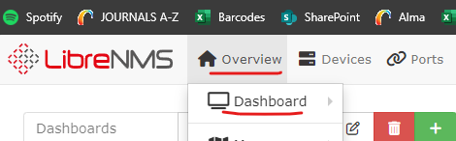

* 1. Click the **Edit** button for the default dashboard, then set the dashboard to be **Shared Read** instead of **Private**

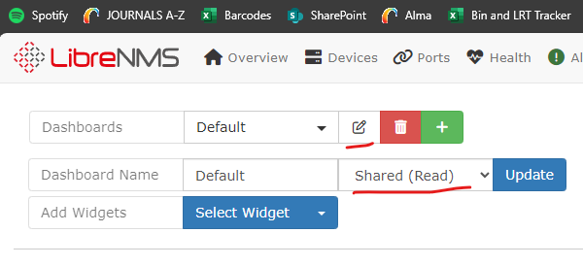

* 1. Click **Select Widget** and choose a few options, such as **Alerts** and **Alert History**

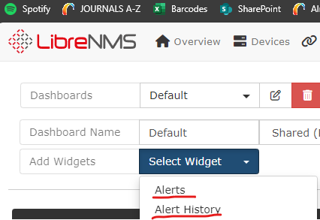

* 1. By Clicking and dragging the headers of the widgets you can place the widgets to create a display that functions with your needs. The Alerts may be populated if you decide to add a device and test alerts before this

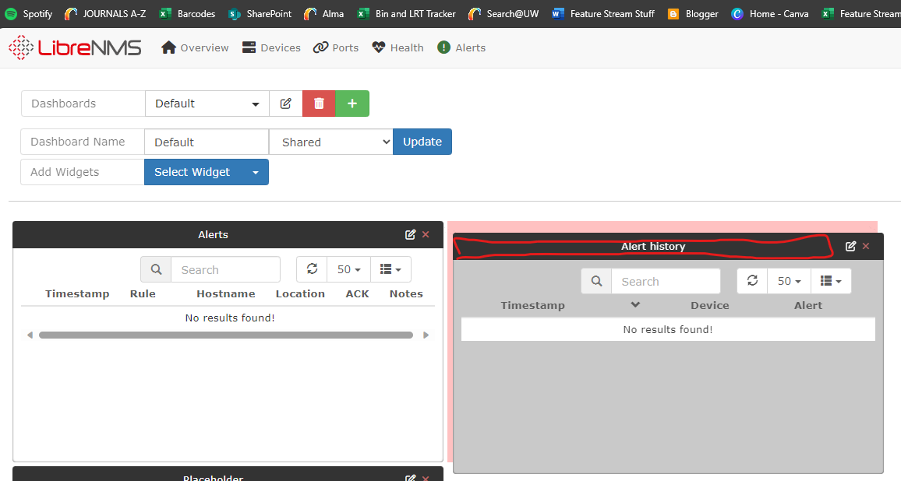

* 1. Select **Update** to confirm changes to the dashboard

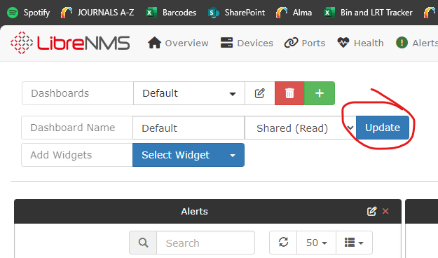

1. Many times we wish to know when a networking device or server is acting outside of its baseline. There is a way to determine a rough baseline per device, and then configure the device settings or alerts to give us warning when it is exceeding that baseline. This can be tested with devices added through SNMP, as they will provide LibreNMS with detailed information outside of connectivity.
   1. First, we will examine how you would do this through alert rules, then through the device settings itself to show as a warning on LibreNMS
      1. Click on one of your devices to view more details about it

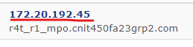

* + 1. Go to **Ports** to view current throughput. Lets examine the throughput on g0/0/2, the port connecting to the internet. For this example, lets say the typical usage is lower than this at about 50Mbps.

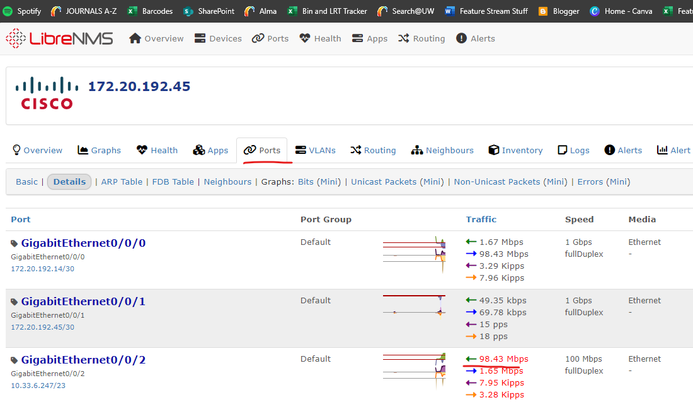

* + 1. Next go to **Health > Memory.** You can view the typical memory usage if you are currently operating as normal. Take note of this number

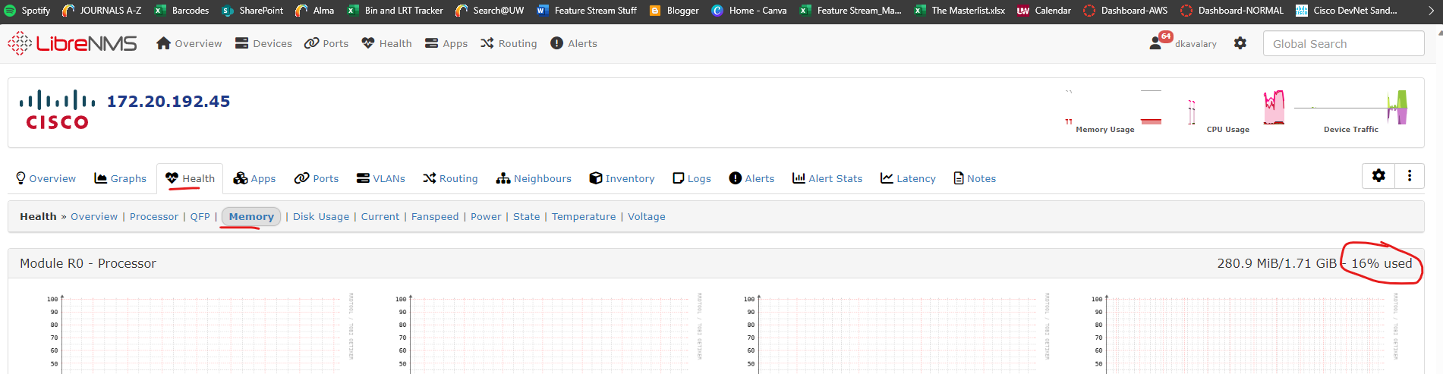

* 1. Go to **Alerts > Alert Rules**
     1. Add a new rule to detect when memory and port throughput are above your chosen baseline
     2. In this instance, we are creating a rule to alert the admins group through email if memory used or port in throughput is above 25 and 50 percent respectively. We are also applying it to specifically the device in question.

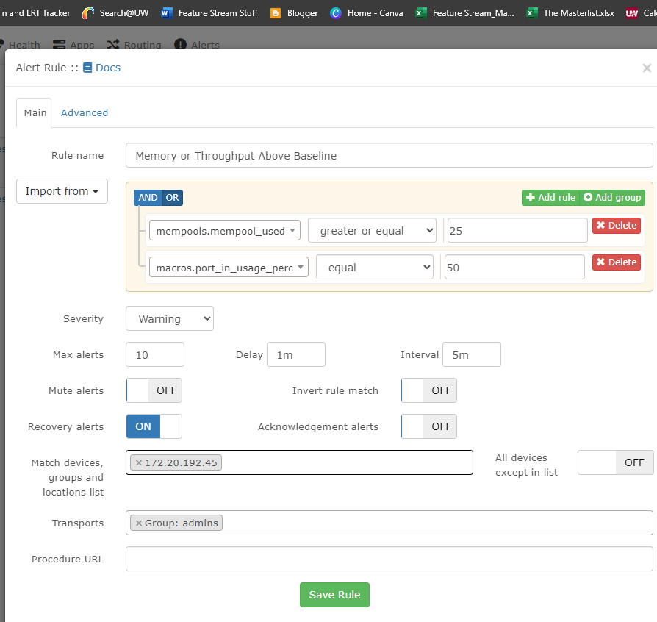

* + 1. We can see in **Alerts > Notifications** if one of these triggers the alert. In this case, we had started running processes that would use up more router memory

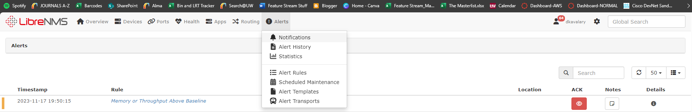

* + 1. We can also see through email notifications such as this one created for memory or processor usage



* 1. Lets look at how we can see if a device is working above its baseline through another method. The % Warn method in LibreNMS.
     1. Go to **Device Settings > Processors** on a device**.** Examine the rough percentage of the processors. Use these to assign a rough baseline warning to each processor.
     2. There is a % Warn field you can edit. The number entered will make LibreNMS trigger a warning if the current usage % exceeds the % Warn
        1. You can assign a % Warn for each processor. For high usage processors you might set a warning baseline of a high percentage since that would be typical. For low usage processors, you might set a warning baseline of 50% to warn you if they suddenly become used more.
        2. Generally, you want to set your baseline warning 15-20 percent above typical usage

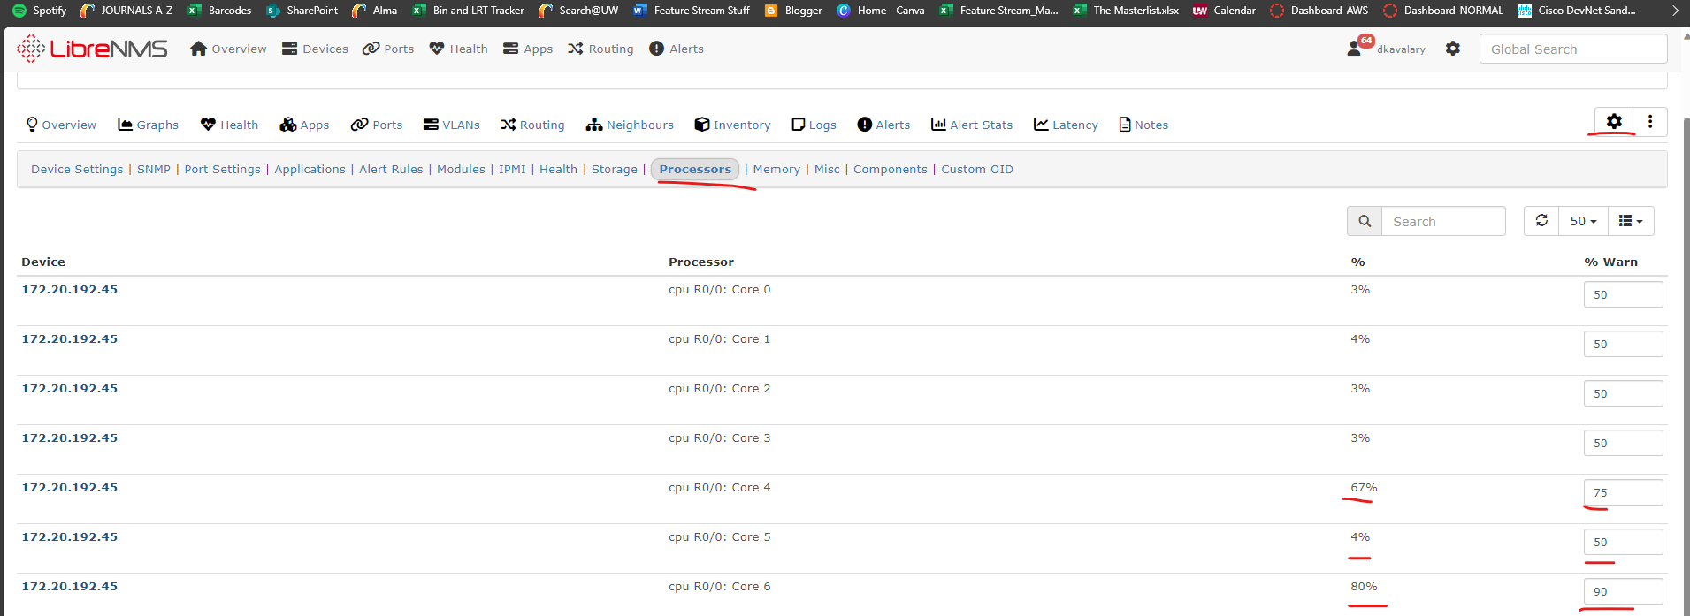

* + 1. The same can be done in **Memory and Storage** for example

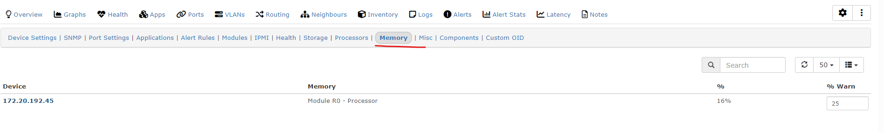

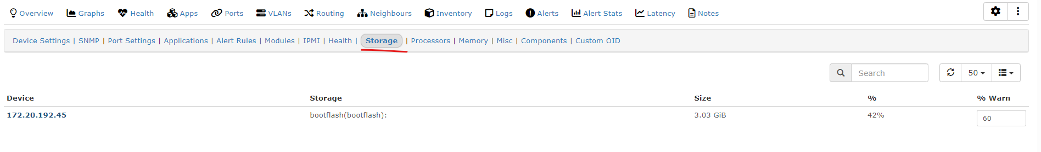

* + 1. Lets look at the device overview of a server to see how these warnings appear.
       1. This is what device statistics look like when stats are below the baseline
       2. Examine the color

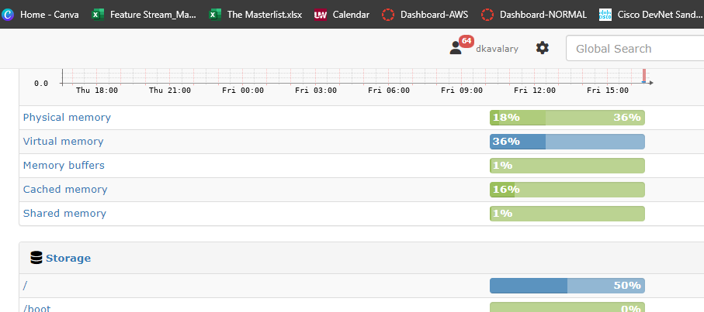

* + - 1. This is what device statistics look like when the % Warn was set to 10% for each memory and storage slot

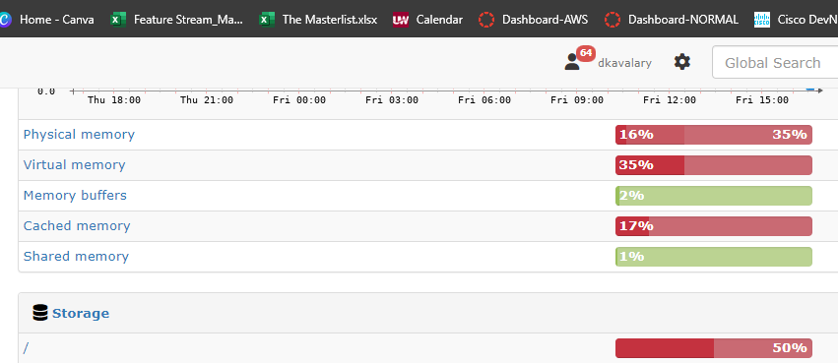

* + - 1. This can also be seen under **Health > Memory,** which shows every device being monitored. Only the server is being monitored in this example

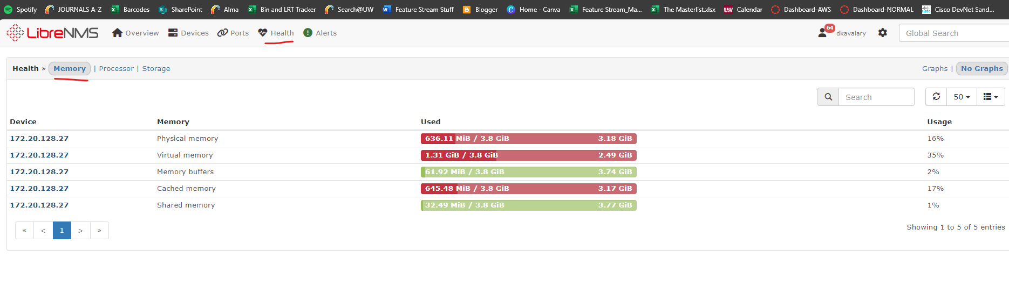

* + - 1. Conveniently, alert rules can be set to email users when a warning is triggered.